佐賀県-大問４ |   2022年 公立高校入試
※QRコードを読み込むと，英文と連動した音声再生ができます（スマホにも対応）

次の英文は，中学３年生の翔太（Shota）と聡美（Satomi）が，学年にアンケート調査（questionnaire）を行い，その結果を【表１(Table 1)】と【表２(Table 2)】にまとめて，英語の授業で対話をしながら発表をしている場面である。これを読んで，問１～問５に答えなさい。

Shota: These tables are the results of the questionnaire we did a week ago.
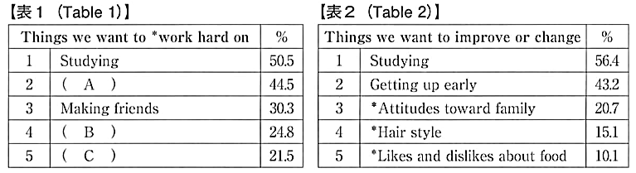

Satomi: We wanted to know what students think about their school life after they become high school students.
Shota: Table 1 is about things we want to work hard on, and Table 2 is about things we want to improve or change.
Satomi: First, “Studying” took first on these tables. This is the result we guessed, and we were right. We will learn a lot of things in high school, and they are necessary for our future. I can understand why “Club activities” came near the top on Table 1, too.
Shota: “Making friends” was *ranked third on Table 1. I agree with it because we may go to different high schools and meet new people there.
Satomi: That's right. I want to make a lot of friends next year, too. Well, “Getting up early” took second on Table 2. What do you think of this, Shota?
Shota: Well, I can really understand that. *In my case, I want to get up early in the morning without my mother's help.
Satomi: I see. It is interesting that “Attitudes toward family” took third on Table 2.
Shota: I think so, too. I will improve my attitudes toward my family.
Satomi: Now, let's talk about “Volunteer activities” on Table 1. Surprisingly, “Volunteer activities” was ranked lower than “School events.” I think we should do more volunteer activities when we are in high school. By doing them, people can help each other and also find new ways to see things.
Shota: I agree. *According to a *survey, about 65 percent of young people in the U.S. are interested in volunteer activities, but only 33 percent of young Japanese people are interested in them. Do you know why this happens, Satomi?
Satomi: I think we have a lot of things to do and don't have much time.
Shota: That is a good point. But I think there is another reason. Students don't have much
① about volunteer activities held in their hometowns.
Satomi: Actually, I didn't know what kind of volunteer activities we had in my *community. But I found a lot of information about them on the Internet. There are many volunteer activities in our communities. Some of them are easy to do and don't take much time. I'm sure it is easy for us to join them.
Shota: Yes. It is important for us to ask our communities for the information. By doing so, Satomi and I will ② . Why don't you join us?
Satomi and Shota: Thank you for listening!

*work hard on ～ ～に一生懸命取り組む *attitude(s）toward ～ ～に対する態度 *hair style 髪型
*likes and dislikes 好き嫌い *rank(ed）～ ～を位置づける *in one's case ～の場合
*according to ～ ～によると *survey 調査 *community(-ies) 地域社会，コミュニティ

問１ 【表１(Table 1)】と【表２(Table 2)】について，勉強が１位になった理由を聡美はなぜだと考えているか。日本語で書きなさい。
問２ 本文の内容から，【表１(Table 1)】の（ Ａ ）～（ Ｃ ）にあてはまる語句の組み合わせとして最も適当なものを，次のア～エの中から一つ選び，記号を書きなさい。
ア (Ａ) Club activities (Ｂ) School events (Ｃ) Volunteer activities
イ (Ａ) Volunteer activities (Ｂ) School events (Ｃ) Club activities
ウ (Ａ) School events (Ｂ) Volunteer activities (Ｃ) Club activities
エ (Ａ) Club activities (Ｂ) Volunteer activities (Ｃ) School events
問３ ① にあてはまる英語１語を，本文中から抜き出して書きなさい。
問４ ② にあてはまる英語として最も適当なものを，次のア～エの中から一つ選び，記号を書きなさい。
ア get up early in the morning every day during our high school days
イ study harder before we go to high school
ウ experience a new club activity after we go to high school
エ do various volunteer activities when we are in high school
問５ 本文の内容に合うものとして最も適当なものを，次のア～エの中から一つ選び，記号を書きなさい。
ア Shota and Satomi want to know how students feel about their junior high school life.
イ Satomi wants to work hard on making a lot of friends when she is in high school.
ウ Shota will not change his attitudes toward his family.
エ Satomi doesn't have any ideas why young Japanese people are interested in volunteer activities.

解答
問１ 高校では多くのことを学び，それらは将来必要だから。
問２ ア
問３ information
問４ エ
問５ イ

