佐賀県-大問５ |   2022年 公立高校入試
※QRコードを読み込むと，英文と連動した音声再生ができます（スマホにも対応）

次の英文は，中学生の美弥（Miya）が英語の授業で行ったスピーチの原稿である。これを読んで，問１～問５に答えなさい。
One day, I visited my friend Aki's house and met her dog, Koko. Koko was a very small and cute *female *teacup poodle, and her brown *fur was very soft. She didn't *bark very much. She ran to me and *sat on my lap. I was very happy to meet her. That evening, I talked to my family about Koko. My parents smiled and listened to my story, so I said to them, “I want to have a dog like Koko.” Then their smiling faces changed, and my father said, “No.” He said, “①It's hard for you to have a dog. You don't do anything by yourself, right?” I couldn't say anything. The next day, I started to wake up by myself, cook my breakfast and clean my room. It was very difficult, and I became tired sometimes, but I tried to do many things by myself.
A few weeks later, I found an *article about *animal shelters. In Japan, many dogs are brought to animal shelters, and some of them have to spend their whole life there. I was very sad to know ②those facts. I told my father that I wanted to keep a dog from an animal shelter. He said, “I've heard some dogs kept in animal shelters have had sad experiences, and they may not trust people. I think it is very difficult for us to have such dogs in our house. There are other ways to help those dogs. As a volunteer, you can help people who work at animal shelters. You can *donate money.” I said to him, “Dad, I can do many things by myself now. So I think I can help and take care of such dogs!”
That weekend, my father and I visited an animal shelter. It was a very cold day. In the shelter, there was ③a dog in a *cage. It was a female dog. She wasn't very small, and she didn't have brown fur like Koko. She was sitting and didn't bark at all. A man in the shelter said, “I found this dog in front of this shelter. She was very dirty and weak. She didn't eat anything for a long time.” I tried to *draw her attention. She just kept sitting and looking at me. I thought that she wanted to say something to me. I kept looking at her. I said to my father, “I want this dog.” He asked, “ ④ ” I said, “Yes.” I didn't want to leave there without her.
We went home together. I gave her dog food. She ate all of it. When she finished eating, she barked. She looked happy. At that time, it began to snow, and I said in Japanese, “It's snowing.” Then, she barked again. I said to her, “Yuki.” She barked this time, too. I said to her, “OK. Your name is Yuki.”
When Yuki goes out with me, she looks very happy. I don't want to make her sad. This experience gave me a dream. I want to be an animal doctor. I gave her a new life, and she has changed my life, too.

*female メスの *teacup poodle ティーカッププードル（犬種の１つ) *fur (動物の）毛
*bark(ed) ほえる *sit(sat）on one's lap ～のひざに乗る *article 記事
*animal shelter(s) 動物保護施設 *donate money 募金する *cage (動物の）おり，ケージ
*draw one's attention ～の注意を引く

問１ 下線部①について，なぜ父はそう言ったのか。その理由を日本語で書きなさい。
問２ 下線部②とは具体的にどのようなことか。日本語で書きなさい。
問３ 下線部③を表す絵として最も適当なものを，次のア～エの中から一つ選び，記号を書きなさい。
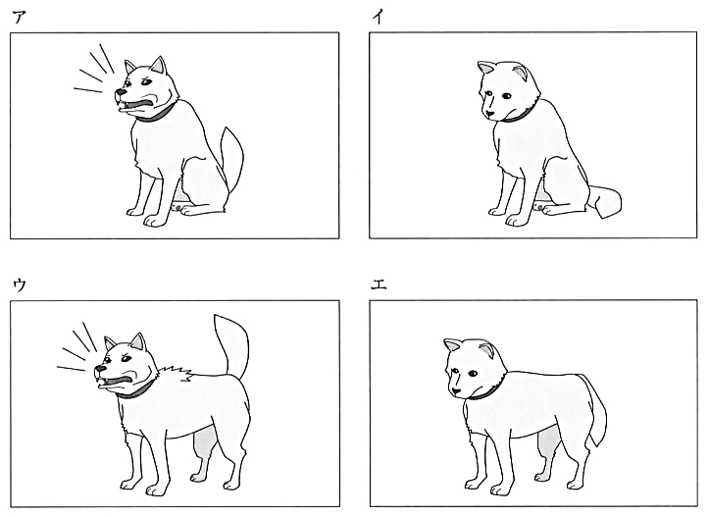

問４ ④ にあてはまる英文として最も適当なものを，次のア～エの中から一つ選び，記号を書きなさい。
ア Me, too. イ Why? ウ Are you sure? エ The brown one?
問５ 本文の内容に合うものとして最も適当なものを，次のア～エの中から一つ選び，記号を書きなさい。
ア Miya's father wanted to have a dog that had soft and brown fur.
イ Miya did her best to have a dog, and she does many things by herself.
ウ Dogs kept in animal shelters can help people because they had sad experiences.
エ The dog from the animal shelter was called Yuki because the dog had white fur.

解答
問１ (例)美弥が自分で何もしていないから。
問２ (例)日本では，多くの犬が動物保護施設に持ち込まれ，それらの一部は一生施設で過ごさなければならないこと。
問３ イ
問４ ウ
問５ イ

