兵庫県-大問３ |   2022年 公立高校入試
※QRコードを読み込むと，英文と連動した音声再生ができます（スマホにも対応）

高校１年生の生徒が，英語の授業での発表に向けて，次の英文を読んでポスターを作成しました。あとの問いに答えなさい。
Do you know what a fishfinder* is? It is a machine fishers* use to find groups of fish in the sea. The first fishfinder was invented about 70 years ago. With this machine, they were able to catch more fish than before because they could see where the groups of fish were on the screen.
However, the old fishfinder caused a problem. Fishers sometimes caught too many young fish because they could not see the size of each fish. As a result, the number of fish became smaller in some areas, and fishers could not catch enough fish.
A Japanese man who used to study dolphins got an idea to improve this problem. He knew how dolphins could swim fast and were good at catching fish. They have a special skill for hunting with sound waves. Dolphins emit* sound waves many times very quickly. These sound waves will reach the fish and come back. So, dolphins can easily find where the fish are. They can see the shape, size, and speed of the fish, too.
He applied* the dolphins' skill to his fishfinder. It was a great success. Today, his new fishfinder can show the image more clearly than the old one. So, fishers can even see how large each fish is. When they find that the fish are too young, they can stop fishing and go to another place. This is helpful to save young fish in that area. Fishers can keep catching fish there for many years.
He said, “The sea has given us a lot of good things for a long time. I'd like to give something back to it. I believe we have to learn from nature around us. The dolphins' skill is one of the examples. From dolphins, I got the idea and invented the new fishfinder. I want to continue inventing useful machines for our daily lives. If more children like the sea because of my work, I'll be very happy.”
(注) fishfinder：魚群探知機 fishers：漁師 emit：出す apply：応用する
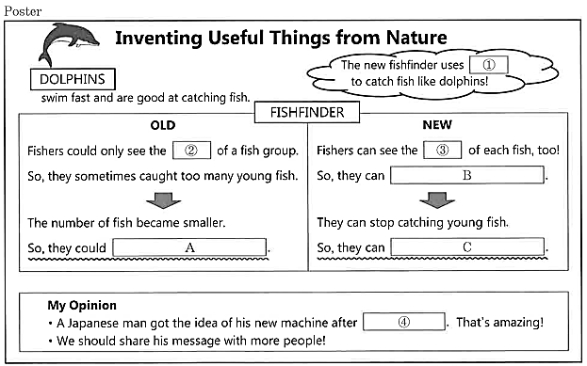

問１ ポスターの ① に入る適切なものを，次のア～エから１つ選んで，その符号を書きなさい。
ア large screens
イ old machines
ウ swimming skills
エ sound waves
問２ ポスターの ② ， ③ に入る語の組み合わせとして適切なものを，次のア～エから１つ選んで，その符号を書きなさい。
ア ② place ③ speed
イ ② speed ③ place
ウ ② place ③ size
エ ② speed ③ shape
問３ ポスターの Ａ ～ Ｃ に入る適切なものを，次のア～エからそれぞれ１つ選んで，その符号を書きなさい。
ア choose the fish they want to catch
イ continue catching fish for many years
ウ learn how to catch fish from dolphins
エ catch only a small number of fish
問４ ポスターの ④ に入る適切なものを，次のア～エから１つ選んで，その符号を書きなさい。
ア inventing something useful in our daily lives
イ paying attention to the hunting skills of dolphins
ウ catching a lot of fish with the new machine
エ improving the machine to get many kinds of fish

解答
問１ エ
問２ ウ
問３ Ａ：エ Ｂ：ア Ｃ：イ
問４ イ

