兵庫県-大問４ |   2022年 公立高校入試
※QRコードを読み込むと，英文と連動した音声再生ができます（スマホにも対応）

高校２年生のかおるさんと留学生のトムさんが，かおるさんの家族とドライブの途中で立ち寄った施設で，話をしています。次の英文を読んで，あとの問いに答えなさい。
Kaoru: Let's have a break here.
Tom: OK. What's this place?
Kaoru: This is a roadside station*. It's a station for cars. We can use the toilets and take a rest.
Tom: Look! A lot of vegetables and fruits are sold here. They are very fresh and not so expensive.
Kaoru: Yes, farmers bring them from their fields near here. They can decide the prices of their products.
Tom: Nice! ① , what's printed on the box of tomatoes?
Kaoru: It's the name of a farmer, Mr. Tanaka. It also tells us that he grew his tomatoes without using agricultural chemicals*.
Tom: I see. I feel safe if I know ② and how they were grown.
Kaoru: I think so, too.
Tom: Well, do farmers sell anything else?
Kaoru: Yes, they also sell their handmade products. For example, my grandmother sells her jam in all seasons. She makes it from blueberries* she grows in her field. It's popular and is sold quickly.
Tom: That's nice.
Kaoru: Roadside stations are good for local farmers because the farmers can ③ .
Tom: I agree. We can buy original products sold only in this roadside station.
Kaoru: Also, we can enjoy original events planned to attract a lot of people at roadside stations.
Tom: Really? What kind of events do they have?
Kaoru: For example, this roadside station has a knife sharpening* event every month. Some companies in this town have made excellent knives since the Edo period. There is a museum about their products next to this building.
Tom: Oh, we can learn about the history, too.
Kaoru: In addition, people can get a lot of convenient information for their travels. Roadside stations spread information about their towns. Many people from other cities visit them, and they're always crowded on weekends. Local people become more cheerful.
Tom: That's true. Roadside stations attract many visitors. I think those visitors ④ . I want to visit many different roadside stations, too.
Kaoru: How about visiting another roadside station next week?
Tom: That sounds wonderful.

(注) roadside station(s)：道の駅 agricultural chemicals：農薬 blueberries：ブルーベリー
knife sharpening：刃物研ぎ

問１ 文中の ① に入る適切なものを，次のア～エから１つ選んで，その符号を書きなさい。
ア By the way
イ In total
ウ For example
エ Of course
問２ 文中の ② に入る適切なものを，次のア～エから１つ選んで，その符号を書きなさい。
ア who made them
イ why he grew them
ウ when they were sold
エ what made the price low
問３ 文中の ③ に入る適切なものを，次のア～エから１つ選んで，その符号を書きなさい。
ア have a break and learn about the history of the town
イ grow their products and see the name of visitors
ウ decide the price by themselves and sell their products
エ visit other local museums and show more products
問４ 文中の ④ に入る適切なものを，次のア～エから１つ選んで，その符号を書きなさい。
ア have the chance to sell local products
イ help local farmers buy other products
ウ tell local people to go to other cities
エ make the local community more active
問５ トムさんは，この日の出来事を日記に書きました。本文の内容に合うように， あ ～ う
に入る適切な英語を，本文中からそれぞれ１語を抜き出して書き，英文を完成させなさい。
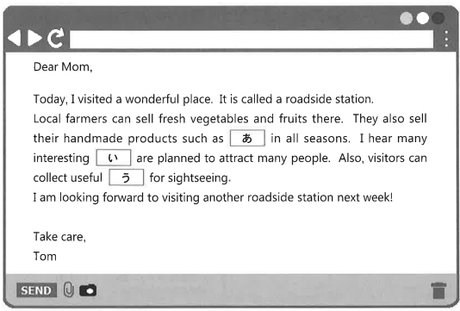

解答
問１ ア
問２ ア
問３ ウ
問４ エ
問５ あ：jam い：events う：information

