北海道-大問３Ｃ |   2022年 公立高校入試
※QRコードを読み込むと，英文と連動した音声再生ができます（スマホにも対応）

次の英文は，高校生の直樹（Naoki）が，シンガポール（Singapore）から来た留学生のルーカス（Lucas）と会話している場面のものです。これを読んで，問いに答えなさい。

Naoki: Hi, Lucas. Today's English class was interesting. It was my first time to use the *web meeting system. It was really fun.
Lucas: Yes. I enjoyed talking with the students in Korea on the Internet.
Naoki: If we use this web meeting system, we can talk and see each other's faces. This information *technology helps us have good communication.
Lucas: That's true. I sometimes use this system to talk with my family in Singapore.
Naoki: Wow, you've already used the system in your daily life, too.
Lucas: Yes. It's really useful, but my family sometimes send me *handwritten *postcards with pictures of Singapore. The postcards always make my heart warm and *remind me of my country. So both the new technology and the traditional things are important for me.
Naoki: I understand what you mean. Your story reminds me of my uncle's job. He's a farmer and has grown *cabbages on his large *field for a long time. One of the important jobs he has is checking all his fields by himself to find areas which have some problems, but it takes so much time to do that. So he's trying to use new technologies now. He's using *drones and *AI. His drones are used for taking pictures of his fields and the *data is sent to AI. Then it finds which areas have problems by using the data.
Lucas: Wow, that's wonderful. His work is getting easier because he checks only the areas with problems.
Naoki: I think so, too. But he says that AI isn't good enough because it can't show why the areas have problems.
Lucas: What do you mean?
Naoki: *Even if it shows that some areas have a *common problem such as having smaller cabbages, the reasons for the problem may be different in each area. Some areas need more *fertilizers, and other areas need more water.
Lucas: Really? Then, how does he find the reason?
Naoki: Well, he goes to the areas with problems and finds the reason with the *knowledge from his past experience. He remembers the *similar conditions of the field in the past.
Lucas: Wow, that sounds interesting!
Naoki: Yes. I think that he's using both new technologies and his knowledge *effectively.
Lucas: I agree with you. Both of them are useful for his job, so we don't need to think about which is better.
Naoki: That's right. It's important for us to decide when to use new technologies and traditional things and how to use them.

(注) web meeting system ウェブ会議システム technology（technologies) 技術
handwritten 手書きの postcard(s) 絵はがき remind ～ of … ～に…を思い出させる
cabbage(s) キャベツ field(s) 畑 drone(s) ドローン（無人航空機) AI 人工知能
data 情報，データ even if たとえ～だとしても common 共通の fertilizer(s) 肥料
knowledge 知識 similar condition(s) 同じような状況 effectively 効果的に

問１ 下線部において行ったこととして，最も適当なものを，ア～エから選びなさい。
ア ウェブ会議システムを使った，韓国の生徒との会話
イ 初めて来日した外国人との交流
ウ 海外への手紙の書き方についての学習
エ 情報技術を使った農業についての学習
問２ 本文の内容に合うものを，ア～オから２つ選びなさい。
ア Lucas has used the web meeting system to talk with his family in Korea.
イ Lucas's heart gets warm when he reads handwritten postcards from his family.
ウ Naoki says his uncle's drones give fertilizers and water to the field.
エ Naoki's uncle uses AI to find the areas with problems in the field.
オ Naoki says his uncle can't use the data from his drones to grow cabbages.
問３ 次の図は，直樹とルーカスの会話の内容について整理したものです。本文の内容から考えて， (1) ～
(3) に入る英語を書きなさい。ただし，(1)は２語，(2)，(3)はそれぞれ１語とします。
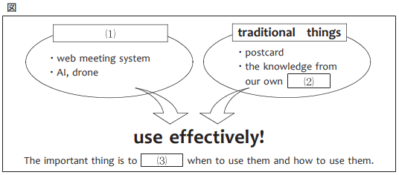

問４ 次の英文は，ルーカスが直樹との会話の後に書いた日記の一部です。日記の内容から考えて，
に共通して入る適当な英語を１語で書きなさい。
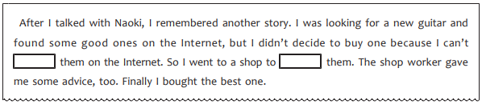

解答
問１ ア
問２ イ エ
問３ (1)(例）new technologies
(2)(例）experience
(3)(例）decide
問４ (例）play

