千葉県-大問８ |   2022年 公立高校入試
※QRコードを読み込むと，英文と連動した音声再生ができます（スマホにも対応）

アメリカのオレゴン（Oregon）州ポートランド（Portland）出身のネイサン（Nathan）が故郷を紹介しています。この文章を読んで，あとの問１～問４の問いに答えなさい。
My hometown, Portland, is in Oregon. Oregon is in the northwest part of the United States. Portland is one of the best cities to live in and the best “green cities” in the world. About 650,000 people live there. Many people around the world are interested in this city.
About 50 years ago, there were plans to build freeways along the river in the center of the city. [ ア ] However, people in Portland were already thinking about the environment then. In 1974, people in Portland chose to build parks with beautiful trees and flowers and not to build the freeways. [ イ ] They wanted to spend more time in beautiful nature. Thanks to the voices of people in Portland, the city became kind to the environment. The city map about 50 years ago shows some freeways on it, but they weren't actually built. There are more than 300 parks in this city now. [ ウ ] You can see many flowers, birds, and other animals there. You can enjoy walking, running, relaxing, or even having festivals there. [ エ ] One popular festival is The Portland Rose Festival. Portland is so warm that they can grow many roses, so it is called “The City of Roses.” This festival has continued since 1907. Today, Portland has a long history.
The city also has a good public transportation system. Many workers go to their offices by bicycle or by public transportation. The use of cars in the city has been decreasing because its public transportation system has been getting better and better. The trains are especially convenient. It is easy to travel in the center of the city by train. For example, when you leave the stores after shopping, the station is just in front of you. You don't have to go up or down stairs. When you take the train from the airport with a lot of bags, you can get off in the main area of the city and walk to your hotel easily.
Buses are also easy ways to go around the city. There are many bus lines, so you can go to the places that you want to go without cars. You can even ride the bus with your bicycle. Before you get on the bus, you can put your bicycle on the front of the bus. When you get off, you can take it down. This means you don't have to look for a bicycle parking and you can go anywhere in the city with your bicycle. In addition, buses use biofuels, so they don't have much effect on the environment. They don't give off much carbon dioxide. In the near future, the city is planning to use buses that run only on electric power. The city decided to reduce their carbon dioxide emissions to 1990 levels. Many people in Portland know about this project.
Portland is known as a fantastic city by many people. If people around the world want to try something to make their cities better, Portland has many good examples. You can get some good ideas from Portland.

(注) northwest 北西 green 環境に優しい freeway 高速道路rose バラ
public transportation system 公共交通機関 convenient 便利な bicycle parking 駐論場
in addition さらに，加えて biofuel バイオ燃料 effect 影響 give off 排出する
carbon dioxide 二酸化炭素 emission 排出 electric 電気の
問１ 次の英文を入れるのに最も適当な場所を，本文中の [ ア ] ～ [ エ ] のうちから一つ選び，その符号を書きなさい。
At that time, people were cutting down many trees and building roads in many cities.
問２ 本文の内容に関する次の質問に，英語で答えなさい。
Why did people in Portland stop planning the freeways in the center of the city and build parks there?
問３ ポートランドを走っているバスを表した絵として最も適当なものを，次のア～エのうちから一つ選び，その符号を書きなさい。
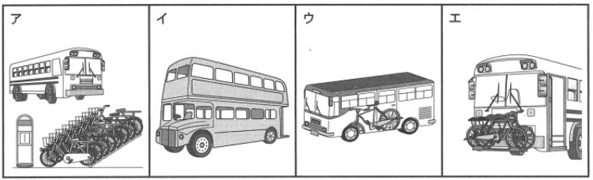
問４ 本文の内容に合っている英文として最も適当なものを，次のア～エのうちから一つ選び，その符号を書きなさい。
ア When you finish shopping, you need to go up and down to get to the station in Portland.
イ More people in Portland use their own cars because of its public transportation system.
ウ You can see some freeways on the city map of Portland about 50 years ago.
エ Many people in Portland know about the project to reduce the number of electric buses.

解答
問１ ア
問２ (例)（Because）they wanted to spend more time in beautiful nature.
問３ エ
問４ ウ

