和歌山県-大問２ |   2022年 公立高校入試
※QRコードを読み込むと，英文と連動した音声再生ができます（スマホにも対応）

次の英文は，高校生の由衣（Yui）が，販売実習について，英語の授業で行ったスピーチの原稿です。これを読み，問１～問４に答えなさい。
In our school, we can study agriculture. I'm in the agriculture course. I learn how to grow good vegetables, flowers, and fruits. I grow them with my classmates. At school, we sometimes make processed products like juice.
In June, we started to sell vegetables, flowers, fruits, and processed products. Every Friday, we sold them at the station near our school. When we sold them, I recorded the sales there. I was happy when many people came to the station to buy our products. I sometimes asked them how they liked our products.
At the end of each month, I made a pie chart to check the percentage of all sales in the month. Today, I'll show you the pie charts of June and July. In those months, we sold vegetables the most. In June, the percentage of processed products was higher than fruits and flowers. However, in July, processed products weren't so popular. Compared to June, the percentage of fruits became higher and the percentage of flowers was the same.
It has been a great experience for me to make and sell products. At the station, people tell me what they think about our products. And the pie charts show me the popular products in different seasons. I'm glad I have some useful information now.
Well, here is the thing which I want to tell you the most. I want to improve our products by making use of the things I learned.
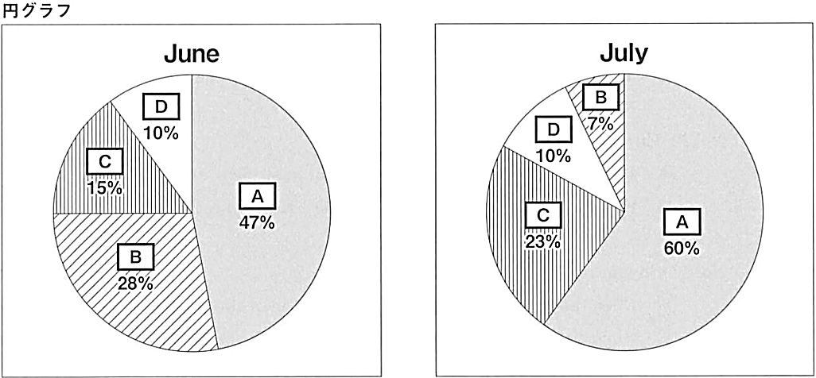

(注) agriculture 農業 course 学科 grow 育てる processed product 加工製品 sold ＜ sellの過去形
record 記録する sales 売上げ end 終わり pie chart 円グラフ percentage 割合
compared to ～ ～と比較すると make use of ～ ～を生かす

問１ 本文の内容に合うように，次の( ）にあてはまる最も適切なものを，ア～エの中から１つ選び，その記号を書きなさい。
Yui（ ).
ア sold the products in her school
イ made juice at the station
ウ wanted to teach agriculture at school
エ recorded the sales at the station
問２ 文中の下線部 the pie chartsについて，本文の内容に合うように円グラフの Ａ ～ Ｄ にあてはまる最も適切なものを，次のア～エの中から１つずつ選び，その記号を書きなさい。
ア vegetables イ flowers ウ fruits エ processed products
問３ 由衣が，スピーチを通して一番伝えたいことはどのようなことですか。最も適切なものを，次のア～エの中から１つ選び，その記号を書きなさい。
ア Yui wants to make better products.
イ Yui wants to show her pie charts.
ウ Yui wants to record the sales.
エ Yui wants to think about more products.
問４ 由衣は，スピーチの後，ALT（外国語指導助手）のトム（Tom）と話をしました。次の対話文は，そのやりとりの一部です。これを読み，あとの(1)，(2)に答えなさい。
Tom: That was a wonderful speech. It's a good idea to sell products at the station.
Yui: Yes. People look happy when they buy our products. So I become happy.
Tom: Good. I want to buy some fruits next Friday.
Yui: Please come to the station. I want more people to come.
Tom: Well, what can you do about that?
Yui: I think I can .
Tom: That's a good idea. If you do it, more people will come to the station.
(1) 対話の流れに合うように，文中の にふさわしい英語を書きなさい。ただし，語数は２語以上とし，符号（ . , ? ! など）は語数に含まないものとする。
(2) 対話の内容に合う最も適切なものを，次のア～エの中から１つ選び，その記号を書きなさい。
ア Yui could buy some fruits on Sunday.
イ Yui wants people to enjoy the products.
ウ Tom was sad to hear Yui's speech.
エ Tom has a question about fruits.

解答
問１ エ
問２ Ａ：ア Ｂ：エ Ｃ：ウ Ｄ：イ
問３ ア
問４ (1)make posters (2)イ

