埼玉県-大問４Ａ |   2022年 公立高校入試
※QRコードを読み込むと，英文と連動した音声再生ができます（スマホにも対応）

次の１～４は，書道部のNaoto，KimmyとAyakoの会話です。これらを読んで，問１～問８に答えなさい。*印のついている語句には，本文のあとに〔注〕があります。

１ One day after school, Naoto, Kimmy and Ayako are talking.
Naoto : Our ALT, Mr. Smith is going back to Australia. He often comes to this calligraphy club. All the members in our club like him very much.
Kimmy : He is very nice to us. He gives us good *advice.
Ayako : He helps us a lot. He loves the calligraphy *works we make, too. Hey, I have an idea. How about giving him a present?
Naoto : That's a good idea! What should we get for him?
Kimmy : Let's write messages for him on shikishi. I think he'll be glad to read our messages.
Ayako : Ａ It's a popular present and easy to make. Should we make something else for him?
Naoto : We should give him shikishi and one more thing, but I cannot think of any good ideas *right now.
Kimmy : I *wonder what he would like.
Ayako : Let's tell the other members of our club about our ideas. I think they will help us choose a good present.
〔注〕 advice：助言 work：作品
right now：今すぐに wonder～：～だろうかと思う
問１ 空欄 Ａ にあてはまる最も適切なものを，次のア～エの中から一つ選び，その記号を書きなさい。
ア I don't believe it.
イ That sounds good.
ウ Don't worry about it.
エ I'll give it to you.
問２ 本文１で，Ayakoは，自分たちの考えを他の部員たちに伝えようとするのはなぜだと述べていますか。日本語で書きなさい。

２ The next day, they start a *discussion after talking with the club members.
Naoto : So, everyone in our club wants to give Mr. Smith a present, right?
Ayako : Yes, we talked about plans for a present during the club meeting yesterday, but we couldn't decide what to give him as a present with the shikishi.
Kimmy : Then, we need to think of a good plan.
Naoto : After we talked in the club meeting, one of the club members gave me Mr. Smith's *self-introduction sheet. Mr. Smith gave it to all the students in his first English class. I think it'll help. Let's look for ideas on the sheet. It's better to give 〔 is / he / him / interested / something 〕in.
Ayako : Oh, I remember I was given this sheet when I was a first-year student. That's a good idea.
Naoto : *Based on this sheet, how about giving him flowers, too? I'm sure he'll like them.
Kimmy : I don't think that's a good idea. I think there are rules for taking flowers or plants out of the country.
Naoto : Oh, you mean that he cannot take flowers from Japan to Australia?
Kimmy : I'm not sure, but if the flowers we give him cannot be taken from Japan to Australia he may have trouble.
Ayako : If we give him things that are too large or heavy, it'll be hard for him to carry them to Australia, so we shouldn't choose things like that.
Naoto : You're right. What should we give him instead?
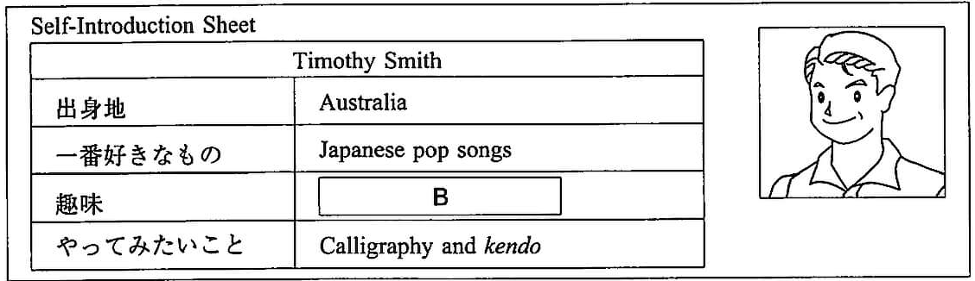

〔注〕 discussion：話し合い self-introduction：自己紹介based on～：～に基づけば
問３ 〔 〕内のすべての語を，本文の流れに合うように，正しい順序に並べかえて書きなさい。
問４ 本文２の内容と合うように，Self-Introduction Sheetの空欄 Ｂ にあてはまる最も適切なものを，次のア～エの中から一つ選び，その記号を書きなさい。
ア Collecting pens イ Cooking ウ Traveling エ Taking care of flowers
問５ 本文２の内容と合うように，次の英語に続く最も適切なものを，ア～エの中から一つ選び，その記号を書きなさい。
Naoto said that
ア flowers were good as a present, but Kimmy didn't agree with that idea.
イ something that was too large or heavy was not bad as a present.
ウ he needed Mr. Smith's self-introduction sheet, so he asked Ayako to find it at her house.
エ the self-introduction sheet was easy to read, so Ayako thought it was very useful to study English.

３ They continue their discussion.
Ayako : How about singing some songs for him? Do you know any good Japanese pop songs, Kimmy?
Kimmy : Yes, I do. I'll think of some Japanese pop songs we can sing for him.
Naoto : Thanks. I'm sure he'll like listening to Japanese pop songs because he wrote so on his self-introduction sheet.
Kimmy : Well, I can play the piano, so I will play the piano for the songs. I think we can use the music classroom at school if we ask our music teacher, Ms. Fukuda. If we choose to sing songs for him, I'll ask her.
Naoto : Great. Well, how about collecting pictures of us and making a photo *album for him?
Kimmy : That's also a good idea. We'll have to find a lot of pictures. Oh, I have another idea, too.
〔注〕 album：アルバム
問６ 本文３の内容と合うものを，次のア～エの中から一つ選び，その記号を書きなさい。
ア Naoto thinks it is difficult to take good pictures.
イ Ayako has a lot of pictures she collected with Mr. Smith.
ウ Mr. Smith has never listened to Japanese pop songs.
エ Kimmy will play the piano if they sing songs for Mr. Smith.

４ They try to reach a *conclusion.
Kimmy : We can also make some calligraphy works as a present. What do you think?
Naoto : Good idea. I wonder what words we should write for the works.
Kimmy : So, we have *come up with three ideas for presents. Singing songs for him, a photo album, and calligraphy works. How about giving him the shikishi and all three of these presents?
Naoto : We don't have enough time to *prepare all of them. We should give him the shikishi and one more present. Let's choose one of the three.
Ayako : OK. I think we should Ｃ
Kimmy : I agree with you. I hope Mr. Smith will like our presents.
Naoto : I hope so, too. Let's tell the other club members about our plan. I'm sure they'll like it.
〔注〕 conclusion：結論 come up with～：～を思いつく prepare～：～を準備する
問７ 空欄 Ｃ について，あなたなら，本文の３つのプレゼントの案の中からどのプレゼントを選びますか。会話が自然な流れになるように，I think we shouldに続けて，あなたが選んだプレゼントについて２文以上の英文を書きなさい。１文目は選んだプレゼントを１つあげて，２文目以降はその理由が伝わるように書きなさい。
問８ 次は，後日のNaotoとKimmyの会話です。自然な会話になるように，( ）に適切な４語以上の英語を書きなさい。
Naoto : Finally, we are ready. Let's give him our presents.
Kimmy : I hope he will like them. （ ）them to him?
Naoto : How about this Friday afternoon? I think he will be at school.
Kimmy : OK. I can't wait!

解答
問１ イ
問２ (例)Ayakoたちがよいプレゼントを選ぶのを，彼らは助けるだろうと思うから。
問３ It's better to give 〔 him something he is interested 〕in.
問４ エ
問５ ア
問６ エ
問７ (例)I think we should（ give him calligraphy works. I want him to remember his time with us. )
問８ (例)(When should we give ）them to him?

