大分県-大問２-１ | 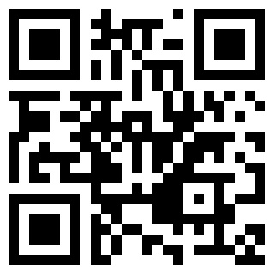  2022年 公立高校入試
※QRコードを読み込むと，英文と連動した音声再生ができます（スマホにも対応）

次の英文は，留学生のJohnとクラスメートのTakuyaが，学校で行われた避難訓練の後に話をしている場面のものです。英文を読み，(1)～(4)の問いに答えなさい。

John: Why was this *evacuation drill *held today?
Takuya: In the past, a big earthquake happened in the Kanto area. We have many *typhoons in this season too. So we must have the drills and think of what to do if *disasters happen.
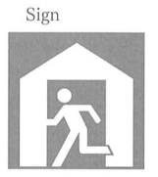
John: I think so too. We must know（ ① ）to go when disasters happen. Look at that sign. That sign means we should come here.
Takuya: Yes. Many people will come to our school to stay when they can't live in their houses after the disasters.
John: Takuya, do you keep anything in a bag at home for the disasters?
Takuya: Yes. Food and water are necessary. The（ ② ）is also important because we can get information about the disasters.
John: I will soon keep them in a bag at home. Today, I learned important things to do for the disasters. I had the evacuation drill for the first time in Japan. We should ③
many times.
Takuya: I agree with you. If we practice many times, we can understand what to do. Is there anything else to do? What is your idea?
John: The signs help us understand what to do. I hope there are many signs around us.
Takuya: That's an interesting point. ④Let's find them together after school.
(注) evacuation 避難 held 行われた typhoon 台風 disaster 災害

(1) ( ① ）に入る最も適当なものを，ア～エから１つ選び，記号を書きなさい。
ア what イ when ウ where エ who
(2) ( ② ）に入る最も適当なものを，ア～エから１つ選び，記号を書きなさい。
ア clothes イ money ウ blanket エ radio
(3) ③ に入る最も適当な連続する英語３語を，英文中から抜き出して書きなさい。
(4) 下線部④が表す内容として最も適当なものを，ア～エから１つ選び，記号を書きなさい。
ア Takuya and John will buy food and water.
イ Takuya and John will look for the signs around them.
ウ Takuya and John will talk about what to keep at home.
エ Takuya and John will learn about earthquakes.

解答
(1) ウ
(2) エ
(3) have the drills
(4) イ

