大分県-大問２-２ | 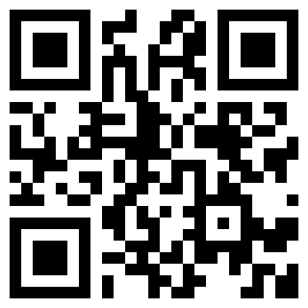  2022年 公立高校入試
※QRコードを読み込むと，英文と連動した音声再生ができます（スマホにも対応）

次の英文は，Smith先生と中学生のHana，Davidが，英語の授業で，「タブレット端末の使い方」について，話をしている場面のものです。英文を読み， ① ～ ④ に入る最も適当なものを，ア～オから１つずつ選び，記号を書きなさい。

Mr. Smith: Now, you have your own *tablet at school. You can use it in many ways when you study. Do you think it is useful?
Hana: Yes. We had only four or five tablets in our class. We had to use them with other students. But now, I can use my own tablet. Tablets are useful when we want to know something. I think ① . I usually use the tablet when I study.
David: I think ② . It is important to know the ideas of other students.
Mr. Smith: Thank you, Hana and David. You can also use your tablet when you want to study English. For example, you will record your voice and check it at home. By the way, do you have any problems?
Hana: Last Sunday, I used my tablet for many hours. I felt tired. I couldn't sleep well. I think ③ .
David: There is a lot of information on the Internet. There is some information which is not true. So I think ④ .
Mr. Smith: Thank you. The tablets are useful. However, we must understand the rules and find better ways to use the tablets.
(注) tablet タブレット端末

ア we can show and share our ideas on the tablet
イ we should decide where we should put the tablets when we don't use them
ウ we should not believe the wrong information
エ we should decide how many minutes we spend when we use our tablets
オ we can get some information easily on the Internet

解答
①オ ②ア ③エ ④ウ

