大分県-大問４ |   2022年 公立高校入試
※QRコードを読み込むと，英文と連動した音声再生ができます（スマホにも対応）

次の英文は，中学３年生のTakashi，Aya，Emi，Yutaの班が英語の授業で，自分たちが調べたことを発表している場面のものです。グラフ（Graph)，スライド（Slide）および英文をもとにして，問１～問５の問いに答えなさい。

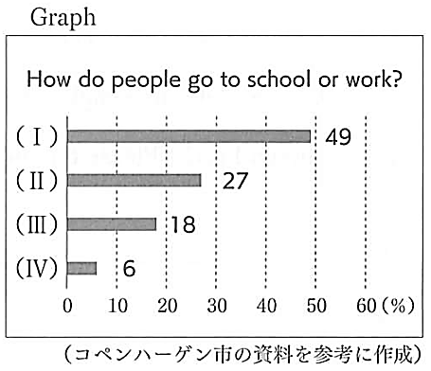
Takashi: What will our city look like in the future? We hope our city will be a better place for everyone. Today our group will tell you about “ ① .”
Aya: Do you know the city, *Copenhagen? It is the *capital city of *Denmark. Please look at ②this graph. It shows how people in this city go to school or go to work. About half of the people in the city use bicycles. Using cars comes next, and 18% of them take buses or trains. The other people walk to school or work.
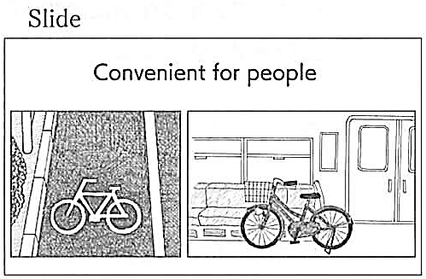
Emi: Why are bicycles popular in this city? Please look at this slide. ③I am surprised to find these things. For example, there are some roads and traffic lights only for bicycles. Also, people can bring their bicycles with them on the train. This city is convenient for people who use bicycles. So a lot of people can enjoy riding bicycles.
Yuta: Using bicycles has some good points for our lives. I'll show you ④three slides. The first slide shows that riding bicycles is good for the environment. The *amount of CO₂ is smaller when we use bicycles. So if we go to school or work by bicycle, it will keep the environment clean. The second slide shows that riding bicycles gives us a chance to *exercise. I'm afraid people don't have enough time to exercise. However, if we often ride bicycles, we will make our health better. The last slide shows that our city is trying to create a new style of *sightseeing. Our city has beautiful *nature and some famous places. More people can come to our city and visit those famous places by bicycle. They will enjoy visiting those places.
Takashi: Using bicycles will give us a good chance to make our city better for the environment and the people. To enjoy our lives with bicycles, we should be careful of *accidents when we ride bicycles. Wearing a *helmet is one of the ways. ⑤There are other ways to be *safe when we ride bicycles. What should you do? Let's think about it. Thank you for listening!

(注) Copenhagen コペンハーゲン capital city 首都 Denmark デンマーク
amount of CO₂ 二酸化炭素の量 exercise 運動する sightseeing 観光 nature 自然
accidents 事故 helmet ヘルメット safe 安全な

問１ 英文中の ① に入る発表のタイトルとして最も適当なものを，ア～エから１つ選び，記号を書きなさい。
ア A long history of bicycles
イ The most popular road for bicycles
ウ A better life with bicycles
エ A new way to invent bicycles
問２ 下線部②が示すグラフ内の（ Ⅰ ）～（ Ⅳ ）に入る語句の組み合わせとして最も適当なものを，ア～エから１つ選び，記号を書きなさい。
 | Ⅰ | Ⅱ | Ⅲ | Ⅳ
ア | bicycles | buses or trains | cars | walk
イ | bicycles | cars | buses or trains | walk
ウ | bicycles | cars | walk | buses or trains
エ | buses or trains | bicycles | walk | cars
問３ 下線部③について，Emiが発言した理由になるように，次の英文の に入る最も適当なものを，ア～エから１つ選び，記号を書きなさい。
Emi is surprised to learn that .
ア there are a lot of people who use cars to go to work in Japan
イ there are some festivals many people from abroad can join in Copenhagen
ウ there are some roads for people riding bicycles in Japan
エ there are some ways to help people who use bicycles in Copenhagen
問４ 下線部④について，Yutaが示したスライドをア～エから３つ選び，発表の順番に並べかえ，記号を書きなさい。
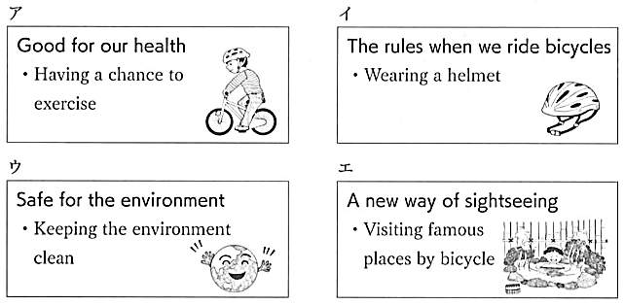

問５ 下線部⑤について，次の条件にしたがって，あなたの考えを英語で書きなさい。
条件
① 自転車を安全に運転するために注意すべきことについて，主語と動詞を含む５語以上の英語で書くこと。ただし，英文中で述べられていない内容を書くこと。
② 英文の数はいくつでもよい。
③ 短縮形（I'mなど）は１語として数えることとし，ピリオド，コンマなどの符号は語数に含めないこと。

解答
問１ ウ
問２ イ
問３ エ
問４ ウ → ア → エ
問５ （例）We shouldn't ride too fast.

