大阪府Ａ-大問３ |   2022年 公立高校入試
※QRコードを読み込むと，英文と連動した音声再生ができます（スマホにも対応）

次は，高校生の義雄（Yoshio)，アメリカからの留学生のサラ（Sarah)，久保先生（Mr. Kubo）の３人が交わした会話の一部です。会話文を読んで，あとの問いに答えなさい。

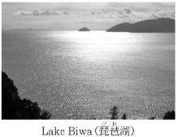
Yoshio: Hello, Sarah. Look at this picture. This is the largest lake in Japan. It is ① Lake Biwa. I went there with my aunt last Sunday.
Sarah: Oh, Yoshio. Sounds nice.
Yoshio: Have you ever been there?
Sarah: ② I want to go there someday.
Mr. Kubo: Hello, Yoshio and Sarah. What are you talking about?
Sarah: Hello, Mr. Kubo. Yoshio went to Lake Biwa with his aunt.
Mr. Kubo: Really? How was it, Yoshio?
Yoshio: When I arrived at Lake Biwa, I was surprised at its size. It was very big.
Mr. Kubo: Sounds fun. When I visited it for the first time, I thought so, too.
Sarah: I can understand your feelings. When we visit a place, we can feel something new about it, right?
Yoshio: That's true. The lake looked like the ocean!
Mr. Kubo: Sarah, do you have such an experience?
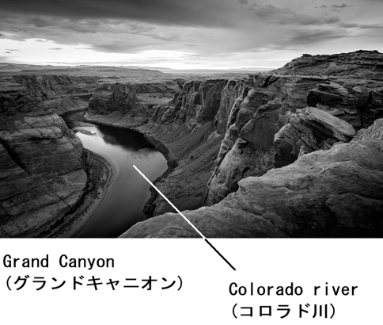
Sarah: Yes, I do. When I was in America, I visited Grand Canyon and I felt like that.
Mr. Kubo: Please tell us about your experience.
Sarah: OK. I ③ a picture.
Yoshio: Wow! Is it a mountain?
Sarah: It's not a mountain. Grand Canyon is a kind of valley. ④
Mr. Kubo: Oh, tell us more.
Sarah: OK. A long time ago, a river started to flow. The river has been carving Grand Canyon for many years.
Yoshio: A river?
Sarah: Yes. Yoshio, can you find a river in this picture?
Yoshio: Yes, I can. Oh, wait! Do you mean that this river made Grand Canyon?
Sarah: That's right! It is Colorado River. It started carving Grand Canyon about five or six million years ago. And, the river still keeps carving Grand Canyon.
Yoshio: So, we can say that ⑤ .
Sarah: That's right, Yoshio.
Mr. Kubo: Sarah, when did you go to Grand Canyon?
Sarah: I went there three years ago.
Mr. Kubo: I remember that in 2019, special events were held at Grand Canyon, right?
Sarah: Yes. Grand Canyon became a National Park in 1919. 100 years passed after that, so special events like concerts, art lessons, and night tours were held in 2019. People from all over the world joined the special events. I joined one of Ⓐthem with my family.
Yoshio: Sounds fun.
Sarah: Before I visited Grand Canyon, I learned many things about it and I thought that I knew a lot about it. But, when I saw Grand Canyon in front of me, I felt something more than the things I learned. Grand Canyon was really great. I could understand that Grand Canyon was really great only by visiting it. ⒷI noticed this through my experience.
Mr. Kubo: Thank you for telling an interesting story. I really enjoyed listening to it.
Yoshio: I enjoyed it, too. I want to visit Grand Canyon someday.
(注) valley 谷 flow 流れる carve 削る National Park 国立公園

問１ 次のうち，本文中の ① に入れるのに最も適しているものはどれですか。一つ選びなさい。
ア called イ joined ウ liked エ talked
問２ 本文の内容から考えて，次のうち，本文中の ② に入れるのに最も適しているものはどれですか。一つ選びなさい。
ア Yes, I did. イ Yes, he has.
ウ No, you don't. エ No, I haven't.
問３ 本文中の ‘ I ③ a picture.' が，「私はあなたたちに１枚の写真を見せましょう。」という内容になるように， に英語３語を書き入れ，英文を完成させなさい。
I a picture.
問４ 本文中の ④ が，「私はグランドキャニオンを訪れる前に，それがどのようにして作られたのかを学びました。」という内容になるように，次の〔 〕内の語を並べかえ，英文を完成させなさい。
Before I visited Grand Canyon, I learned 〔 it made how was 〕.
問５ 本文の内容から考えて，次のうち，本文中の ⑤ に入れるのに最も適しているものはどれですか。一つ選びなさい。
ア Grand Canyon stopped the river
イ Grand Canyon was made by people
ウ Grand Canyon is a mountain
エ Grand Canyon is made by a river
問６ 本文中の Ⓐthem の表している内容に当たるものとして最も適している ひとつづきの英語３語を，本文中から抜き出して書きなさい。

問７ 次のうち，本文中のⒷI noticed this through my experience. が表している内容として最も適しているものはどれですか。一つ選びなさい。
ア Sarah could understand how great Grand Canyon was by visiting it.
イ Sarah didn't learn anything about Grand Canyon before visiting it.
ウ Sarah found that a river started to carve Grand Canyon about 100 years ago.
エ Sarah could feel that Grand Canyon was really great before visiting it.
問８ 本文の内容と合うように，次の問いに対する答えをそれぞれ英語で書きなさい。ただし，①は３語，②は５語の英語で書くこと。
① Did Yoshio go to Lake Biwa alone last Sunday?
② What did Grand Canyon become in 1919?

解答
問１ ア
問２ エ
問３ (I) will show you (a picture.)
問４ (Before I visited Grand Canyon, I learned) how it was made(.)
問５ エ
問６ the special events
問７ ア
問８ ①No, he didn't. ②It became a National Park.

