大阪府Ｃ-大問５ |   2022年 公立高校入試
※QRコードを読み込むと，英文と連動した音声再生ができます（スマホにも対応）

Read the passage and choose the answer which best completes each sentence（1),（2),（3),（5）and（6), and choose the answer to the question（4).

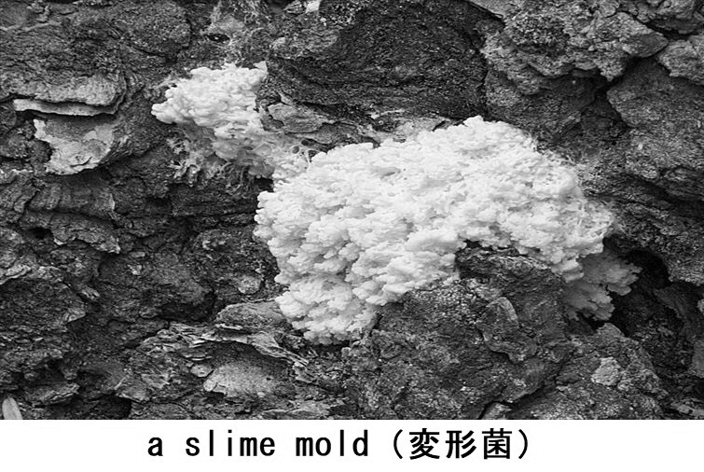
A slime mold is a single-celled organism. It is a kind of an ameba. We can find various kinds of slime molds in a forest. Many scientists in the world have been ① this interesting creature for many years.
A slime mold has a strange system for living. It is born from a spore. A slime mold also explores for food. A slime mold can get nutrients from the food and grow. It can change its body shape when it explores for food.
For example, it can shrink and spread its body. If a slime mold is cut into some pieces, each piece can ② separately and explore to get food. When one piece of the slime mold meets another piece of the slime mold, these pieces can merge and live as one slime mold.
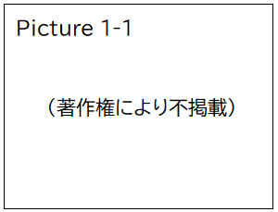
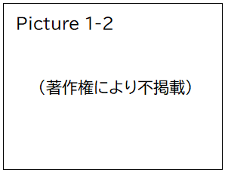
To see how a slime mold gets nutrients from food which is put at two different places, a scientist did a simple experiment. First, he put a slime mold in the middle of a case. Then, he put its favorite food at two places in the case. Some food was put to the left side and some other food was put to the right side（see Picture 1-1). Then, what happened? The slime mold started to spread its body to both pieces of the food. The pieces of the food were covered with the slime mold. After that, its body shape between the two pieces of the food looked like a line（see Picture 1-2). The line became the shortest route between the two places of the food. This experiment showed that the slime mold could reach both pieces of the food by ③ and could get nutrients from them at one time.
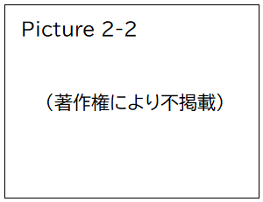
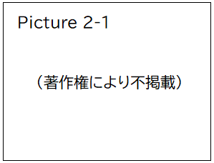
The scientist did another experiment by using a maze. He found that a slime mold could find the shortest route through the maze. Here are the things the scientist did. ④
After the slime mold filled the maze（see Picture 2-1), the scientist put the slime mold's favorite foodat two different places of the maze, and waited for a few hours. The slime mold's body parts which were far from the food started to shrink and move to the food put at the two places. After doing such actions, almost all of the two pieces of the food were covered with the slime mold and its body shape between the two places of the food became a line（see Picture 2-2). The line was the shortest route in the maze between the two places of the food. This experiment showed that the slime mold found the shortest route between the two places in the maze.

The slime mold didn't have any guide to lead it or get any order from something or someone. The things the slime mold actually did were covering the food with most parts of its body and shrinking its body parts which were far from the food. As one slime mold, changing its body shape was efficient for getting nutrients. The slime mold could get most nutrients from the food put at the two places. The slime mold may teach us that to be simple is the key to being efficient.
(注) single-celled organism 単細胞生物 ameba アメーバ creature 生き物 spore 胞子
explore 探索する，動き回る nutrient 養分 shrink 縮む，縮める spread 広げる
cut ～ into … ～を…に切り分ける separately 別々に merge 融合する experiment 実験
route 経路 maze 迷路 efficient 効率のよい

問１ The expression which should be put in ① is
ア study. イ studied. ウ studying. エ to study.
問２ The word which should be put in ② is
ア blow. イ count. ウ disappear. エ live.
問３ The phrase which should be put in ③ is
ア changing its body shape. イ doing a simple experiment.
ウ learning from a scientist. エ cutting its body.
問４ The following passages（ⅰ)～(ⅲ）should be put in ④ in the order that makes the most sense.
(ⅰ) Each of them started to explore in the maze, and, when each met another one, they merged.
(ⅱ) The scientist cut a slime mold into many pieces and put them in many different places of the maze.
(ⅲ) In a few hours, by doing such actions many times, they became one.
Which is the best order?
ア (ⅰ）→（ⅱ）→（ⅲ) イ (ⅰ）→（ⅲ）→（ⅱ)
ウ (ⅱ）→（ⅰ）→（ⅲ) エ (ⅱ）→（ⅲ）→（ⅰ)
問５ According to the passage, for a slime mold,
ア being in a maze is an efficient way to live.
イ spreading its body is the way of reaching the food put at the two places.
ウ it is impossible to merge after the slime mold is cut into many pieces.
エ it is necessary to know how other creatures get nutrients from food.
問６ According to the passage,
ア the life of a slime mold is strange, so no one can find it in a forest.
イ a slime mold can teach us that doing nothing in a difficult situation is efficient.
ウ a slime mold needs to follow an order from something or someone when it explores for food.
エ the shortest route between the food put at the two places was shown by a slime mold.

解答
問１ ウ
問２ エ
問３ ア
問４ ウ
問５ イ
問６ エ

