宮崎県-大問２ |   2022年 公立高校入試
※QRコードを読み込むと，英文と連動した音声再生ができます（スマホにも対応）

次の対話は，彩乃（Ayano）と留学生のメグ（Meg）が話をしているときのものです。後の問１，問２の問いに答えなさい。
Ayano: Hi, Meg. How are you?
Meg: Hi, Ayano. I'm good.
Ayano: Can we talk about the camping trip we'll have next month?
Meg: １ I'm happy to go with you and your family.
Ayano: I'm glad to hear that. I visited Hinata Camping Village with my family last summer. It's a wonderful place.
Meg: Really? Our trip will be great fun.
Ayano: Please look at the map of the Camping Village to check the *camping sites.
Meg: OK.
Ayano: ２ I'd like to choose a good one.
Meg: I see. How about site Ａ? It's very close to the *office.
Ayano: Oh, we stayed there last year. Do you have any other ideas?
Meg: Let's see. ３ The scenery from the sites must be beautiful, right?
Ayano: Yes. We can enjoy taking a boat there.
Meg: Can we also enjoy swimming?
Ayano: Sure. Then sites Ｂ and Ｄ are near the lake. ４
Meg: I think site B looks good. It's easier to take a shower by the site. I hope your sister will also like the site.
Ayano: ５ She can play in the park beside site Ｃ. So site Ｂ is the best place for all of us.
Meg: I can't wait for next month.
(注) camping site キャンプ場の区画 office 事務所

問１ １ ～ ５ に入る最も適切なものを，それぞれ次のア～オから１つずつ選び，記号で答えなさい。
ア The Camping Village has a lake.
イ Of course, we can.
ウ She loves any activities outside.
エ Shall we choose one from the two sites?
オ There're four different camping sites.
問２ 対話の内容から，the map としてsite Ａ～ site Ｄ の位置が正しくなるように，【地図】 の①～④に，それぞれＡ～Ｄを１つずつ書き入れなさい。
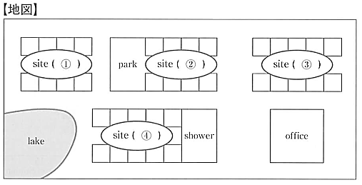

解答
問１ １：イ ２：オ ３：ア ４：エ ５：ウ
問２ ①Ｄ ②Ｃ ③Ａ ④Ｂ

