富山県-大問２-２ |   2022年 公立高校入試
※QRコードを読み込むと，英文と連動した音声再生ができます（スマホにも対応）

達也さんは，夏休みに家族とキャンプに出かけた時，キャンプ場（campsite）が以前よりにぎわっていることに気づき，最近のアウトドア（outdoor activity）人気に興味をもちました。達也さんが調べて作ったグラフ（graph）を用いて書いた次の英文レポートを読んで，あとの問いに答えなさい。

１ When I went camping with my family during summer vacation, I found that more people were there than before. My father told me that outdoor activities are getting more popular. I became interested in this and decided to find out why it has become so popular.
２ *Camping is a popular outdoor activity in Japan. From 1980 to 1989 many campsites were built around Japan and the number of campsites increased. Please look at ① this graph. The number of people who went camping also increased after that and in 1995 the number increased more than 50% from 1990. However, many people stopped going camping after 1995. 20 years later, the number of people who went camping kept increasing. Why did camping become popular again today?
３ There are three reasons for this. First, people who enjoyed spending time in cities thought spending time in *nature was more interesting. People can enjoy outdoor activities without being in *crowded places. Second, more people now think spending time with their families or their friends is more important than going abroad or buying expensive things. When you go camping, you can *relax with family or friends and have a good time with them. Third, because of the internet, the image of camping has changed and camping is thought as an exciting and cool activity. Some famous people who enjoy camping put their pictures or videos on the internet. Then their fans who watch them become interested in camping.
４ There are different ways of camping that people enjoy today. Some people enjoy staying in *comfortable tents and having good food. Everyone thinks this kind of camping is exciting. A lot of people believe that camping is an activity for families or groups of people, but some people go camping *alone. It is becoming *common for people to enjoy activities alone, like going to karaoke or onsen, *regardless of gender or age.
５ Through this report, I found out why camping is becoming more popular now. I learned that a lot of things are changing in our *society, and ② our ways of thinking are also changing. I never thought that they *had an influence on our free time. More people are doing things they really want to do. I don't have time to go camping now, but I would like to enjoy camping with my family again at my favorite campsite in the future.

注) camping キャンプ nature 自然 crowded 込み合った relax くつろぐ
comfortable 快適な alone ひとりで common ふつうの
regardless of gender or age 性別や年齢に関係なく society 社会
have an influence on ～ ～に影響を与える

(1) 下線部①について，達也さんが示したグラフとして最も適切なものを，次のア～エから１つ選んで記号で答えなさい。
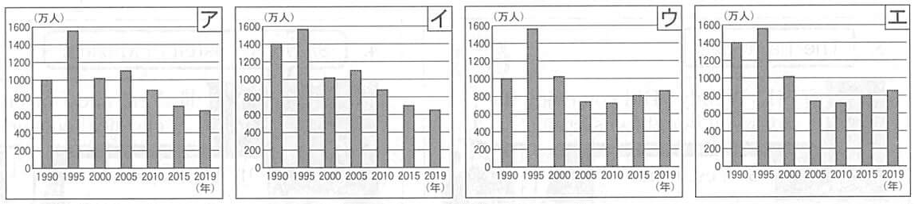

(2) 下線部②で述べられていることについて，達也さんは段落で具体例を３つ述べています。そのうちから２つ選んで，日本語で書きなさい。
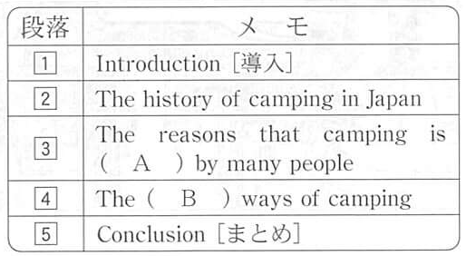
(3) 右のメモは達也さんがこのレポートの構成を考える際に，各段落の概要を書き出したものです。( Ａ ），( Ｂ ）に入る最も適切な１語を同じ段落からそれぞれ抜き出し，解答欄に書きなさい。

解答
(1) ウ
(2) ・都会で時間を過ごすことを楽しんでいた人々が，自然の中で時間を過ごすことをより面白いと考えるようになっていること。
・多くの人々が家族や親しい友人と時間を過ごすことの方が，海外へ行ったり高価な物を買ったりすることよりも大事だと考えるようになっていること。
(3) Ａ：enjoyed Ｂ：different

