山口県-大問５ |   2022年 公立高校入試
※QRコードを読み込むと，英文と連動した音声再生ができます（スマホにも対応）

次は，Saoriが英語の授業で発表する際に用いた【グラフ】(graph）と【原稿】である。これらを読んで，下の問１～問３に答えなさい。
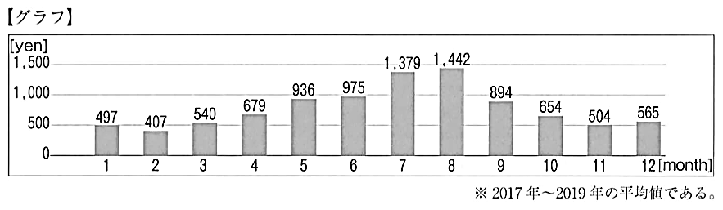
【原稿】
Do you often eat ice cream? The graph shows how much money a family used for ice cream in a month on average in Japan. According to the graph, （A） . It's hot in summer especially in these months, so I'm sure many people like to eat cold food. Then, the spending on ice cream decreases from August to November.
However, the spending increases in December and decreases again in January. That's interesting. That means (B) is not the only reason to eat ice cream. Then, why do people buy ice cream in cold December? I'll look for more information and find out the reason.
(注) show(s)～ ～を示す on average 平均して spending（on ～) (～についての）支出
decrease(s) 減る find out ～ ～を見つけ出す

問１ 【原稿】 の文脈に合うように，下線部(A)に入る最も適切なものを，次の１～４から選び，記号で答えなさい。
１ ice cream sold in June is as popular as ice cream sold in October
２ a family used more than one thousand yen for ice cream in July and August
３ more than eight hundred kinds of ice cream are sold in summer
４ in May, a family used about nine hundred yen for ice cream
問２ 下線部(B)に入る最も適切なものを，次の１～４から選び，記号で答えなさい。
１ hot weather ２ variety of ice cream
３ cold season ４ changes in life
問３ Saoriの発表全体のテーマとして，最も適切なものを，次の１～４から選び，記号で答えなさい。
１ The easy way to make delicious ice cream at home
２ The important information to save money
３ The funny reason to buy ice cream in cold winter
４ The interesting change of the spending on ice cream
解答
問１ ２
問２ １
問３ ４

