山形県-大問３ |   2022年 公立高校入試
※QRコードを読み込むと，英文と連動した音声再生ができます（スマホにも対応）

中学生の千恵（Chie）さんは，姉妹・友好都市（sister city）に興味を持ち，姉妹・友好都市提携（sister city relationship）について調べ，グラフ（graph)，表（table)，図（chart）にまとめました。次は，グラフ，表，図を見ている，千恵さんと留学生のビル（Bill）さんの対話です。グラフ，表，図および対話について，あとの問いに答えなさい。
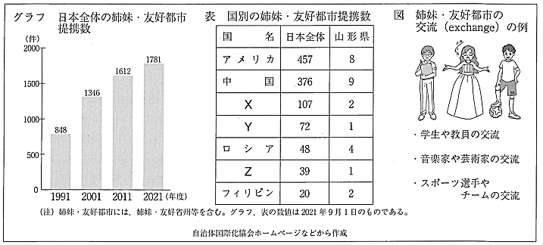

Chie: Last week, I met a lot of foreign people at an event, and I heard that my city has some sister cities in the world. One of them is your city in America. I wanted to know more about sister cities, so I made the graph after the event.
Bill: Wow! There are so many sister city relationships in Japan. The number is increasing.
Chie: I was surprised, too. Look at the table. Your country has many sister cities. In Japan, there are more sister city relationships with Canada than with Italy.
Bill: That's right.
Chie: In Yamagata-ken, there are eight sister city relationships with America, and two with Australia.
Bill: There is one with Italy, too. Chie, what does the chart tell us?
Chie: It shows exchanges between sister cities. For example, many cities send students to their sister cities. Your city in America has the exchange with my city, so you came to Japan. ①There are many good points of the exchange for you, right?
Bill: Yes. I can make new friends and learn a different culture.
Chie: That's good. I could learn a lot from you, too.

問１ 表中のＸ～Ｚには，カナダ，イタリア，オーストラリアのいずれかの国名が入ります。対話の内容に即して，Ｘ～Ｚのそれぞれにあてはまる国名を，日本語で書きなさい。
問２ 下線部①について，ビルさんがあげている具体的な例を，対話の内容に即して日本語で書きなさい。
問３ グラフ，表，図および対話の内容に合うものを，次のア～オから二つ選び，記号で答えなさい。
ア Chie wanted to tell foreign people about sister cities, so she made the graph before the event.
イ The graph shows that the number of sister city relationships in Japan is not over two thousand.
ウ In Yamagata-ken, there are more sister city relationships with America than with China.
エ The chart shows that there are not any exchanges for sports between sister cities.
オ Bill's city in America is a sister city of Chie's city, and there is an exchange between the cities.

解答
問１ Ｘ：オーストラリア Ｙ：カナダ Ｚ：イタリア
問２ (例)新しい友達を作ったり，違った文化を学んだりできること。
問３ イ，オ

