岐阜県-大問４ |   2022年 公立高校入試
※QRコードを読み込むと，英文と連動した音声再生ができます（スマホにも対応）

次の英文は，中学生の賢治(Kenji)が，最近印象に残ったできごとについて，英語の授業でスピーチをしたときのものです。問１～問７の問いに答えなさい。
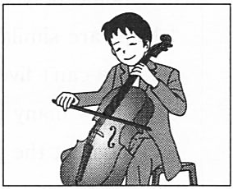
Have you ever heard the sound of a cello? It's soft and warm, and I like the sound. I have been playing the cello since I was eleven, and now I practice it almost every day. My grandpa is a cello maker, so cellos are always close to me. He lives in a small house in the woods.
One sunny morning, I visited Grandpa. He was cutting an old maple tree near his house to make a new cello, so I helped him cut it. While we were working, I asked, “How old is this tree, Grandpa?” He answered, “It's more than a hundred years old, Kenji.” “Wow, it was here before you and I were born!” I said. He taught me that older trees make the sound of a cello deeper and softer. Then he said, “Well, we worked hard today. Let's go back to the house and I'll make you a cup of coffee!”
While we were drinking coffee together in his house, Grandpa told me many things about cellos. He asked, “Do you still use the cello I made?” The cello I use was given by Grandpa when I started to play. “Of course, I do. I like your cello. I want to be a cellist in the future.” Grandpa said, “I'm glad to hear that. And what do you want to do when you become a cellist?” I never thought about that, so I couldn't answer his question. I only said, “Well,（ ① ).” He thought for a while and said, “Come with me, Kenji.”
Grandpa took me to the next room. There were a lot of cellos on the wall, and the smell of trees was everywhere in the room. I asked, “How many cellos have you made?” He said, “I have made hundreds of them. Your cello is the one I made when you were born, and it's my favorite.” “Why did you decide to be a cello maker?” I asked. Then he answered, “Actually I once wanted to be a cellist like you, Kenji. But when I was your age, I hurt my arm and it was difficult to continue playing the cello. I wish I could play it well again.” I was surprised because he never talked about it before. I could imagine ②how he felt when he lost his dream at the age of fifteen. I said, “Then, you decided to be a cello maker, right?” He said, “Yes. I wanted to do something related to cellos because I still liked them. Well, I was lucky because I found something I really like early in my life.” He continued, “Look at all the cellos, Kenji. Every cello is made of old maple trees. Those trees were cut down a long time ago, but they can live forever as a cello.” I said, “I never thought about it that way. But when I listen to the sound of a cello, I really feel relaxed even when I am nervous.” He smiled and said, “It's like a voice from the woods that encourages you. I want to make a cello that can express the most beautiful voice of the maple trees, Kenji.” Grandpa's face looked soft and warm when he said so. Again, I looked around the cellos he made. I was impressed that he made a lot of cellos and still continued to hold his dream.
Now I play the cello in a different way. I just played it to be a famous cellist before, but now I try to play the cello to deliver the voice of the trees to people. I want to express it someday with the cello Grandpa made.
(注) cello : チェロ grandpa : おじいさん cello maker : チェロ職人 close : 身近な maple tree : カエデの木
cellist : チェロ奏者 smell : 香り be impressed : 感動する deliver : 届ける
問１ 次のＡ～Ｃの絵を，本文の内容に合わせて並べかえたとき，正しい順序になるものを，ア～エから１つ選び，符号で書きなさい。
ア Ａ→Ｂ→Ｃ イ Ａ→Ｃ→Ｂ ウ Ｂ→Ａ→Ｃ エ Ｂ→Ｃ→Ａ
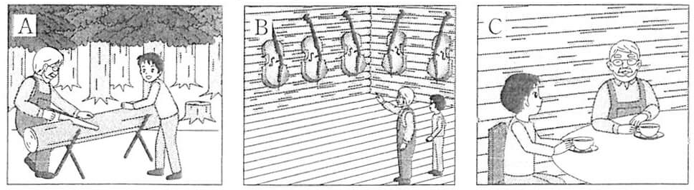

問２ 本文中の( ① )に入る最も適切なものを，ア～エから１つ選び，符号で書きなさい。
ア I just want to be a famous cellist
イ I just want to be a famous cello maker
ウ I want to be a cellist like you
エ I want to be a cello maker like you

問３ 本文中の下線部②のおじいさんの気持ちとして最も適切なものを，ア～エから１つ選び，符号で書きなさい。
ア excited イ glad ウ proud エ sad
問４ 次の質問に対する最も適切な答えを，本文の内容に即して，ア～エから１つ選び，符号で書きなさい。
When did Grandpa give the cello to Kenji?
ア Grandpa gave it when Kenji was born.
イ Grandpa gave it when Kenji was five years old.
ウ Grandpa gave it when Kenji was eleven years old.
エ Grandpa gave it when Kenji was fifteen years old.
問５ 次の質問に対する答えを，本文の内容に即して，英語で書きなさい。
(1) Did Grandpa want to be a cellist before he hurt his arm?
(2) How does Kenji feel when he listens to the sound of a cello?
問６ 本文の内容に合っているものを，ア～オから１つ選び，符号で書きなさい。
ア Kenji has been playing the cello for a long time, but he doesn't practice it now.
イ Kenji still uses the cello Grandpa made, and both Kenji and Grandpa like it.
ウ Kenji visited Grandpa on a rainy day, so they didn't work in the woods.
エ Grandpa can play the cello very well now because he is a cello maker.
オ Grandpa is very old now, so he doesn't want to make a new cello.
問７ 次の英文は，賢治がおじいさんに書いた手紙の一部です。( ③ )，( ④ )に入る最も適切な英語を，本文中から抜き出して１語ずつ書きなさい。ただし，( )内に示されている文字で書き始め，その文字も含めて答えること。
Thank you for spending time with me and talking a lot last week, Grandpa. I respect you because you still continue to have your dream even after you became a cello maker. I can't forget that you told me that the sound of a cello is like the（③ v ）of the trees. Now I want to express and deliver it to the people who listen to my cello. Please tell me when you finish making a new cello with the maple tree that we（④ c ）together! See you soon, Grandpa.

解答
問１ イ
問２ ア
問３ エ
問４ ウ
問５ (1)Yes, he did.
(2)He feels relaxed even when he is nervous .
問６ イ
問７ ③voice ④cut

