岡山県(特)-大問４ |   2022年 公立高校入試
※QRコードを読み込むと，英文と連動した音声再生ができます（スマホにも対応）

Yuyaは，漁船漁業（capture fisheries）と養殖業（aquaculture）を合わせた魚の生産量（fish production）についてのグラフ（graph）を見せながら発表をしました。次の英文は，その発表と，発表を聞いたSakiとの会話の一部です。問１～問５に答えなさい。

■発表
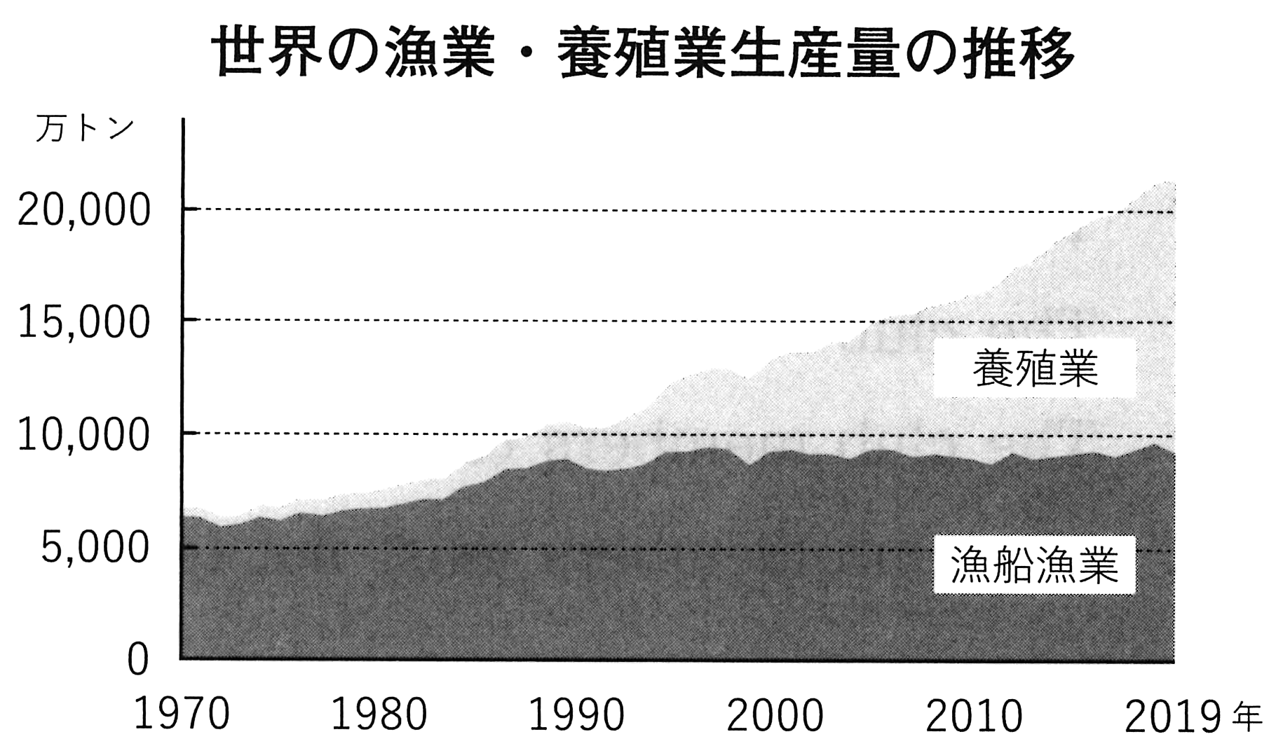
How much fish do you eat in a year ? Now people in the world are eating more fish. So, it's necessary to keep stable fish production.
Look at the graph. Production from capture fisheries has been almost the same since about 1985. However, aquaculture production is becoming larger and about （あ） % of fish production came from aquaculture in 2019.
Why ? I think that aquaculture with new technology has brought success to fish production. I'll show you some examples.
Farmers usually need lights to raise fish. Some of them use green LED lights for hirame. With more effective lights, hirame can swim more in the water, get more food, and grow faster. Before, raising hirame took about twelve months, but now it takes about nine months. Farmers can save money because of the green LED lights and the shorter period of raising hirame. We may eat cheaper hirame in the future.
I have also found another example. Most of the money is used for feeding fish. By using（_{い)}AI technology, farmers can check how much food the fish eats, the weather, and the environment in the sea. The farmers get all the data about them through their smartphones. Then they can decide the right amount of food to give to the fish and when to feed them. Now they just use their smartphones to feed fish. Feeding them well is important because farmers can keep clean water in the sea.
New technology is changing the ways of aquaculture. That may help farmers keep fish production and save money for raising fish. That may also help people keep eating fish and protect the environment.

■会話の一部
Saki: Yuya, I am surprised to know that the period of raising hirame is shorter. The difference is about
（う） months !
Yuya: You are right.
Saki: That's amazing. By the way, （え）
Yuya: Well, the sun light mainly has red, green, and blue light. Each light has different waves that can reach different depths in the sea. Farmers say that hirame can get bigger in the water especially with the green lights.
Saki: That's interesting !
〔注〕 stable 安定した farmer 養殖業者 light 照明，光 raise ～ ～を養殖する LED light LED灯
hirame ヒラメ food えさ period 期間 feed ～ ～にえさを与える environment 環境
data データ smartphone スマートフォン amount 量 difference 差 mainly 主に wave 波長
reach ～ ～に達する depth 深さ
問１ （あ） に入れるのに最も適当なのは，ア～エのうちではどれですか。一つ答えなさい。
ア 5 イ 25 ウ 55 エ 85
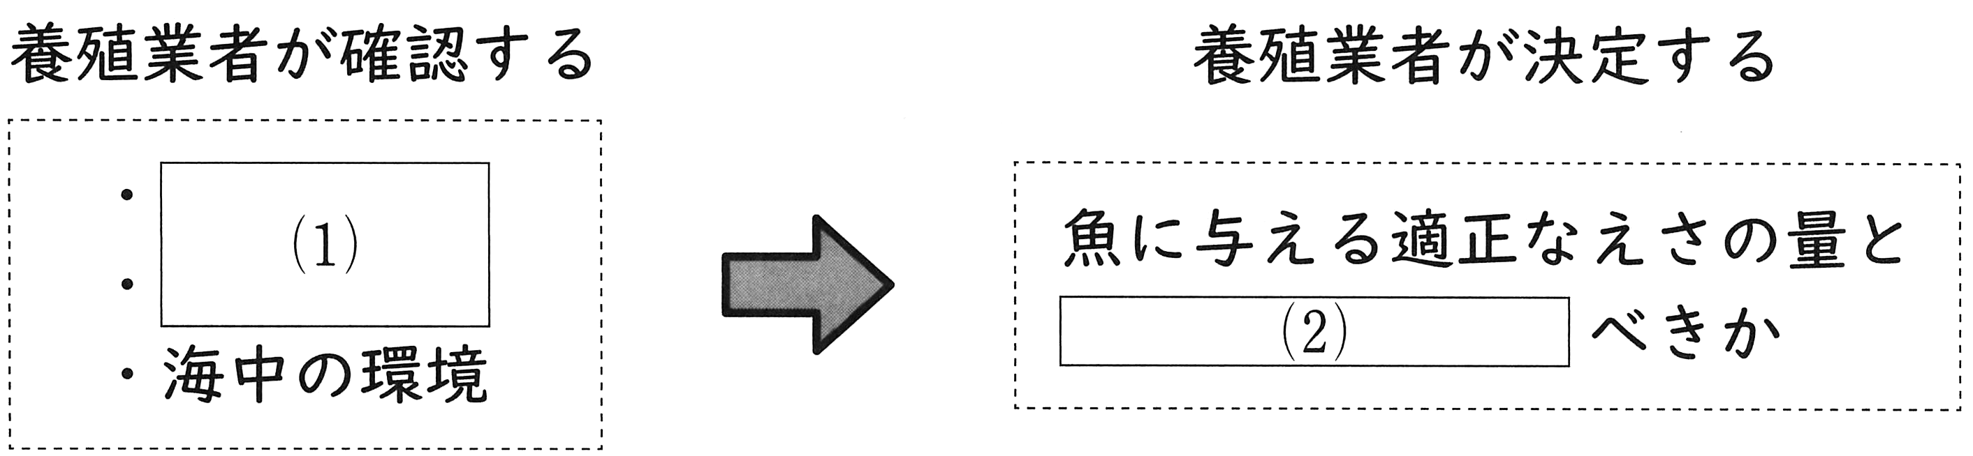
問２ Sakiは発表を聞きながら，下線部(い)によっておこる内容をまとめました。次の （1） について当てはまるものは，ア～エのうちではどれですか。二つ答えなさい。また， (2) に適当な日本語を入れなさい。

ア 魚の体長 イ 食べるえさの量 ウ 食べるえさの形状 エ 天気
問３ （う） に入れるのに最も適当な英語１語を書きなさい。
問４ （え） に入れるのに最も適当なのは，ア～エのうちではどれですか。一つ答えなさい。
ア when was the green light made ?
イ how is the green light used in the water ?
ウ where do farmers feed hirame ?
エ why do farmers choose the green light ?
問５ 発表の中でYuyaが伝えたい内容として最も適当なのは，ア～エのうちではどれですか。一つ答えなさい。
ア Production from capture fisheries will be bigger because of new technology.
イ New technology used for aquaculture is dangerous for people's health.
ウ Using new technology for aquaculture may be useful for both people and nature.
エ All farmers must use new technology if they want to solve problems about feeding.

解答
問１ ウ
問２ (1) イ，エ
(2) 魚にいつえさを与える
問３ three
問４ エ
問５ ウ

