島根県-大問４ |   2022年 公立高校入試
※QRコードを読み込むと，英文と連動した音声再生ができます（スマホにも対応）

中学生のエリ（Eri）さんが，ボランティアに関するスピーチを英語で行っています。次の英文はその内容です。これを読んで，あとの問１～問６に答えなさい。
(*印のついている語句には本文のあとに〈注〉があります。)
“Are you free on Saturday? Shall we *plant flowers along the river near our school? You can enjoy it.” Miho, one of my friends, asked me to do the volunteer activity just before the last spring vacation. But Ａ . I was busy because I needed to practice at the brass band. I didn't know why she was so excited about the volunteer work.

At the end of last summer, I talked on the phone with my aunt living in Tokyo. She told me about her experience as a volunteer during the big sports event. At first, about 80,000 people planned to help it, but many of them *gave up for various reasons. However,（1)my aunt didn't change her decision. Before this event, she helped two international sports events several years ago. She knew they couldn't have such big events without the help of volunteers. Besides,
she hoped to make friends by working with other volunteers. This time, her work was to guide the athletes to the stadium. She got tired every day. But at home, she folded paper shurikens with a message as a gift for the athletes, though it wasn't her job. “When they got the gift, they showed me glad smiles,” she said *proudly. After talking with her, I thought, “Can such a little thing encourage people?”
A week passed. Our brass band was asked to hold an autumn concert by a home for old people. Many of them felt lonely, so the staff there wanted them to listen to *live music *online. （2)That was the thing we wanted to do most because many events were *canceled. We prepared for it very hard and gave our best performance. After the concert, a staff member said to us, “Some people *clapped to the beat and some were singing to the music. Thanks to your music, we saw smiles on their faces.” Those words were really special to us. This experience reminded me of my aunt's shurikens. Even the small gifts had the power to encourage the athletes, and their smiles also made my aunt happy. Helping someone else CAN help us, too!
Two weeks ago, Miho said to me, “How about taking care of the flowers planted last spring?” （3)I accepted her plan. I'm looking forward to joining the event next weekend.

〈注〉plant ～ ～を植える gave up あきらめた proudly 誇らしげに live ライブの・生の
online オンラインで cancel ～ ～を中止する clap to the beat 手拍子をする
問１ Ａ に入る最も適当なものを，次のア～エの中から一つ選び，記号で答えなさい。
ア I said “Yes” to the questions
イ I said “No” to the questions
ウ I asked Miho another question
エ I asked Miho the same questions
問２ 下線部（1）の理由について，エリさんが挙げているものを次のようにまとめました。本文の内容に合うように（ ａ )，( ｂ ）に入る適当な日本語を答えなさい。
・大規模なスポーツ大会の運営は（ ａ ）ということを叔母は知っていたから。
・叔母は他のボランティアの人たちと働くことで（ ｂ ）から。
問３ 本文の内容について，次の質問の答えとして（ ）に入る適当な英語を答えなさい。
質問 What job as a volunteer did Eri's aunt do during the big sports event last summer?
答え She（ ）.
問４ 下線部（2）の内容を英語で表すとき，次の（ ）に入る適当な表現を本文中から４語で抜き出して答えなさい。
to（ )
問５ エリさんがスピーチの中で述べている内容として正しいものを，次のア～エの中から一つ選び，記号で答えなさい。
ア Eri's aunt didn't take part in any sports events as a volunteer before last summer.
イ The athletes weren't encouraged by the shurikens, because they were too small.
ウ Eri came up with an idea of a charity concert after she talked with her aunt.
エ Both the audience and the brass band members were satisfied with the concert.
問６ スピーチ終了後，下線部（3）について理由を求められたエリさんが，英語で答えています。エリさんになったつもりで次の（ ）に入る表現を考え，文を完成させなさい。ただし，４語以上の英語で書くこと。
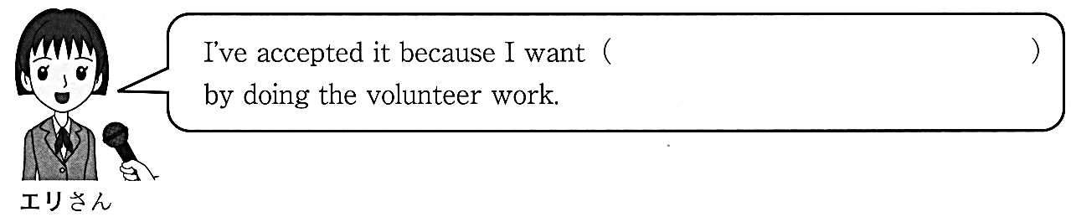

解答
問１ イ
問２ ａ：ボランティアの助けなしではできない ｂ：友達を作ることを望んでいた
問３ guided the athletes to the stadium
問４ hold an autumn concert
問５ エ
問６ (例)to broaden my horizons many people to see beautiful flowers

