徳島県-大問６ | 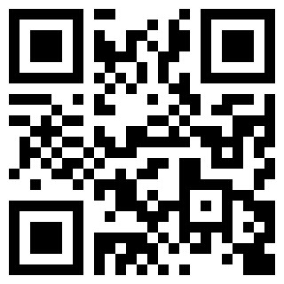  2022年 公立高校入試
※QRコードを読み込むと，英文と連動した音声再生ができます（スマホにも対応）

次の英文は，中学生のほのかさんが，英字新聞のウェブサイトに投稿した文章の一部である。これを読んで，問１～問３に答えなさい。
To create a better life
Yesterday I found an article about the opening ceremony of the museum in our town. When I read it, I felt happy. So let me share it with you. ア
Our town had a plan to build a new museum. Then young, old, foreign people, and people using wheelchairs were chosen as members to think about it. イ Their ideas were needed to make the museum comfortable for everyone. Some of their ideas were used. ウ For example, we can get information in many languages. Also, some works of art are put in lower places for children or people using wheelchairs. エ So, the new museum became friendly for everyone. From this article, I learned important things about creating a better life.
Thinking about each other is wonderful. We are all different, so we can share various ideas to live together. Look around. There are many things we can change to make each life more comfortable.
(注) article 記事 share ～を共有する comfortable 心地よい

問１ 次の英文は，本文中から抜き出したものである。この英文を入れる最も適切なところを，本文中の
ア ～ エ から選びなさい。
Do you know why?
問２ ほのかさんが本文中で一番伝えたいことはどのようなことか，最も適するものを，ア～エから選びなさい。
ア It's important to talk with various people to get ideas to make life better.
イ It's necessary to know various differences to make our world cleaner.
ウ It's important to help each other to create the new museum in our town.
エ It's necessary to look around each place to find the people who need help.
問３ 下のようなほのかさんの投稿の続きを読んだあなたは，返事を投稿することにした。質問に対するあなたの答えを，15語以上30語以内の英語で書きなさい。ただし，数を書く場合は数字ではなく英語で書くこととし，文の数はいくつでもよい。また，符号は語数に含めない。
Now I want various people who visit my school to feel comfortable. How about you? What can you do to change your school like this museum? Tell me about your ideas.

解答
問１ イ
問２ ア
問３ (例)I think that small children and foreign people can't read difficult kanji. So, we should make our school map with pictures and easy Japanese.

