愛媛県-大問５ | 2022年 公立高校入試
※QRコードを読み込むと，英文と連動した音声再生ができます（スマホにも対応）

中学生の武史 (Takeshi) と友紀 (Yuki) がジョーンズ先生 (Mr. Jones) と話をしている。対話文とあとのグラフ (graph) をもとにして，問１～問４の問いに答えなさい。なお，Graph AとGraph Bの(ａ)，(ｂ)には，それぞれ同一の国の名が当てはまる。
Mr. Jones: Hi, Yuki. Hi, Takeshi. How are you?
Takeshi: I'm fine, thank you. And you?
Mr. Jones: I'm fine, too. (ア)あなたたちは，何について話しているのですか。
Yuki: About studying abroad. I'm going to study abroad next year.
Mr. Jones: Really? Where will you go?
Yuki: I'll go to America. I want to improve my English skills there.
Mr. Jones: ① ?
Yuki: For a year.
Takeshi: She says she wants to get a job that needs English. So studying abroad is good for her.
Yuki: I think people can learn a lot through studying abroad. But the percentage of Japanese students who are interested in it has gone down.
Takeshi: Here are two graphs about studying abroad. We found them on the Internet.
Mr. Jones: Oh, please explain them to me.
Takeshi: Sure. They show how high school students in Japan, America, China, and Korea feel about studying abroad. Graph A shows the result of the question: “Do you want to study abroad?” Japan has the highest percentage of students who don't want to do so.
Mr. Jones: I don't know why Japanese students don't want to study abroad.
Takeshi: We found some reasons on the Internet. I'll tell you one of them. They think living alone in a foreign country is difficult for them.
Mr. Jones: That's not difficult for them. ② . When I was young, I went to a foreign country alone to study. Many people there were so kind, and I had a good time.
Yuki: I hope I'll have such a wonderful time in America. Mr. Jones, please look at Graph B. It shows the result of the question: “Why do you want to study abroad?” In Japan, America, and Korea, the most popular reason is “I want to improve my language skills.” In China, the most popular one is “I want to get the advanced knowledge.” As for the reason: “I want to make new friends,” the percentage is higher in America than in the other countries.
Mr. Jones: ③ . I understand each country has a different characteristic.
Yuki: I also want to make new friends in America. Takeshi, do you want to study abroad?
Takeshi: Yes. I want to go to Australia in the future.
Yuki: Why?
Takeshi: Because I can learn a lot about tennis there. Many young people go there to learn it. My dream is to be a world tennis champion. Also, I have another reason. (イ)私が会いたい選手が，そこに住んでいます。 I hope I can become like him. I want to improve my English skills there, too.
Mr. Jones: You have a big dream! I think studying abroad gives you the chance to learn many things.
Takeshi: I think so, too. Thank you very much, Mr. Jones.
(注) abroad 外国で skill(s) 技能 percentage 割合 explain ～ ～を説明する
China 中国 Korea 韓国 result 結果 reason(s) 理由 alone 一人で
advanced knowledge 先進的な知識 as for ～ ～について言えば
characteristic 特徴 champion チャンピオン chance 機会
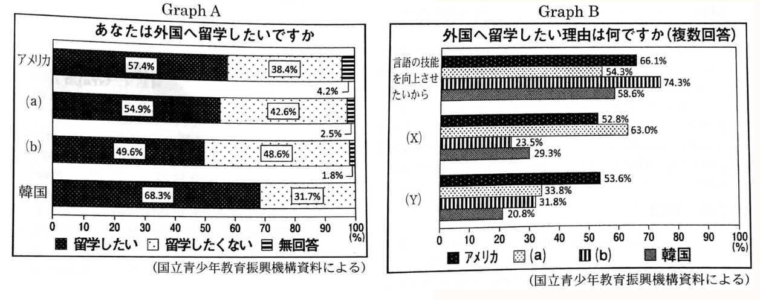
問１ 対話文中の①～③に当てはまる最も適当なものを，それぞれ次のア～エの中から一つずつ選び，その記号を書け。
① ア How much money will you need イ How long will you stay there
ウ How often will you go there エ How old will you be next year
② ア They should not live in a foreign country
イ They must go there with their friends
ウ They can't be kind to foreign people
エ They don't have to worry about that
③ ア You're welcome イ Here you are ウ That's interesting エ Call me soon
問２ 対話文中の(ア)，(イ)の日本語の内容を英語に直せ。
問３ 対話文の内容に合うように，Graph AやGraph Bの(a)，(b)，(X)，(Y)にそれぞれ当てはまる最も適当なものの組み合わせを，次のア～エの中から一つ選び，その記号を書け。
ア (a) 日本 (b) 中国 (X) 新しい友達を作りたいから (Y) 先進的な知識を得たいから
イ (a) 日本 (b) 中国 (X) 先進的な知識を得たいから (Y) 新しい友達を作りたいから
ウ (a) 中国 (b) 日本 (X) 新しい友達を作りたいから (Y) 先進的な知識を得たいから
エ (a) 中国 (b) 日本 (X) 先進的な知識を得たいから (Y) 新しい友達を作りたいから
問４ 次の(1)～(3)の英文の内容が，対話文，Graph Aの内容に合うように，〔 〕のア～エの中から，最も適当なものをそれぞれ一つずつ選び，その記号を書け。
(1) Takeshi says that〔ア it is difficult to explain the graphs to Mr. Jones イ Yuki should ask him which country to visit ウ it is good for Yuki to study abroad エ Mr. Jones should use the Internet to find the graphs〕.
(2) Yuki〔ア has to go to America to find a job イ wants to enjoy her stay in a foreign country like Mr. Jones ウ is going to learn a lot about tennis in Australia エ isn't interested in making friends in America〕.
(3) Graph A Shows that〔ア Korea has the highest percentage of students who want to study abroad イ the students of each country have different reasons to study abroad ウ more than 50% of the students in America don't want to study abroad エ the percentage of students who want to study abroad has gone up〕.

解答
問１ ①イ ②エ ③ウ
問２ (ア)〈例〉 What are you talking about?2
(イ)〈例〉 The player I want to meet1 / lives there.1
問３ エ
問４ (1)ウ (2)イ
(3) ア

問１ ①期間をたずねる疑問文。
問２ ｢～している」から，現在進行形の文。
問３ Graph Aは武史の４番目の発言，Graph Bは友紀の５番目の発言を参照。
問４ (1) 武史の２番目の発言を参照。 (2) 友紀の５番目の発言を参照。

