東京都-大問２ | 2022年 公立高校入試
※QRコードを読み込むと，英文と連動して音声再生ができます（スマホにも対応）
プリントは 問１，問２，問３ 共通です。

(＊印の付いている単語には，本文のあとに [注] がある。)

問１ 高校生のRikuとイギリスからの留学生のTonyは，Rikuが授業で公園について発表するために調べて作成した資料を見ながら話をしている。 (A) 及び (B) の中に，それぞれ入る語句の組み合わせとして正しいものは，下のア～エのうちではどれか。ただし，下のⅠは，二人が見ている資料である。
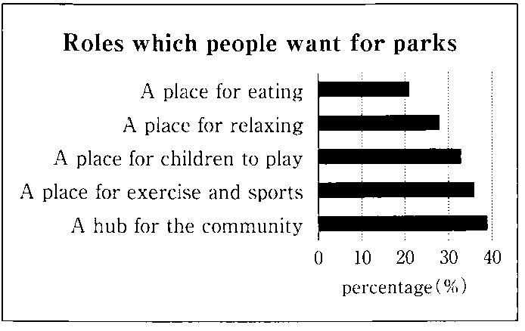
Ⅰ

Tony: What are you going to *present in the next class?
Riku: I’m going to present my idea for a new park. I think people want many *roles for parks. They are important. I want to make a wonderful new park in my town in the future.
Tony: Great!
Riku: What is the most important role for parks to you?
Tony: Well, I think (A) is the most important.
Riku: I think that is important, too. But the *percentage for it is the lowest in this *graph.
Tony: Interesting. In my country, I often enjoy eating lunch in a park.
Riku: I think (B) is the most important. Many other people also want that role.
Tony: Yes. The percentage for it is a little lower than the percentages for “A place for *exercise and sports” and “A *hub for the *community.” But it’s higher than the percentages for the other *items.
Riku: Parks can *play a lot of roles in a town. I’ll try to make a park that plays important roles. There are many *possible roles for a park in a town. I hope people find good roles for my park.
Tony: Great! I think your presentation will be really interesting. I want to know more about parks and towns.
[注] present：発表する role：役割 percentage パーセンテージ：graph：グラフexercise：運動
hub：拠点 communit：地域社会 item：項目 play：果たす possible：あり得る

ア (A) A place for eating (B) A hub for the community
イ (A) A place for relaxing (B) A place for children to play
ウ (A) A place for eating (B) A place for children to play
エ (A) A place for relaxing (B) A hub for the community

問２ 都市と公園についてさらに学びたいと思ったRikuとTonyは，インターネットの画面を見ながら話をしている。 (A) 及び (B) の中に，それぞれ入る語句の組み合わせとして正しいものは，下のア～エのうちではどれか。ただし，次のⅡは，二人が見ている，海外のある大学のオンライン講義の予定表であり，表中の時間は日本時間である。

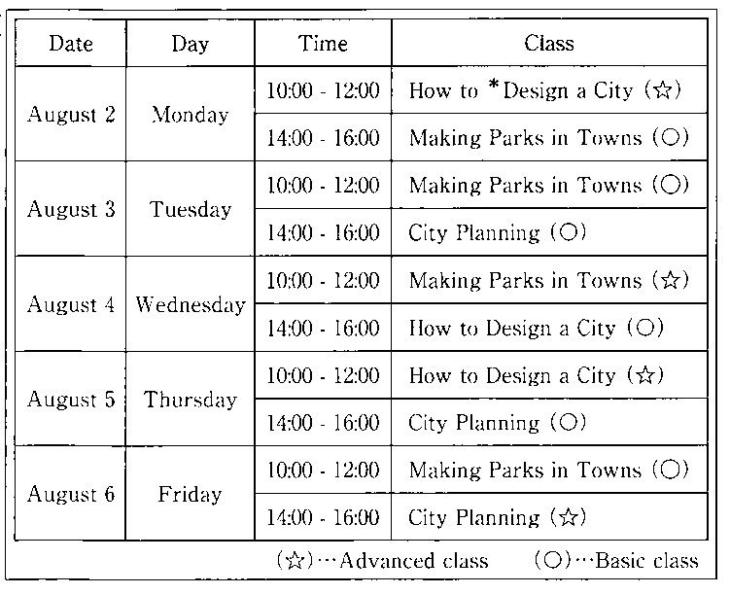
Ⅱ

Riku: Tony, look! We can join some *online classes of the university.
Tony: Sounds interesting. I want to take one. I’m interested in City Planning.
Riku: Do you want to take a *Basic class or an *Advanced class?
Tony: I want to take a Basic class. But I talk with my family on the Internet every Thursday afternoon, so I can’t take it on that day.
Riku: Really? But you can take it on (A) , right?
Tony: Yes. I’ll take it. Riku, which class are you interested in the most?
Riku: I’m interested in Making Parks in Towns the most. In the future, I want to make some parks in Tokyo.
Tony: Great! But, Riku, can you take that class? I think you are busy with the tennis club.
Riku: We practice every Monday, Wednesday, and Friday in the afternoon. So I can take a morning class.
Tony: OK. Do you want to take a Basic class or an Advanced class?
Riku: I want to take an Advanced class.
Tony: So you’re going to take an online class on (B) , right?
Riku: Yes!
[注] online オンラインの basic 基本的な advanced 発展的な design デザインする

ア (A)Tuesday afternoon (B)Wednesday morning
イ (A)Thursday afternoon (B)Wednesday morning
ウ (A)Tuesday afternoon (B)Friday morning
エ (A)Thursday afternoon (B)Friday morning



問３ 次の文章は，イギリスに帰国したTonyがRikuに送ったＥメールの内容である。
Dear Riku,
Thank you for your help during my stay in Japan. Taking an online class of the university is a special memory for me. In the class, we learned how parks could make our lives better. Now I am very interested in parks and towns. Now I realize that parks are very important for towns.
After returning to my country, I *researched about parks in my town. I knew some big festivals were held in the parks. But I didn’t know that many other events were also held in them. I was a little surprised to learn that. I will tell my sister about those events. She will enjoy talking with people at them. I think parks are wonderful places for people to *communicate.
I’m going to join an online meeting about City Planning next week. I want to know more about parks and towns. What are some good points to you about having parks in towns? Please tell me some of your ideas.
Yours,
Tony
[注] research：調べる communicate：意思の疎通をする

(1) このＥメールの内容と合っているのは，次のうちではどれか。
ア Tony realized that online classes could make his life better.
イ Tony was a little surprised that many other events were also held in the parks in his town.
ウ Tony’s sister researched about parks in her town because she wanted to take online classes.
エ Tony’s sister joined an event in a park and enjoyed talking with Tony there.
(2) RikuはTonyに返事のＥメールを送ることにしました。あなたがRikuだとしたら，Tonyにどのような返事のＥメールを送りますか。次の＜条件＞に合うように，下の の中に，三つの英語の文を書きなさい。
＜条件＞
○前後の文につながるように書き，全体としてまとまりのある返事のＥメールとすること。
○Tonyに伝えたい内容を一つ取り上げ，それを取り上げた理由などを含めること。

Hello, Tony,
Thank you for your e-mail. I learned a lot from a class, too. I'm glad to hear that you
are very interested in parks and towns. The online meeting you're going to join sounds
very interesting.
I'll try to answer your question. You asked me, "What are some good points to you about having parks in towns?" I'll tell you one good point.
I hope my idea can help you.
I'm looking forward to seeing you again.
Your friend,
Riku

解答
問１ ウ
問２ ア
問３ (1) イ
(2) (例)My grandfather and I often go to a park near my house.
He enjoys seeing trees and flowers there.
The park gives us a chance to have a good time together.

