沖縄県-大問10 |   2022年 公立高校入試
※QRコードを読み込むと，英文と連動した音声再生ができます（スマホにも対応）

ある日，あなたはALTの先生から以下の英字新聞の切り抜き記事（お悩み相談コーナー）をもらいました。今回のお悩み相談コーナーは，相談員キャシー（Kathy）が中学生トム（Tom）の悩みに答えています。次の英文を読み，各問いに答えなさい。

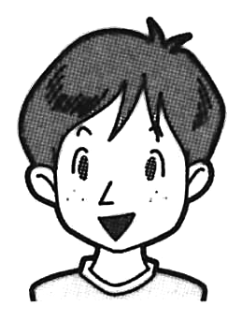
Dear Kathy,
Hi. I'm Tom, a 15-year-old student in junior high school. I have a problem. I can't sleep well at night. I try to go to bed early, but I just can't ^{*1} fall asleep. Please help me!

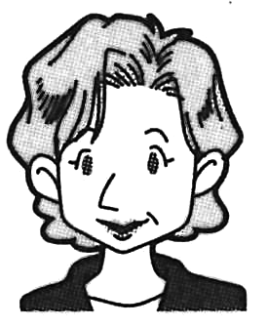
Dear Tom,
Thank you for your question. I understand that you are very worried. However, you are not the only one to have this type of problem. Some research shows that many people have a hard time sleeping at night. I have four ^{*2} tips for better sleep.
The first tip is to try to wake up and go to bed at the same time every day. For example, if you wake up at 6 a.m. and go to bed at 10 p.m. on weekdays, ①do the same on weekends. Why? It's because we all have a 24-hour clock in our bodies. You will feel great when your body knows what to do and when to do it. Many people use^{*3} an alarm clock to wake up in the morning. If you often study or watch TV until late at night, I have a great idea for you to try. Set an alarm to know when to go to bed, too.
The second tip is to keep your bedroom cool. Your head and your body need to cool down to sleep well. This is the reason you can't fall asleep when the room is too hot. Keep the room temperature around 25℃.
The third tip is to keep your bedroom dark. It will make you feel sleepy. One hour before you go to bed, do not use computers and smartphones. This means that you should not watch TV or play games on your smartphone in bed. If you share a bedroom with your brothers or sisters and can't turn off the light at your bedtime,（ ② ）will be helpful.
The final tip is to have ^{*4} a wind-down routine. We can't just turn off the light and sleep right away. It takes some time to ^{*5} slow down the body and feel sleepy. In the last 20 minutes before you go to bed, do something ^{*6} relaxing and remember happy memories of the day. For example, some people like taking a shower, ^{*7} stretching their bodies, or listening to quiet music. Other people remember the day's events that made them happy. Find a good way for you and do it every night.
Sleep is very important for us to be healthy and happy. Please try some of these tips. I hope they will help you sleep well, Tom!

^{*1} fall asleep : 眠りに落ちる ^{*2} tip(s）: コツ ^{*3} an alarm clock : 目覚まし時計
^{*4} a wind - down routine :気持ちを落ち着かせる日課 ^{*5} slow down : ペースを落とす
^{*6} relaxing : リラックスするような ^{*7} stretching ～ : ～を軽く動かすこと

問１ 下線部①は具体的にどうすることか。次のア～エのうちから１つ選び，その記号を書きなさい。
ア have a 24-hour clock in your body
イ wake up at 6 a.m. and go to bed at 10 p.m.
ウ have a hard time sleeping at night
エ use an alarm clock to wake up in the morning
問２ ( ② ）に入る適切な語句を次のア～エのうちから１つ選び，その記号を書きなさい。
ア earphones イ a watch ウ a sleep mask エ socks
問３ 以下の３名はより良い睡眠をとりたいと思っています。３名それぞれの状況を踏まえて，本文に出てくる４つのコツのうち，あなたはどれを教えてあげますか。それぞれ下のア～エのうちから最も適切なコツを１つずつ選び，その記号を書きなさい。
① Yasu: When I go to bed at night, the TV in my bedroom is on.
② Toshi: I sometimes go to bed at 8 p.m. and other times at 11 p.m.
③ Sara: When I am in bed to sleep, I often worry about the next day and feel nervous.
ア the first tip イ the second tip ウ the third tip エ the final tip
問４ 本文の内容と一致していない文を次のア～エのうちから１つ選び，その記号を書きなさい。
ア There are many people who can't sleep well at night.
イ Kathy tells Tom that he can use an alarm for his bedtime.
ウ When the bedroom is hot, it's difficult to fall asleep.
エ Kathy tells Tom to follow all the tips for better sleep.
問５ この記事にタイトルをつけるとしたら，次のどれが最もふさわしいですか。次のア～エのうちから１つ選び，その記号を書きなさい。
ア Why Tom should sleep well at night
イ Kathy says, “Don't go to bed late at night!”
ウ Kathy's three tips for better sleep
エ Help me, Kathy. I can't sleep!
問６ トムはキャシーに教えてもらったコツを実践したおかげで，夜ベッドに入るとすぐに眠れるようになりました。今は睡眠の悩みも解消して，健康で充実した学校生活を送っています。トムは，キャシーにお礼のメールを書くことにしました。トムになったつもりで，「実践したコツ」と「そのコツを実践した結果や感想」を伝えるメールを英文で書きなさい。ただし，以下の条件を踏まえて解答すること。
〈条件〉
・英文は主語・動詞を含む文であること。
・16～32語の英語で書くこと。ただし，符号（, . ! ? “ ”等）は語数に含めない。
・実践したコツは，キャシーに教えてもらったものから１つを選んで書くこと。
・解答欄に示された英文（メールの書き出し）に続けて書くこと。

解答
問１ イ
問２ ウ
問３ ① ウ ②ア ③エ
問４ エ
問５ エ
問６ （略）

