滋賀県-大問３ |   2022年 公立高校入試
※QRコードを読み込むと，英文と連動した音声再生ができます（スマホにも対応）

知美(Tomomi)さんと健太(Kenta)さんの学級では，英語の授業で興味のある社会的な問題についての意見発表を行いました。次は，【知美さんの発表】【知美さんの発表資料】【健太さんの感想】です。これらを読んで，後の問１から問６までの各問いに答えなさい。

【知美さんの発表】
Hello, everyone. Have you ever thought about the food you eat every day? Where does it come from? How does it come to you? I believe food and the environment are important.
Look at graph 1. Japan's food self-sufficiency rate is 37%. It means that Japan imports more than 60% of its food. I didn't know that, but I understood it when I thought about my breakfast. I ate rice, grilled fish, and miso soup. The rice was grown in Japan, but the fish was（ ① ）in a foreign country. The miso and tofu are made from soybeans. However, most of the soybeans are imported from other countries. The breakfast was washoku, traditional Japanese cooking, but it was international.
Look at graph 2. Do you know how far your food traveled to get to you? You can see the food mileage here. Food mileage is calculated by multiplying weight and distance and it tells how much fuel is used to transport food. Japan's food mileage is higher than the other countries' food mileage in the graph. Japan buys a lot of food from many countries and a lot of fuel is used when the food is transported. Using too much fuel is not good for the environment, so we need to think about this. If we buy locally produced food, we don't use much fuel. I think buying locally produced food is one of the good ways to solve this problem.
There is another problem. There are ②【 around / from / hunger / many / suffer / people / who 】the world. However, food waste in Japan is more than six million tons a year. According to graph 3, [ ③ ] . I think we should do something to solve this problem. If we reduce food waste from home, it can make all the difference. When I opened the refrigerator last week, I found some food that was too old to eat. I had to throw it away and I felt very sorry. We should buy only the food we will eat.
Food is very important for us. We should think about the food we eat every day. I believe that we can find answers to our environmental problems. What is your opinion?
Thank you.

(注) food mileage：フード・マイレージ（単位はt・km(トン・キロメートル）) calculate(d)：計算する
multiplying：multiply（かける）のing形 weight：重さ distance：距離 fuel：燃料
locally produced food：地元でつくられた食べ物 refrigerator：冷蔵庫

【知美さんの発表資料】
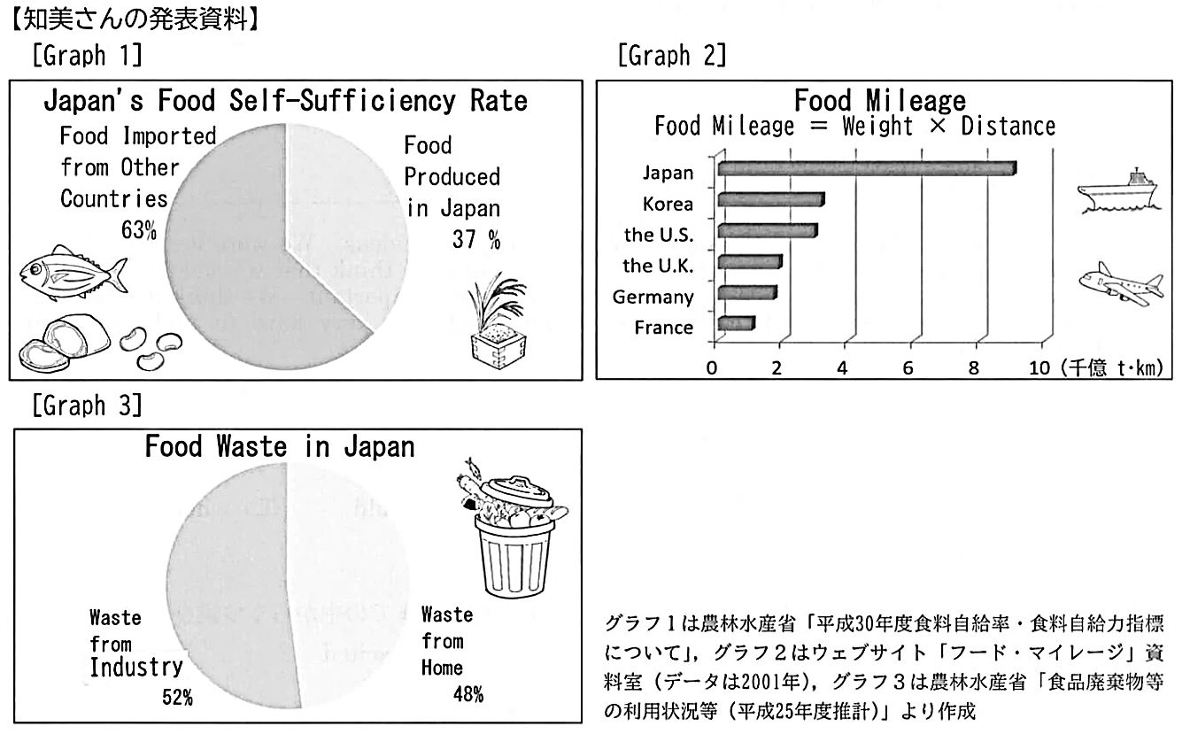
【健太さんの感想】
Thank you, Tomomi. Your presentation is great. You say that buying locally produced food is good for the environment and it has other good points, too. A few days ago, I went to the market near my house. A lot of vegetables grown in my town are sold there. The vegetables are fresh and we can get them in season. Sometimes the farmers who grew the vegetables come to the market to sell them. I met a farmer and enjoyed talking with him. He also taught me how to cook the vegetables. I ate them for dinner and they were delicious. If I know who grows the vegetables, I feel safe about my food. ④ I think it is good to buy the food produced in our local area not only for the environment but also for us.

問１ 【知美さんの発表】について，次の(1)，(2)の質問に対する答えになるように，( ）に入る適当な英語を２語以上で書きなさい。
(1) Does Japan import more than 60 % of its food from foreign countries?
→ ( ).
(2) What food in Tomomi's breakfast was produced in Japan?
→ ( ).
問２ ( ① ）に入る最も適当なものを，次のアからエまでの中から１つ選びなさい。
ア caught イ eaten ウ swum エ thought
問３ ②【 】内の語を，意味が通るように並べかえなさい。

問４ [ ③ ] に入る最も適当なものを，次のアからエまでの中から１つ選びなさい。
ア the food waste from home is larger than the food waste from industry
イ the food waste from home is half of the food waste from industry
ウ the food waste from home is more than six million tons a year
エ the food waste from home is almost half of all the food waste
問５ 【知美さんの発表】の内容として合っているものを，次のアからオまでの中から１つ選びなさい。
ア All of the food we eat in Japan comes from foreign countries.
イ The food mileage of Japan is the lowest of the six countries in graph 2.
ウ Tomomi says locally produced food needs less fuel than imported food.
エ Tomomi believes that reducing the food waste from industry is more important.
オ We can do nothing to solve the food waste problem because it is too serious.
問６ 下線部④の健太さんの意見について，あなたの考えとその理由を10語以上の英語で書きなさい。２文以上になってもかまいません。ただし，知美さんが話したこととは違う内容で，書き出しは次のどちらかを用いることとし，書き出しの語句は語数に含めるものとする。
書き出し I agree / I disagree

解答
問１ (1)(例)Yes, it does (2)(例)The rice was
問２ ア
問３ many people who suffer from hunger around
問４ エ
問５ ウ
問６ (例)I agree with Kenta because we can get fresh vegetables in season.

