熊本県-大問２-４ |   2022年 公立高校入試
※QRコードを読み込むと，英文と連動した音声再生ができます（スマホにも対応）

次は，高校生の由美（Yumi）と，ブラウン先生（Ms. Brown）との対話である。英文を読んで，１，２の問いに答えなさい。

Ms. Brown: Hi, Yumi. What are you doing now?
Yumi: I'm collecting information about how Japanese people communicate with people from other countries. I'm thinking about making a presentation about it.
Ms. Brown: Oh, that's interesting. What did you find out about it?
Yumi: Please look at the graph. Communication with gestures is ① way for Japanese people. I was surprised to find that the rate of talking in easy Japanese is ②
the rate of talking in foreign languages such as English.
Ms. Brown: That's a good point. I often feel that speaking to me in easy Japanese is as nice as speaking to me in English because I feel like a member of Japanese people.
Yumi: I see. I didn't know that. Next, please look at the table. We can see people in different ages choose different ways of communication. For example, the rate of people between 16 and 19 years old who use gestures is ③ the rate of people in their 40s or 70s who use gestures.
Ms. Brown: You're right, and the rate of the youngest group of people using applications on smartphones is almost the same as the rate of people in their 70s talking in Japanese .

(注) communicate with ～ = ～と意思の疎通を図る make a presentation = 発表をする graph = グラフ
gesture = 身ぶり rate = 割合 table = 表 in their 40s = 40歳代の application = アプリケーション（アプリ)
smartphone = スマートフォン the same as ～ = ～と同じ
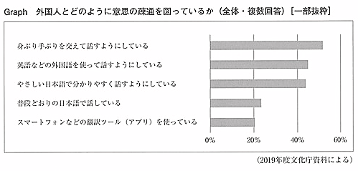

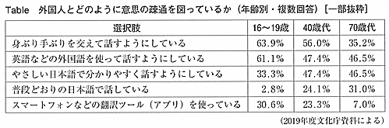

１ ① ～ ③ に入れるのに最も適当な組み合わせを，次のア～カから一つ選び，記号で答えなさい。
ア ① the most difficult ② higher than ③ lower than
イ ① the most difficult ② higher than ③ higher than
ウ ① the most difficult ② almost as high as ③ lower than
エ ① the most popular ② higher than ③ higher than
オ ① the most popular ② almost as high as ③ lower than
カ ① the most popular ② almost as high as ③ higher than
２ に，対話が成り立つような英語を４語以内で書きなさい。

解答
１ カ
２ (例）which they usually use

