石川県-大問３ |   2022年 公立高校入試
※QRコードを読み込むと，英文と連動した音声再生ができます（スマホにも対応）

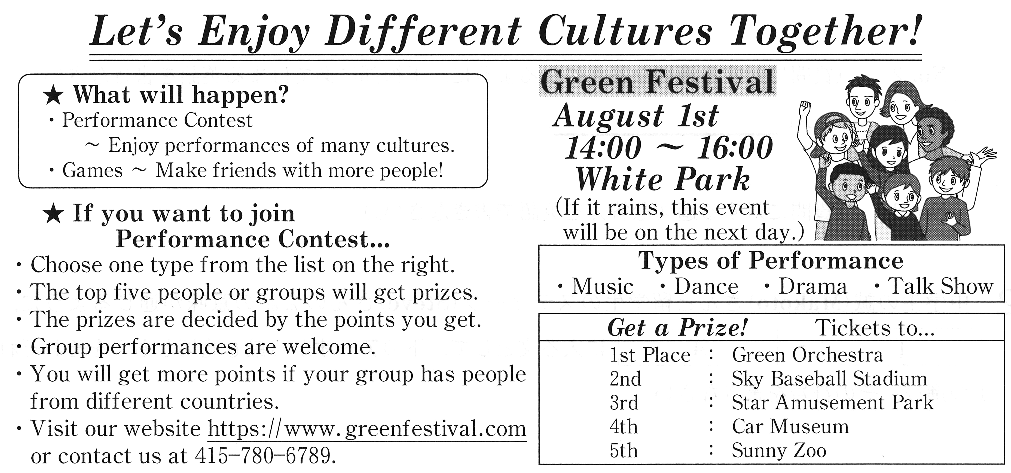
夏休みにアメリカでホームステイをしている高校生の葵（Aoi）さんと同級生の雅樹（Masaki）さんが，それぞれのホストファミリーのエミリー（Emily）さん，オリバー（Oliver）さんと話しています。ポスター（poster）と会話を読んで，あとの各問に答えなさい。

Oliver: Look! I brought a poster for an interesting event. This Saturday, an exciting event is going to be held in our community. Let's go together and have fun!
Emily: Oh, Green Festival. My favorite part is あ . Last year, I enjoyed the performance of students from Brazil. They performed a traditional dance and came in first place.
Masaki: Sounds interesting! It'll be fun to see performances from different cultures.
Aoi: ①But just（ as / as / good / is / not / performing / watching performances ). Masaki, what do you think about joining the contest with me? Let's do something about Japanese culture together!
Masaki: OK. But what can we do? ②Do you have anything in mind?
Aoi: How about a calligraphy performance? It's getting popular with young people in Japan.
Emily: I know about calligraphy, but what is a calligraphy performance? Ａ
Masaki: It is a team activity. A group of people work together to make a big calligraphy work and they usually wear traditional Japanese clothes. They use big brushes and large paper. Japanese pop music is often played during their performance.
Oliver: Wow! I'm sure the audience will be surprised. I enjoyed calligraphy when I visited Japan last summer. I want to try this new type of calligraphy. Can I join you?
Masaki: Of course. Our performance will be more exciting if we have more people with us. Emily,
(1) ?
Emily: Well... It'll be the first time for me to do calligraphy, but don't worry. I'll do my best!
Aoi: Have fun with us!
Masaki: OK, everyone will join the contest. Well, what type of performance will our performance be?
Aoi: Maybe, dance... because music is played when we are performing. Ｂ
Oliver: Umm... I'm not sure. OK, I'll call the office tomorrow and ask.
Aoi: Thank you. Emily, did you check the prizes?
Emily: No, let's see... Wow, I want to go to い . I'm a big fan of its top violin player.
Aoi: To me, the Ferris wheel in Star Amusement Park is more attractive! I saw it in a magazine before I came here. Let's go and ride it if we win the prize!
Masaki: Good idea, Aoi! According to the rules, we can get a prize more easily because
(2) .
Oliver: Yes. We are American, and Aoi and Masaki are Japanese.
Emily: By working with people from different cultures in the same performance, we learn a lot.
Masaki: Oh, what can we learn? Give me one example.
Emily: (3)
Masaki: You're right, Emily. I think that is an important goal of this contest. Now, let's get ready for the performance!
(注) prize : 賞品，景品 brush : 筆

問１ あ ， い の中に入る英語として，次のア～エから最も適切なものをそれぞれ１つ選び，その符号を書きなさい。
ア the concert by Green Orchestra イ the night tour at Sunny Zoo
ウ the performance contest of many cultures エ the talk show by a famous actor
問２ 下線部①の（ ）内の語句を，会話の意味が通じるように正しく並べかえ，文を完成させなさい。
問３ 下線部②は，ここではどのような意味で使われているか，次のア～エから最も適切なものを１つ選び，その符号を書きなさい。
ア Can you give me an idea for our performance?
イ Do you agree with me?
ウ How about doing something about Japanese culture?
エ What do you know about a calligraphy performance?
問４ Ａ ， Ｂ の中に入る英語として，次のア～エから最も適切なものをそれぞれ１つ選び，その符号を書きなさい。
Ａ ア How did you like it? イ I've never heard of it.
ウ What a good performance! エ What are you going to do?
Ｂ ア What can you do? イ What do you think?
ウ What shall I do? エ Why do you think so?

問５ (1) , (2) の中に，それぞれ４語～８語の適切な内容の英語を書きなさい。
問６ (3) について，あなたがエミリー（Emily）さんなら何と言いますか。２文以上のまとまりのある英文で書きなさい。
問７ 次のア～オのうち，ポスター及び会話の内容に合うものを２つ選び，その符号を書きなさい。
ア Aoi wants to come in third place in the contest and win the prize.
イ Emily was in the group from Brazil and gave a performance last year.
ウ If we cannot hold Green Festival on August 1st because of rain, it will be on Sunday.
エ The type of the performance of the four students is dance.
オ When you want to take part in the performance contest, you must visit the office.

解答
問１ あ：ウ い：ア
問２ watching performances is not as good as performing
問３ ア
問４ Ａ：イ Ｂ：イ
問５ (1)(例)why don't you join us
(2) (例)ur group has people from different countries
問６ (例)We can learn to know cultural differences and respect each other's cultures.
問７ ア，ウ

