神奈川県-大問６ |   2022年 公立高校入試
※QRコードを読み込むと，英文と連動した音声再生ができます（スマホにも対応）

次の英文は，高校生のハルカ（Haruka）が夏休み後，地元の商店街（shopping district）の取り組みについて英語の授業で行った発表の原稿です。英文を読んで，あとの問１～問３の問いに答えなさい。
Hello, everyone. I am Haruka. I did *research during summer vacation. Today, I want to *share the things I learned in my research.
My research was about the *trash problem in the shopping district in Kamome City. There are some famous places in Kamome City, so many *tourists visit our city. A lot of people, tourists and people living in our city, enjoy buying many kinds of things in the shopping district. But some of them were leaving a lot of trash on the streets. On the news, I learned that there were people who were working to solve the problem, and I decided to do research about it.
Some people who came to the shopping district were leaving *PET bottles, *cans, paper, and other things on the streets. So there was a large *amount of trash. *Volunteers from the shopping district, for example, the *shop owners, sometimes *picked up the trash. They usually collected more than 20 kg of trash in one day. They said that（ ① ). They worked hard but there was always trash on the streets.
So people from the *City Hall and the shop owners met and talked about the problem. They met many times, and after that, they had an idea for a *project. They called it the Kamome Clean Project.
The Kamome Clean Project used *crowdfunding. Crowdfunding is a way to collect money from many people who like a project and want to help it. Please look at this *flyer.
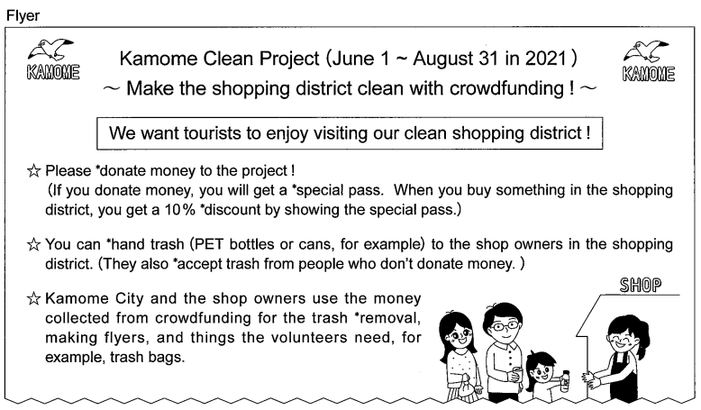

The project started last June. During my research, I asked one of the shop owners about the project. She said, “After people drink something,（ ② ). We accept the *empty PET bottles or cans from them. So they don't have to carry their trash around the shopping district. Many people like the project.”
Next, look at this *graph. It shows the kinds of trash the shops accepted *by percentage for three months. More than 40% of the trash was PET bottles, and about 20% of the trash was cans.

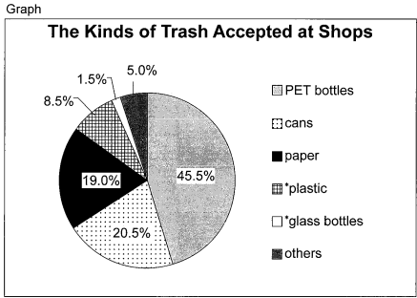

I think some of you may ask, “Why did the shop owners agree to accept trash from everyone visiting the shopping district ?” Because it was also good for the shops ! Some people bought things at the shops after they handed their trash to the shop owners. Some people stayed for a little at the shops and talked with the shop owners.
I talked about this project with my family. They liked it, donated money, and got the special pass. Last month, I went shopping in the shopping district. I bought *a bottle of water. After I drank it, I took the empty PET bottle to a cake shop. I got a 10% discount on a birthday cake for my grandmother. The cake shop owner told me that（ ③ ). She also said, “*Thanks to this project, many people have learned that Kamome City and the shopping district are working hard to solve the trash problem. The shopping district is becoming cleaner now because more people have become interested in the trash problem.”
I want to tell you the most important thing I've learned from my research. To solve the trash problem, the people from the City Hall and the shop owners told each other *various ideas. Then, they had the idea for the Kamome Clean Project. Many people joined the project, and the shopping district has become cleaner. Now I think, “ When people work together, problems will be solved.” Thank you for listening.

research : 調査 share ～ : ～を共有する trash : ごみ tourists : 観光客 PET bottles : ペットボトル
cans : 缶 amount : 量 Volunteers : ボランティア shop owners : 店主 picked up ～ : ～を拾った
City Hall : 市役所 project : 企画 crowdfunding : クラウドファンディング flyer : ちらし
donate ～ : ～を寄付する special pass : 特別な券 discount : 割引 hand ～ : ～を手渡す
accept ～ : ～を受け取る removal : 撤去 empty : 空の graph : グラフ
by percentage : パーセンテージで plastic : プラスチック glass bottles : 瓶 a bottle of water : 一本の水
Thanks to ～ : ～のおかげで various : 様々な

問１ 本文中の（ ① )～( ③ ）の中に，次のＡ～Ｃを意味が通るように入れるとき，その組み合わせとして最も適するものを，あとの１～６の中から一つ選び，その番号を答えなさい。
Ａ a PET bottle or can is left in their hand
Ｂ it was very difficult for them to clean the streets
Ｃ the shop accepted a lot of trash from many people
１ ①Ａ ②Ｂ ③Ｃ ２ ①Ａ ②Ｃ ③Ｂ ３ ①Ｂ ②Ａ ③Ｃ
４ ①Ｂ ②Ｃ ③Ａ ５ ①Ｃ ②Ａ ③Ｂ ６ ①Ｃ ②Ｂ ③Ａ
問２ 本文中の の中に入れるのに最も適するものを，次の１～４の中から一つ選び，その番号を答えなさい。
１ If we solve one problem, we will have another one.
２ If we share ideas and talk about them, we can find the answer.
３ If we meet and talk many times, more trash will be left on the streets.
４ If we start crowdfunding, the volunteers have to work harder than before.
問３ 次のａ～ｆの中から，ハルカの発表の内容に合うものを二つ選んだときの組み合わせとして最も適するものを，あとの１～８の中から一つ選び，その番号を答えなさい。
ａ Many shopping districts in Kamome City worked hard to collect money for the trash removal.
ｂ The trash problem was solved because some volunteers from the shopping district collected trash.
ｃ The shop owners accepted PET bottles but they didn't accept paper.
ｄ Only people who donated money could take their trash to the shops in the shopping district.
ｅ The graph shows that more plastic was accepted at the shops than glass bottles by percentage.
ｆ Haruka thinks that the Kamome Clean Project made more people learn about the problem her city had.
１ ａとｃ ２ ａとｅ ３ ｂとｄ ４ ｂとｆ
５ ｃとｅ ６ ｃとｆ ７ ｄとｅ ８ ｅとｆ

解答
問１ ３
問２ ２
問３ ８

