秋田県-大問４ |   2022年 公立高校入試
※QRコードを読み込むと，英文と連動した音声再生ができます（スマホにも対応）

次は，留学生のベッキー（Becky）と中学生の幸（Sachi）が，ブロードウェイのミュージカル（Broadway musicals）について，チケットや劇場（theater）の館内図を見ながら会話をしている場面です。これらと幸が書いた手紙を読んで，問１～問４の問いに答えなさい。
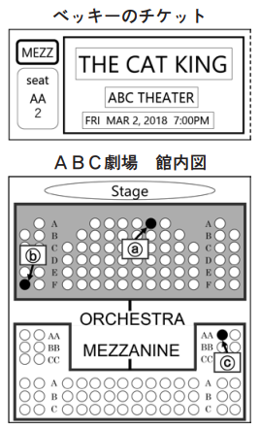
Becky: I hear you're interested in Broadway musicals. [ ① ]. When I was in America, we often went to Broadway together.
Sachi: That's nice. I've never been there but I really like them.
Becky: I brought my ticket for the musical I watched before. Do you want to see it?
Sachi: Yes, please. I want to know more about Broadway musicals.
Becky: Here you are.
Sachi: Wow, you saw “The Cat King” at ABC theater two years 《 》.
Becky: Yes. “The Cat King” was my favorite musical because the music and the performance were really good.
Sachi: That's the one I have wanted to see for a long time. I want to go to America and watch it someday.
Becky: I'm sure you'll have the *chance to do that.
Sachi: Thank you. Oh, I have a question. What does this “MEZZ” on your ticket mean?
Becky: It means mezzanine. It's the area which has seats on the second *floor. Look at this map. In this theater, this area is called mezzanine. I watched “The Cat King” from the mezzanine. The other area is called the orchestra. It's the area which has seats on the first floor.
Sachi: Do you like to see musicals from the mezzanine floor?
Becky: Well, both the mezzanine and the orchestra have their own good points. For example, the orchestra seats are *close to the stage. On the other hand, the mezzanine seats are on a higher floor, so [ ② ]. You should think about that when you see musicals.
Sachi: I see. Thank you for your advice.
The next year, in 2021, Sachi saw the same musical in America and wrote to Becky.
Yesterday, I saw “The Cat King” at ABC theater in New York! I considered which floor to（c ), the mezzanine or the orchestra. Finally, I got the seat just in front of the stage in the orchestra. I could see the facial expressions of the people on the stage well. I was satisfied with that.
【注】 *chance：チャンス，機会 *floor：～階 *close：近い

問１ 本文中の①，②に当てはまる最も適切なものを，次のア～エからそれぞれ１つずつ選んで記号を書きなさい。
① ア I also like your favorite place イ My mother and I like musicals, too
ウ The musical you saw is so famous エ Your parents know why you like it
② ア you can see the whole stage easily イ the orchestra is the best floor to see it
ウ the theater is very crowded now エ your performance looked really good
問２ 本文の《 》に当てはまる英語１語を書きなさい。
問３ 幸がベッキーに書いた手紙の中の（ ）に適する英語１語を書きなさい。ただし，答えは（ ）内に示されている文字で書き始めること。
問４ 幸とベッキーが “The Cat King” を実際に観劇した席を，館内図のⓐ～ⓒからそれぞれ１つずつ選んで記号を書きなさい。また，幸が自分の席で満足した理由を，日本語で書きなさい。

解答
問１ ①イ ②ア
問２ (例）ago
問３ (例）choose
問４ 幸：ⓐ ベッキー：ⓒ
理由：(例）ステージ上の人々の表情がよく見えたから

