群馬県(前)-大問４ |   2022年 公立高校入試
※QRコードを読み込むと，英文と連動した音声再生ができます（スマホにも対応）

次の英文は，ALTのBrown先生（Ms. Brown）が，県立ぐんま天文台（Gunma Astronomical Observatory）で日時計（sundial）を見たことに触れ，英語の授業で話した内容です。これを読んで，後の問１～問４の問いに答えなさい。

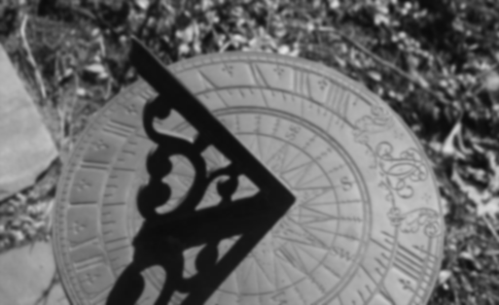
Last Sunday, I visited Gunma Astronomical Observatory with our science teacher, Ms. Tanaka. When we arrived there, I saw something large outside. I asked Ms. Tanaka, “What is this large thing?” Ms. Tanaka said, “It is a sundial. It is a kind of clock which uses *shadow. You can know the time by the *position of the shadow. This kind of clock was the first clock in history.” Then she told me about the history of clocks and watches. It was very interesting, so I will talk about it today.
About 6,000 years ago, people in *Egypt made the first sundial. Sundials were useful. But people couldn't use them at night or when it was cloudy. Later, people started to use water to make clocks. They *were able to know the time at night with water clocks. But in cold areas, water becomes ice in winter. About 700 years ago, people in *Europe started to make new clocks which did not use shadow or water. They were *mechanical clocks, and they were large and heavy. So people wanted to make smaller clocks. About 500 years ago, people started to make watches. People were able to wear them, so they always knew the time.
People in many parts of the world have been looking for a better way of knowing the time. Today, many people have watches, and you can find clocks in so many places. They are in our houses, in our classrooms, in stations, and in shops. Clocks and watches are very useful in our lives today. Knowing the right time is very important for us. I had some troubles when I didn't know the right time. Do you have any experiences like that?
(注) shadow 影 position 位置 Egypt エジプト be able to ～ ～することができる
Europe ヨーロッパ mechanical 機械式の

問１ 本文の内容に合うように，次の表の Ａ ～ Ｃ に入れるのに最も適切なものを，それぞれア～カから選びなさい。
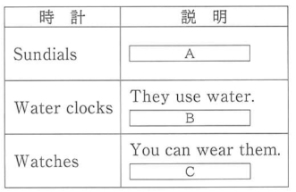
ア They use ice.
イ They use shadow.
ウ They are expensive.
エ They have a problem in winter.
オ The first one was made about 700 years ago.
カ The first one was made about 500 years ago.

問２ 次の①，②の問いに対して，本文の内容に合うように，３語以上の英語で答えなさい。
① What subject does Ms. Tanaka teach?
② What was the problem with sundials?
問３ 本文の内容と合っているものを，次のア～エから１つ選びなさい。
ア Ms. Brown found a large sundial at school last Sunday.
イ Water clocks were used before the first sundial was made in Egypt.
ウ People in Egypt made the first mechanical clock which didn't use shadow or water.
エ People around the world have been trying to make better clocks and watches.
問４ Brown先生の話の後で，本文中の下線部の質問に対して，自分が経験したできごとを話す活動を行いました。そこで，Kenは後のＡ～Ｃで示されたできごとについて話すことにしました。あなたがKenなら，次の で何と言いますか。後の《条件》に従って，英語で書きなさい。
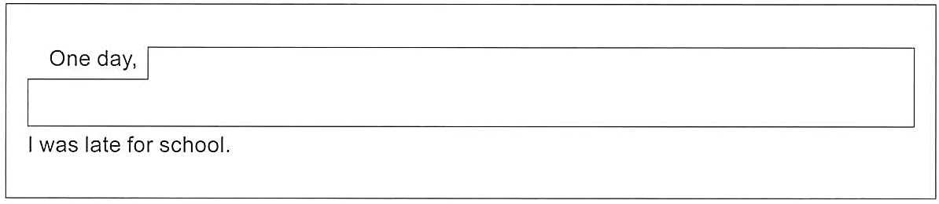

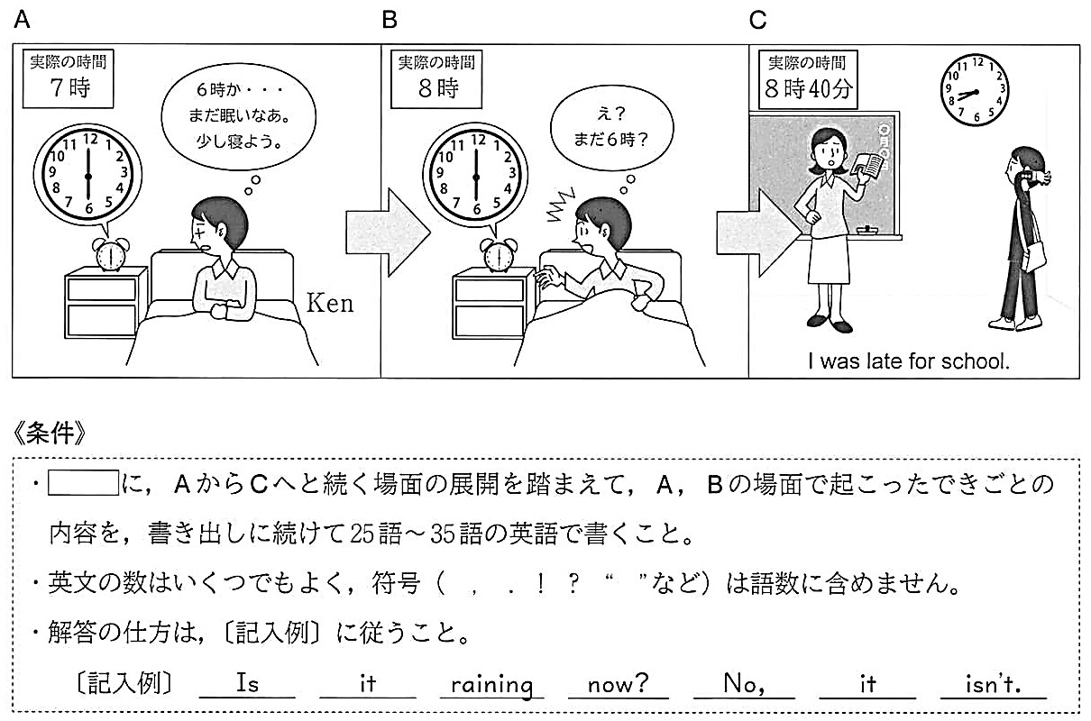

解答
問１ Ａ：イ Ｂ：エ Ｃ：カ
問２ ①（例）She teaches science.
②（例）People couldn't use them at night or when it was cloudy.
問３ エ
問４ （例）( One day, ）I got up at six. I was sleepy, so I slept again. Later, I got up again, but it was still six. I was surprised to know that my clock was not moving.（ I was late for school. )

