茨城県-大問４ |   2022年 公立高校入試
※QRコードを読み込むと，英文と連動した音声再生ができます（スマホにも対応）

高校生のシホ (Shiho) とクラスメイトのアナ (Anna) が，次のページのウェブサイトを見ながら話をしています。下の対話文を読んで，問１，問２に答えなさい。
Anna: Hi, Shiho. What are you doing?
Shiho: I'm looking at Hibari Zoo's website. I will go there with my family. Do you want to come with us, Anna?
Anna: Yes! When will you go?
Shiho: ( ① )
Anna: Sorry, I have a piano lesson this Saturday until three in the afternoon at the City Hall.
Shiho: No problem. We'll go there in the evening. The tickets will be cheaper. Look at the website.
Anna: That's true. Then, each person can save ( ② ) yen.
Shiho: Yes. Also, you should bring your . If you don't show it when you buy a ticket, you can't get the student *discount.
Anna: Okay. Hey, ( ③ ) ?
Shiho: My family and I will go there by car. *Do you want a ride?
Anna: Thank you, but I'll go *directly from the City Hall. It's *far from your house, right?
Shiho: Then you should take the bus ... Look at this page. There is a *timetable.
Anna: There are two lines. Which line should I take?
Shiho: Hmm ... If you take the Blue Line, you need 25 minutes to get to the zoo. If you take the Red Line, 35 minutes.
Anna: All right. Can we meet at the *entrance?
Shiho: Yes. How about meeting at four o'clock?
Anna: Then I'll take the bus ( ④ ).
Shiho: Anna, which event would you like to go to? They have four kinds of events.
Anna: Really? I like big animals, but I cannot pay a lot of money. I can use only 3,000 yen this week.
Shiho: Then how about ( ⑤ ) ?
Anna: That sounds great! It will be fun.

*discount 割引 Do you want a ride? 乗っていく？ directly 直接 far 遠い
timetable 時刻表 entrance 入口

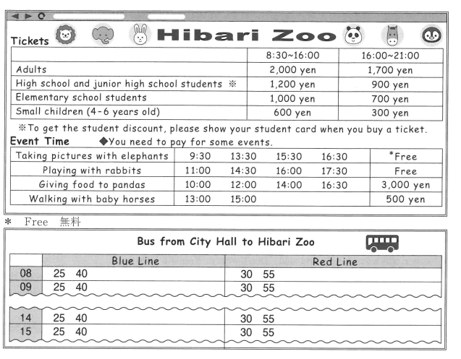
問１ 対話中の ( ① ) ～ ( ⑤ ) に入る最も適切なものを，ア～エの中から一つ選んで，その記号を書きなさい。
① ア Let's go next Sunday. イ How about this Saturday?
ウ When are you free? エ I haven't decided yet.
② ア 1,200 イ 900 ウ 800 エ 300
③ ア how many times have you been there イ who will go with you
ウ how can I get to the zoo エ when do you buy a ticket
④ ア at two forty イ at three twenty-five
ウ at three thirty エ at three fifty-five
⑤ ア “Taking pictures with elephants” イ “Playing with rabbits”
ウ “Giving food to pandas” エ “Walking with baby horses”
問２ 対話の流れに合うように，文中の に入る適切な英語を，対話文またはウェブサイトの中から２語で抜き出し，英文を完成させなさい。

解答
問１ ①イ ②エ ③ウ ④イ ⑤ア
問２ student card

問１ ② 8：30～16：00までは，高校生１人あたり1,200円だが，16：00～21：00までは900円。
③ 手段をたずねる疑問文。
④ ７Shihoの発言から，Blue Lineを使うと25分，Red Lineを使うと35分かかる。Annaは３時までピアノのレッスンがある。４時の待ち合わせに間に合うようにする。
問２ ウェブサイトの To get the student discount, please show your student card when you buy a ticket. に着目。

