長崎県-大問３ |   2022年 公立高校入試
※QRコードを読み込むと，英文と連動した音声再生ができます（スマホにも対応）

次は，中学３年生の春希（Haruki）とALT（外国人指導助手）のスミス先生（Ms. Smith）との会話である。読んであとの問いに答えなさい。なお，あとの注を参考にしなさい。
Haruki: Our school brass band club will have a concert next Sunday. Did you know that?
Ms. Smith: No, I didn't. That sounds interesting. Ａ start?
Haruki: At 2 p.m. I'll give you this Leaflet.
Ms. Smith: Thank you. I think I can go.
Haruki: Great! Our members will be happy to hear that.
Ms. Smith: In this Leaflet, what does this last sentence mean?
Haruki: Oh, yes. After the concert, the guest will Ｂ .
Ms. Smith: Thank you. I want to try it.
Haruki: I hope you'll enjoy the concert.
（The next day after the concert)
Haruki: How was the concert?
Ms. Smith: It was great, and playing the guitar was also interesting. I had a wonderful experience. Well, what do you want to do during the spring vacation before you become a high school student?
Haruki: Ｃ
Ms. Smith: Nice. Have a good vacation.

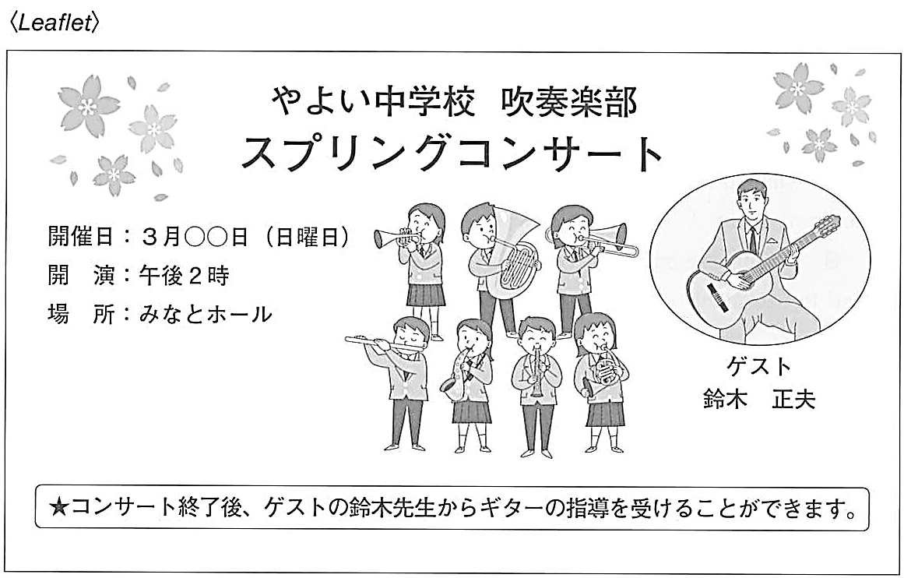
注：brass band club 吹奏楽部 leaflet (広告の）ちらし sentence 文 guest ゲスト

問１ 会話の流れに合うように Ａ ， Ｂ に入る英語を書け。
問２ 下線部の質問に対して，あなたが春希ならどのように答えるか。 Ｃ にあなたの考えを理由とともに10語以上20語以内の英語で書け。なお，英語は２文以上になってもかまわない。ただし，コンマ（ , ）やピリオド（ . ）などは語数に含めない。

解答
問１ Ａ：（例）・What time will the concert [start ?] ・When is it going to [start ?]
Ｂ：（例）[After the concert, the guest will] teach you how to play the guitar [.]
問２ （例）・I want to read a lot of books because I don't have time to read now.
・I want to practice cooking because I will make my own lunch.

