長野県-大問４ |   2022年 公立高校入試
※QRコードを読み込むと，英文と連動した音声再生ができます（スマホにも対応）

各問いに答えなさい。
美緒（Mio)，春斗（Haruto)，悠真（Yuma）のクラスでは，英語の授業で物を大切にすることをテーマに学習し，海外の姉妹校の生徒に向けて発表している。次の英文は，美緒の発表である。

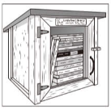
Look at this photo. It looks like a house for birds, but it's a kind of library known as a Little Free Library. This started in America in 2009. Now, we can see such libraries around the world. The only rule of these small open libraries is “Take a book, return a book.” Some people build their own libraries and put their own books in them. People living near a Little Free Library can borrow the books for a very short time or even a long time. I think that Little Free Libraries are good ways to share different kinds of books and ideas. This year I will build my Little Free Library in front of my house.

問１ 美緒の発表を聞いた姉妹校のルークはLittle Free Library に興味をもち，発表でふれられていなかったことについて質問をした。その質問として最も適切な英文を，次のア～エから１つ選び，記号を書きなさい。
ア Can people borrow books from Little Free Libraries for a long time?
イ When did the first Little Free Library start?
ウ Are there any rules for Little Free Libraries?
エ How many Little Free Libraries are there in the world?

次の英文は，春斗の発表である。
Have you ever heard the question, “DO YOU KYOTO?” I learned from some books how people in Kyoto don't waste things. I'll tell you about two of their projects.
The first one is a gym uniform *recycling project. If gym uniforms get old, people stop using them. So, some students in Kyoto started to collect and recycle them into new gym uniforms.
The second one is a website called Moppen. The word is used by people living in the area to say, “one more time.” People can find *repair shops and *reuse shops easily on the website. By using these shops, things can be used again by their *owners or new owners who need them.
In these ways, many people in Kyoto think that old things *are worth using. Their actions *lead to a *zero-waste life. It's good for *nature. Now, you understand what the question means, right? It means, “Do you _{①}( )?” To say yes to the question, I want to start a school uniform recycling project at our school in Nagano.
(注) recycling ← recycle リサイクル(する) repair 修理(する) reuse 再利用(する) owner(s）所有者
are worth ～ing ～することに価値がある lead 導く zero-waste ごみゼロの nature 自然
問２ 春斗は，発表の始めに話の流れを示すスライドを提示した。提示したスライドとして最も適切なものを，次のア～エから１つ選び，記号を書きなさい。
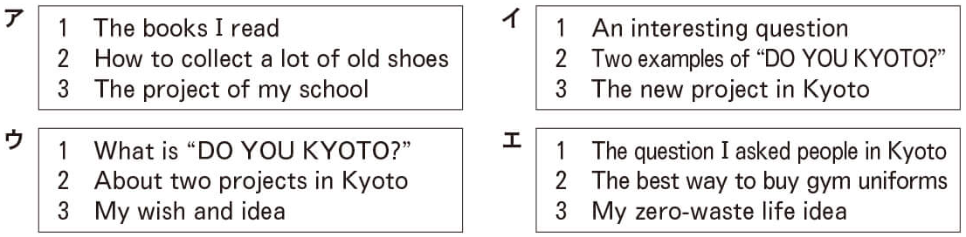
問３ 春斗の話の内容に合うように，下線部①の（ ）に当てはまる最も適切な英語を，次のア～エから１つ選び，記号を書きなさい。
ア have some gym uniforms at home イ do good things for the environment
ウ want to visit Kyoto エ use the internet to find flower shops

次の英文は，悠真の発表である。
Do you know tsukumogami ? When I was little, I thought it *would be *scary to see them. However, I learned a lot from them and my grandfather.
My grandfather is a *toy doctor. Toy doctors are *volunteers who repair broken toys. I'm proud of him because he never says, “I can't repair it.” He helps children with *valuing their toys more. He gave me a bike as a birthday present and taught me how to care for it. I can repair it by myself now, and it is becoming more and more important to me.
My grandfather often says, “If you don't take care of things, *tool ghosts will come and do something bad.” A traditional Japanese story says that things will get *spirits after a long time. We call them tsukumogami. They will become angry if people waste things. Some people have told children about tsukumogami to teach them “don't waste.” This old story is interesting to me, and I want to tell younger people to keep using old things.
Look at this. These are _{②}the points of my speech. I would like to finish my speech by asking a question. _{③}What is an important thing to you? Thank you for listening.
(注) would ～だっただろう scary 怖い toy(s ）おもちゃ volunteer(s）ボランティア
valuing ← value 価値があると考える tool ghost(s）道具のおばけ spirit(s）魂

問４ 次のア～ウは，悠真が発表をするときに使用した絵である。最初の絵に続いて，話の順になるように記号を左から並べて書きなさい。
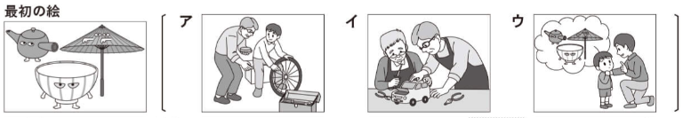

問５ 悠真の発表を聞いた姉妹校のロビンは， tsukumogami について次の にまとめた。下線部あ，いの（ ）に当てはまる最も適切な英語を，それぞれ連続する２語で，悠真の発表の中から抜き出して書きなさい。
It is said that tsukumogami may be seen if people _{あ}（ )（ ). Yuma was afraid to
_{い}（ )（ ）when he was little, but now he is interested in tsukumogami and the old story.
問６ 下線部②について，悠真はスライドを見せながら話をした。スライドの中の に当てはまる英文を，次のア～オからすべて選び，記号を書きなさい。
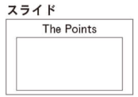
ア Tsukumogami can repair broken toys.
イ We should create something new.
ウ We should take good care of things around us.
エ Younger people should teach something to older people.
オ The traditional way of thinking is still important.
問７ 下線部③の質問に対するあなたの答えと，その理由を書きなさい。語の順番や使い方に注意して，20語以上の正確な英語で書きなさい。ただし，英文の数は問わない。なお，コンマ，ピリオドなどの符号は語数に含めない。短縮形は１語と数えること。

３人の発表を聞いた姉妹校のサラは，次のようにコメントをした。
Thank you for telling us your ways of thinking. I usually try to buy things that _{④}( ).
Many of them are a little expensive, but I will do things that are good for nature. The point of
_{⑤}( ）speeches is about valuing old things, so our way of thinking is similar.
問８ 下線部④，⑤の（ ）に当てはまる最も適切な英語を，次のア～キから１つずつ選び，記号を書きなさい。
ア can be used for a long time イ we need to repair
ウ are repaired by my grandfather エ are new and cheap
オ Mio's and Haruto's カ Haruto's and Yuma's キ Mio's and Yuma's

解答
問１ エ
問２ ウ
問３ イ
問４ イ→ア→ウ
問５ あ：waste things い：see them
問６ ウ，オ
問７ (例)My pencil case is very important to me because it was a present from my friends for my birthday. I want to use it for a long time.
問８ ④ア ⑤カ

