青森県-大問２ | 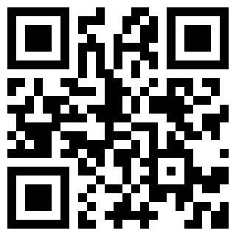  2022年 公立高校入試
※QRコードを読み込むと，英文と連動した音声再生ができます（スマホにも対応）

次の英文は，ケンタ（Kenta）と，アメリカ人留学生のビル（Bill）の対話の一部です。２人は，アメリカ合衆国の硬貨を見ながら話をしています。これを読んで，あとの問１～問３に答えなさい。*印の語句には，対話のあとに（注）があります。
Kenta: Hi, Bill.
Bill: Hi, Kenta. ア（ will interesting show I you ）things. Look at these *coins. I brought them from my country.
【アメリカ合衆国の硬貨】
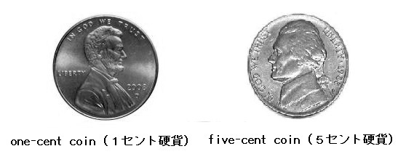

Kenta: Oh, these two coins have a person's face on them.
Bill: You're right.
Kenta: イ（ are whose on designed faces ）the coins?
Bill: Well, for example, the one-cent coin has the face of *Abraham Lincoln on it.
Kenta: Oh, Abraham Lincoln. I know his name.
Bill: This coin is called a *penny. Penny is another name of the one-cent coin.
Kenta: I see. Does the other coin have another name, too?
Bill: Yes, it does. It is a five-cent coin. It is called a *nickel.
Kenta: Interesting! Some coins have other names. I didn't know that.
Bill: Do you have other names for Japanese coins?
Kenta: No, we don't have them, but Japanese coins have interesting *characteristics.
We have six of coins today. Two of them have a hole in them. Did you know that?
Bill: Yes, I did. I was surprised when I saw them *for the first time. I can *distinguish the coins easily by the hole. It's very useful.
Kenta: Do you think so? ウ（ have you I could wish ）a useful hole in your country's coins. Now, I'm interested in the coins of your country. I will look at a website about them. If I have questions, I will send you an e-mail.
Bill: Yes, please.
(注) coin(s) 硬貨 Abraham Lincoln エイブラハム・リンカン(アメリカ合衆国第16代大統領)
penny ペニー(硬貨の通称) nickel ニッケル(硬貨の通称) characteristic(s) 特徴
for the first time 初めて distinguish ～を見分ける
問１ 下線部ア～ウについて，文の意味が通るように，( ）内の語をすべて用いて，正しい順序に並べかえて書きなさい。大文字にする必要のある文字は大文字にしなさい。
問２ に入る最も適切な英語１語を書きなさい。
問３ 次の文章は，ビルと話をした日の夜に，ケンタがビルに送ったメールの内容です。下線部１，２をそれぞれ一つの英文で書きなさい。
Hi, Bill. Thank you for talking with me today. I found some words on the two coins. I don't think that some of them are English. １ 私はその言語が何かを知りたいです。 Do you know that? I also found a nice building on the five-cent coin. I looked at the website about it and I was surprised that it was a part of a World Heritage Site. ２ 世界には訪れるべき建物がたくさんあります。 I think that this building is one of them.

解答
問１ ア：( I will show you interesting ）things.
イ：( Whose faces are designed on ）the coins?
ウ：( I wish you could have ）a useful hole in your country's coins.
問２ (例）kinds
問３ １：(例)I want to know what the language is.
２：(例)There are many buildings to visit in the world.

