鳥取県-大問４ |   2022年 公立高校入試
※QRコードを読み込むと，英文と連動した音声再生ができます（スマホにも対応）

次の会話は，中学３年生のかな（Kana）さんとヒル先生（Mr. Hill）との間で交わされたものです。あとのグラフは，話の途中でヒル先生がかなさんに見せた，青少年のスマートフォンを使ったインターネットの利用時間に関する調査資料です。また，あとのスピーチは，かなさんがスマートフォンの利用について実際に行った発表の原稿です。これらを読み，あとの各問いに答えなさい。

Kana: Good news! My friend, Takahiro, won the first place* at the piano contest yesterday!
Mr. Hill: That's great!
Kana: His parents were so happy. They bought a smartphone for him!
Mr. Hill: Oh, really? Kana, do you have a smartphone?
Kana: No, I don't. But my father says he will buy one for me when I'm a high school student. I can't wait!
Mr. Hill: Today, it is very important to learn how to use information technology*. A smartphone is a small computer. So it may be a good idea to have one when you are young. But when young people use smartphones, there are some problems, too.
Kana: I know. My older brother is using his smartphone too much and my mother is angry.
Mr. Hill: Look at this graph*, Kana. It shows how long Japanese students use smartphones to access* the internet in a day on weekdays*. Junior high school students use them for about 144 minutes a day.
Kana: That's a long time. Elementary school students spend less than* half of that time.
Mr. Hill: Yes. And boys are using them a little longer than girls at every age*. I especially worry about high school students because they use smartphones so much.
Kana: Wow, 208 minutes ... more than three hours a day!
Mr. Hill: What would happen if you used a smartphone for such a long time?
Kana: I get home at six o'clock after school, and go to bed at ten. If I used it for three hours each day, I would have no time to study or talk with my family.
Mr. Hill: Yes. I worry about ①that.
Kana: Before we graduate*, maybe we need to learn more about this problem. I will choose this topic* for my speech next week.

(注) the first place １位 information technology 情報技術 graph グラフ
access ～にアクセスする，つなぐ on weekdays 平日に less than ～ ～より少ない
age 年代 graduate 卒業する topic 話題

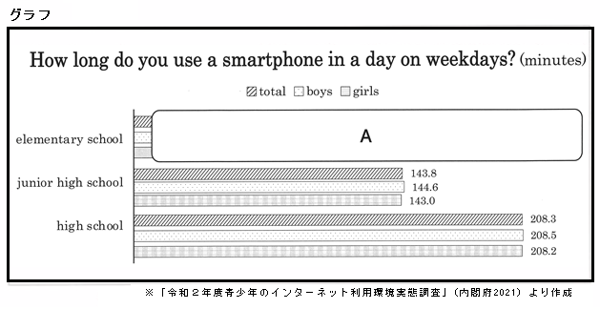

スピーチ
Do you have a smartphone? With smartphones, we can get information easily. We can talk with friends anytime*. Playing games and watching movies on smartphones are fun!
However, what happens if we use smartphones too much? There are some problems. For example, we cannot concentrate on* studying if we send and receive messages all the time. Also, by looking at the screens* for a long time, our eyesight* will get very weak. And they keep our brains too excited at night, so we cannot sleep well. It may be bad for our health.
So, I talked with my parents and we set* three rules*. First, I will turn off* my smartphone when I study. Second, after I use it for an hour, I will stop using it（ ② ). Third, to sleep well, I will not use it in bed. I'll follow* these rules when I get one.
A smartphone is a wonderful tool*. But if we are not careful, smartphones may make our school lives difficult. We should find a good way to live with smartphones. If we can, our lives will become more convenient and fun.

(注) anytime いつでも concentrate on ～ ～に集中する screen(s) 画面 eyesight 視力
set set「～を定める」の過去形 rule(s) ルールturn off ～ ～の電源を切る follow ～を守る
tool 道具

問１ ２人の会話から分かることとして，最も適切なものを，次のア～エからひとつ選び，記号で答えなさい。
ア Kana is very good at music.
イ Mr. Hill is looking at Takahiro's smartphone.
ウ Mr. Hill is telling Kana about Takahiro's good news.
エ Kana wants to have a smartphone.
問２ 会話の内容から判断して，ヒル先生の意見を表しているものとして，最も適切なものを，次のア～エからひとつ選び，記号で答えなさい。
ア A smartphone is more useful than a computer.
イ It may be OK for young people to have smartphones.
ウ Junior high school students are too young to use computers.
エ Kana's brother should stop using his smartphone.
問３ 会話の中で，ヒル先生がかなさんに見せているグラフ中のＡの部分を補ったものとして，最も適切なものを，次のア～エからひとつ選び，記号で答えなさい。
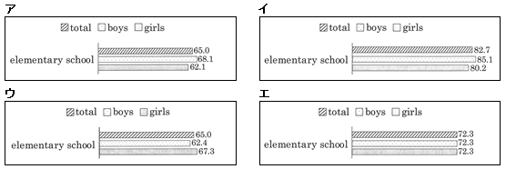

問４ 会話の下線部①はどのようなことを表していますか。次の（ ）にあてはまるように，30字以内の日本語で答えなさい。ただし，句読点も１字に数えることとする。
「スマートフォンを（ ）こと。」
問５ スピーチの内容から判断して，スピーチの( ② ）にあてはまる英語として，最も適切なものを，次のア～エからひとつ選び，記号で答えなさい。
ア to ask questions about my homework
イ to give my eyes some rest
ウ to make my brain excited
エ to send messages to my friends
問６ スピーチにおいて，かなさんが伝えたい内容と一致する英文として，最も適切なものを，次のア～エからひとつ選び，記号で答えなさい。
ア Using smartphones for a long time is good for students' health.
イ Parents should not buy smartphones for their children until they are older.
ウ Strong rules are needed when we use smartphones at school.
エ We should be good users of smartphones and enjoy our lives with them.
解答
問１ エ
問２ イ
問３ ア
問４ (例)（スマートフォンを）長時間使うと，勉強したり家族と会話する時間がなくなる（こと。）
問５ イ
問６ エ

