鹿児島県-大問３-１ |   2022年 公立高校入試
※QRコードを読み込むと，英文と連動した音声再生ができます（スマホにも対応）

次の英文は，中学生のYumiが，奄美大島と徳之島におけるアマミノクロウサギ（Amami rabbits）の保護について英語の授業で行った発表である。英文を読み，あとの問いに答えよ。

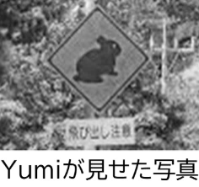
Amami-Oshima Island and Tokunoshima Island became a Natural World Heritage Site* last year. Amami rabbits live only on these islands, and they are in danger of extinction* now. One of the biggest reasons is car accidents*. This graph* shows how many car accidents with Amami rabbits happened every month over* 20 years. There are twice as many car accidents in September as in August because Amami rabbits are more active* from fall to winter. The accidents happened the most in December because people drive a lot in that month. Look at this picture. People there started to protect them. They put this sign* in some places on the islands. It means, “Car drivers must
here.” It is very important for all of us to do something for them.

注 Natural World Heritage Site 世界自然遺産 danger of extinction 絶滅の危機 car accidents 自動車事故
graph グラフ over ～ ～の間（ずっと) active 活発な sign 標識
１ 下線部 This graph として最も適当なものを下のア～エの中から一つ選び，その記号を書け。
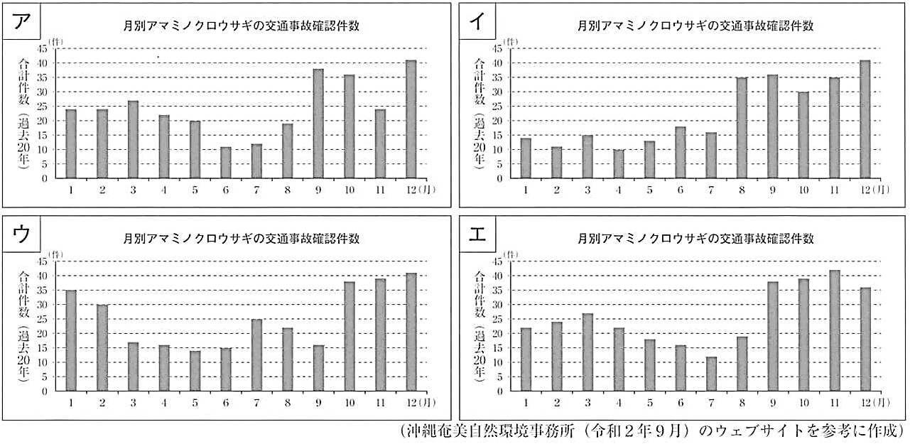
２ 本文の内容に合うように に適切な英語を補って英文を完成させよ。

解答
１ ア
２ be careful of Amami rabbits

