鹿児島県-大問３-２ |   2022年 公立高校入試
※QRコードを読み込むと，英文と連動した音声再生ができます（スマホにも対応）

中学校に留学中のEllenは，クラスの遠足で訪れる予定のサツマ水族館（Satsuma Aquarium）の利用案内を見ながら，同じクラスのMikaと話をしている。次の対話文を読み，あとの問いに答えよ。
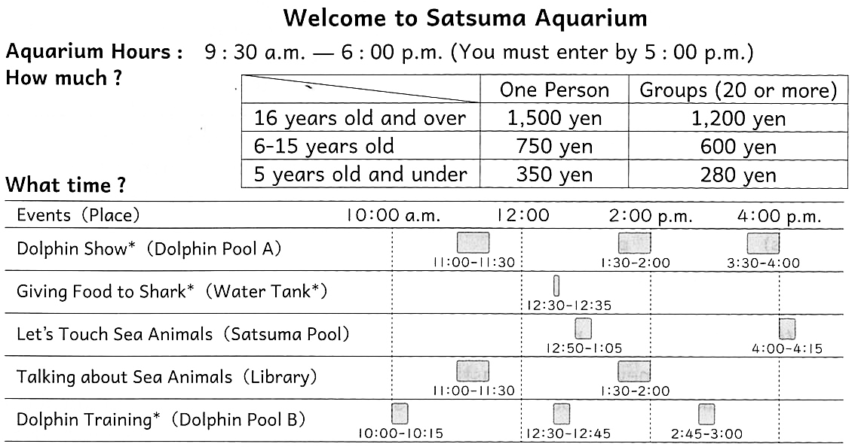

注 Dolphin Show イルカショー shark サメ tank 水そう Dolphin Training イルカの訓練

Ellen: Hi, Mika！ I'm looking forward to visiting the aquarium tomorrow. I want to check everything. First, how much should I pay to enter?
Mika: There are 40 students in our class and we are all 14 or 15 years old, so everyone should pay（ ① ）yen. But our school has already paid, so you don't have to pay it tomorrow.
Ellen: OK. Thank you. Next, let's check our plan for tomorrow. We are going to meet in front of the aquarium at 9:30 a.m. In the morning, all the members of our class are going to see “Dolphin Training” and “Talking about Sea Animals.” In the afternoon, we can choose what to do. Then, we are going to leave the aquarium at 2:30 p.m.
Mika: That's right. What do you want to do in the afternoon?
Ellen: I want to enjoy all the events there. So let's see “( ② )” at 12:30 p.m. After that, we will enjoy “( ③ ),” and then we will see “( ④ ).”
Mika: That's the best plan! We can enjoy all the events before we leave!
１ ( ① ）に入る最も適当なものを下のア～エの中から一つ選び，その記号を書け。
ア 350 イ 600 ウ 750 エ 1,200
２ ( ② ）～（ ④ ）に入る最も適当なものを下のア～エの中からそれぞれ一つずつ選び，その記号を書け。
ア Dolphin Show イ Giving Food to Shark
ウ Let's Touch Sea Animals エ Dolphin Training

解答
１ イ
２ ②イ ③ウ ④ア

