鹿児島県-大問４ |   2022年 公立高校入試
※QRコードを読み込むと，英文と連動した音声再生ができます（スマホにも対応）

次の英文を読み，問１～問６に答えなさい。
There is a small whiteboard on the refrigerator* at Sarah's house. At first, her mother bought it to write only her plans for the day, but it has a special meaning for Sarah now.
When Sarah was a little girl, she helped her parents as much as she could at home. Her parents worked as nurses. Sarah knew that her parents had many things to do.
When Sarah became a first-year junior high school student, she started to play soccer in a soccer club for girls. Her life changed a lot. She became very busy. Sarah and her mother often went shopping together, but they couldn't after Sarah joined the club. She practiced soccer very hard to be a good player.
One morning, her mother looked sad and said, “We don't have enough time to talk with each other, do we?” Sarah didn't think it was a big problem because she thought it would be the same for other junior high school students. But later ①she remembered her mother's sad face again and again.
Sarah was going to have a soccer game the next Monday. She asked her mother, “Can you come and watch my first game?” Her mother checked her plan and said, “I wish I could go, but I can't. I have to go to work.” Then Sarah said, “You may be a good nurse, but you are not a good mother.” She knew that it was mean*, but she couldn't stop herself.
On the day of the game, she found a message from her mother on the whiteboard, “Good luck. Have a nice game!” When Sarah saw it, she remembered her words to her mother. “They made her very sad,” Sarah thought. ②She didn't like herself.
Two weeks later, Sarah had work experience at a hospital for three days. It was a hospital that her mother once worked at. The nurses helped the patients* and talked to them with a smile. She wanted to be like them, but she could not communicate with the patients well.
On the last day, after lunch, ③she talked about her problem to a nurse, John. He was her mother's friend. “It is difficult for me to communicate with the patients well,” Sarah said. “It's easy. If you smile when you talk with them, they will be happy. If you are kind to them, they will be nice to you. I remember your mother. She was always thinking of people around her,” John said. When Sarah heard his words, she remembered her mother's face. She thought, “Mom is always busy, but she makes dinner every day and takes me to school. She does a lot of things for me.”
That night, Sarah went to the kitchen and took a pen. She was going to write ④her first message to her mother on the whiteboard. At first, she didn't know what to write, but Sarah really wanted to see her mother's happy face. So she decided to write again.
The next morning, Sarah couldn't meet her mother. “Mom had to leave home early. Maybe she hasn't read my message yet,” she thought.
That evening, Sarah looked at the whiteboard in the kitchen. The words on it were not Sarah's, instead she found the words of her mother. “Thank you for your message. I was really happy to read it. Please write again.” Sarah saw her mother's smile on the whiteboard.
Now, Sarah and her mother talk more often with each other, but they keep writing messages on the whiteboard. It has become a little old, but it acts* as a bridge between Sarah and her mother. They may need it for some years. Sarah hopes she can show her true feelings to her mother without it someday.
注 refrigerator 冷蔵庫 mean 意地の悪い patient(s) 患者 act(s) 作用する，働く

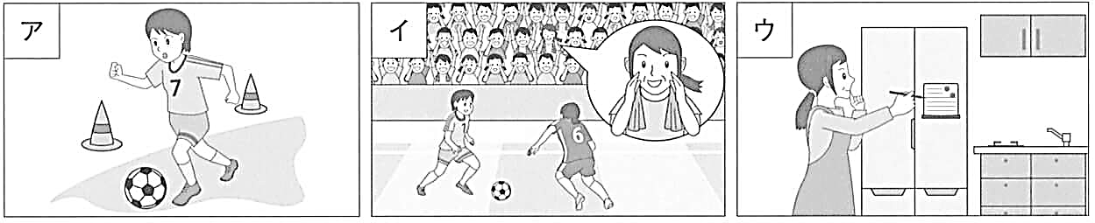
問１ 次のア～ウの絵は，本文のある場面を表している。本文の内容に合わないものを一つ選び，その記号を書け。
問２ 下線部①に関して，次の質問に対する答えを本文の内容に合うように英語で書け。
Why did her mother look sad when she talked to Sarah?
問３ 下線部②の理由として最も適当なものを下のア～エの中から一つ選び，その記号を書け。
ア いつも仕事で忙しい母に代わって，Sarahが家事をしなければならなかったから。
イ Sarahのホワイトボードのメッセージを読んで，母が傷ついたことを知ったから。
ウ 母が書いたホワイトボードのメッセージの内容にSarahがショックを受けたから。
エ Sarahは，励ましてくれる母に対してひどいことを言ったことを思い出したから。
問４ 下線部③に関して，SarahがJohnから学んだことを本文の内容に合うように40字程度の日本語で書け。
問５ 下線部④のメッセージとなるように，Sarahに代わって下の 内に15語程度の英文を書け。２文以上になってもかまわない。
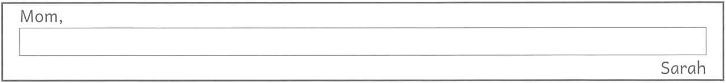
問６ 本文の内容に合っているものを，下のア～オの中から二つ選び，その記号を書け。
ア Sarah and her mother often used the whiteboard to write their plans from the beginning.
イ Sarah helped her parents do things at home before she began playing soccer with her club.
ウ During the job experience at the hospital, Sarah talked with John on her last day after lunch.
エ Sarah wrote her first message to her mother on the whiteboard, but her mother did not answer her.
オ Sarah can talk with her mother now, so she doesn't write messages on the whiteboard.

解答
問１ イ
問２ （例）They didn't have enough time to talk with each other.
問３ エ
問４ 笑顔で話せば相手もうれしく感じ，親切にすれば相手も優しくしてくれるということ。
問５ （例）Thank you for everything you've done for me. You're the best mother in the world.
問６ イ，ウ

