京都府(中)-大問２ |   2022年 公立高校入試
※QRコードを読み込むと，英文と連動した音声再生ができます（スマホにも対応）

次の英文は，高校生のまゆ（Mayu）と留学生のローザ（Rosa）が交わしている会話と寺院に関する特集記事（feature article）である。

Mayu: Hi, Rosa. Emma, one of my friends in Australia, will come to Japan next month. Emma and I will spend one day together. I want to take her to some temples in our city. You and I visited some temples in our city together this summer vacation, so tell me which temples we should visit.
Rosa: OK. Well, I think you should visit Ume Temple. I enjoyed the beautiful *garden at the temple and the *wind bell event very much. We drew a picture on a wind bell for each other at the event.
Mayu: I like the picture of the dolphin you drew for me. I often look at it.
Rosa: I also like the wind bell you gave me. I like the picture of the cat.
Mayu: Emma likes drawing pictures, so we will visit the temple and enjoy the event. How about Yuzu Temple?
Rosa: I enjoyed the beautiful pond there and took many pictures of it. I sent them to my sister in my country and she liked the temple, too. She always says she will visit the temple if she has a chance to visit this city. This feature article in this magazine says the same thing.
Mayu: Yes. I also liked the pond, so we will visit this temple, too.
Rosa: How about Hasu Temple? The large tree at the temple was nice. And the *sakura-flavored ice cream we ate at the famous shop near the temple was good.
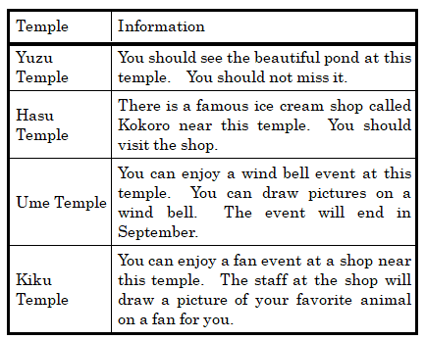
Mayu: This feature article says the name of the ice cream shop. I want to eat the ice cream again, but we have to walk a lot from the station to the temple. If we visit this temple, we will get very tired. We also won't have much time to visit another temple. I want to take Emma to other temples.
Rosa: I see. Well, I liked the temple we visited with your mother by car, too. The temple isn't in this feature article, but we enjoyed the night *view of this city from the temple. I'll never forget. We also drank Japanese tea at the famous tea shop near the temple. It was so good.
Mayu: That is Fuji Temple. My parents can't come with us on that day and it takes a lot of time to go there by train or by bus. Emma wants to visit two or three temples on that day, so we should not go there.
Rosa: Wait, this feature article says that the wind bell event will end this month. How about this temple? You can enjoy a *fan event near this temple. You can buy a fan with a picture of your favorite animal on it.
Mayu: That will be a nice memory for Emma, so we will visit the temple and won't visit Ume Temple.
Rosa: I hope you will have a good day.

（注) garden 庭園 wind bell 風鈴 sakura-flavored さくら風味の view 景色 fan 扇子

Question
１．Mayuは，誰と一緒にどこへ行く予定ですか？
２．Rosaはどの寺院を訪れることを勧めていますか？
３．MayuがHasu寺に行くことを諦めたのはなぜですか？
４．扇子イベントが楽しめる寺はどこですか？

Answer
１．Emmaと一緒に，市内のいくつかの寺院を訪れる予定。
２．Ume寺
３．時間的に余裕がないため。
４．Kiku寺

※QuestionとAnswerは，ＡＩが作成しました。

