京都府(前)-大問２ |   2022年 公立高校入試
※QRコードを読み込むと，英文と連動した音声再生ができます（スマホにも対応）

次の英文は，高校生の大地（Daichi）と留学生のカーター（Carter）が交わしている会話である。

Carter: What are you looking at on your phone?
Daichi: I am looking at a list of running events around our city. I checked the running events held during these two months, and I found these five running events. I'm thinking of joining one of them. Do you want to try with me?
Carter: Oh, yes! Which event will we join among these five running events?
Daichi: Well, I joined this running event last year. When I was running, I saw a beautiful river. That was wonderful. I want to join this running event again. How about you?
Carter: Well, oh, I'm sorry. I can't join the events held on Saturday because I have a guitar lesson every Saturday.
Daichi: I see. Then, how about this one? The list says that we can choose one *category from four categories. The event will start at 3 p.m. to see the *sunset.
Carter: That sounds nice! I want to try it.
Daichi: Oh, look! The list says that people who are twenty years old or more can join it, so we can't do it because we are seventeen years old. We need to find another one.
Carter: So, we have to choose the running events held in December, right?
Daichi: That's right. Which category do you want to join? I ran five *kilometers last year, but I'll try a longer *distance category this year.
Carter: This is my first time to join a running event and it will be difficult for me to try a long distance category. I think a shorter one like three kilometers or five kilometers is better.
Daichi: I agree. How about this event? Are you free on that day?
Carter: No, I will go to ABC Stadium to watch a soccer game with one of my friends from the morning on the day. The running event will start in the morning, so I can't join it.
Daichi: I see. Let's join another one.
Carter: What do you think about this running event?
Daichi: Are you talking about Muko *Marathon? My brother joined it last year. He said it is so hard for people who don't have much experience of running because we have to go up and down in a mountain.
Carter: Really? Then, I think we should choose this running event.
Daichi: I think so, too. Finally, we have decided the running event we will join! Which category will you run in?
Carter: I'll try the three kilometer category, and you?
Daichi: I'll choose the ten kilometer category. Do you have good shoes for running?
Carter: No, I don't. It's Friday today, so let's go to buy new shoes for the event tomorrow.
Daichi: OK.
(注) category 部門 sunset 夕焼け kilometer キロメートル distance 距離 marathon マラソン
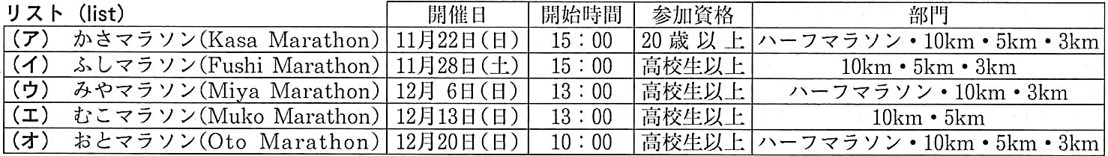

Question
１．Daichiがマラソン大会のリストを見ていたのはなぜですか？
２．Carterが土曜日に開催されるマラソン大会に参加できないのはなぜですか？
３．DaichiとCarterは，どのマラソン大会に参加することに決めましたか？
４．Carterは（ ）キロメートルのカテゴリーに参加することにし，Daichiは（ ）キロメートルのカテゴリーに参加することにしました。
５．会話の後，２人は何を買いに行くことにしましたか？

Answer
１．マラソン大会に参加したかったため。
２．ギターのレッスンがあるため。
３．Muko Marathon（むこマラソン）
４．３，10
５．ランニング用の新しいシューズ

※QuestionとAnswerは，ＡＩが作成しました。

