大分県-大問４ |   2022年 公立高校入試
※QRコードを読み込むと，英文と連動した音声再生ができます（スマホにも対応）

次の英文は，中学３年生のTakashi，Aya，Emi，Yutaの班が英語の授業で，自分たちが調べたことを発表している場面のものです。

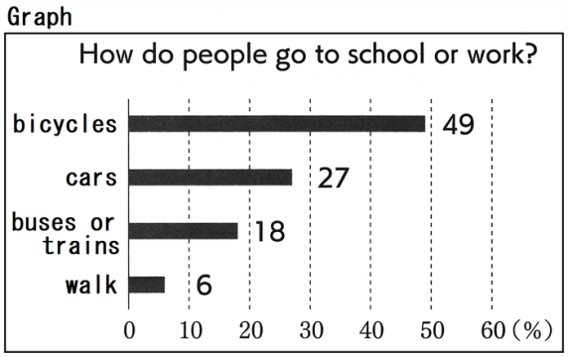
Takashi: What will our city look like in the future? We hope our city will be a better place for everyone. Today our group will tell you about “A better life with bicycles.”
Aya: Do you know the city, *Copenhagen? It is the *capital city of *Denmark. Please look at this graph. It shows how people in this city go to school or go to work. About half of the people in the city use bicycles. Using cars comes next, and 18% of them take buses or trains. The other people walk to school or work.
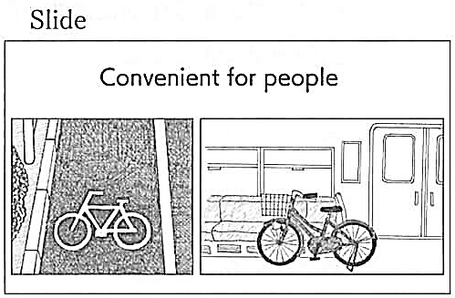
Emi: Why are bicycles popular in this city? Please look at this slide. I am surprised to find these things. For example, there are some roads and traffic lights only for bicycles. Also, people can bring their bicycles with them on the train. This city is convenient for people who use bicycles. So a lot of people can enjoy riding bicycles.
Yuta: Using bicycles has some good points for our lives. I'll show you ④three slides. The first slide shows that riding bicycles is good for the environment. The *amount of CO₂ is smaller when we use bicycles. So if we go to school or work by bicycle, it will keep the environment clean. The second slide shows that riding bicycles gives us a chance to *exercise. I'm afraid people don't have enough time to exercise. However, if we often ride bicycles, we will make our health better. The last slide shows that our city is trying to create a new style of *sightseeing. Our city has beautiful *nature and some famous places. More people can come to our city and visit those famous places by bicycle. They will enjoy visiting those places.
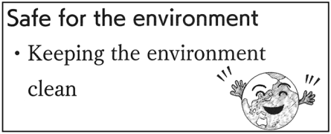
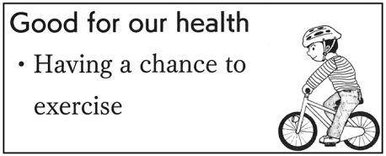
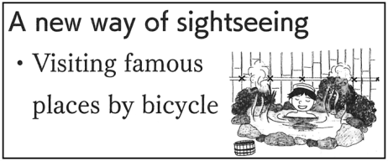

Takashi: Using bicycles will give us a good chance to make our city better for the environment and the people. To enjoy our lives with bicycles, we should be careful of *accidents when we ride bicycles. Wearing a *helmet is one of the ways. There are other ways to be *safe when we ride bicycles. What should you do? Let's think about it. Thank you for listening!

(注) Copenhagen コペンハーゲン capital city 首都 Denmark デンマーク
amount of CO₂ 二酸化炭素の量 exercise 運動する sightseeing 観光 nature 自然
accidents 事故 helmet ヘルメット safe 安全な

Question
１．Ayaが話題にしている都市はどこですか？
２．Emiによると，コペンハーゲンで自転車が人気なのはなぜですか？
３．Yutaによると，自転車に乗ることの良い点は何ですか？
４．Takashiは，自転車に乗る時の注意点について何を言っていますか？
５．このグループが伝えたいことは何ですか？

Answer
１．デンマークの首都であるコペンハーゲン。
２．自転車専用の道路や信号があり，電車内に自転車を持ち込むことができるから。
３．自転車に乗ることで環境に良い影響を与え，運動不足を解消でき，観光に自転車が使えることなど。
４．ヘルメットを着用するなど，安全対策について考えることが必要。
５．自転車を使うことで都市をより良くし，生活を豊かにすることができる。

※QuestionとAnswerは，ＡＩが作成しました。

