大阪府Ａ-大問３ |   2022年 公立高校入試
※QRコードを読み込むと，英文と連動した音声再生ができます（スマホにも対応）

次は，高校生の義雄（Yoshio)，アメリカからの留学生のサラ（Sarah)，久保先生（Mr. Kubo）の３人が交わした会話の一部です。

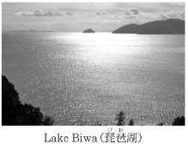
Yoshio: Hello, Sarah. Look at this picture. This is the largest lake in Japan. It is called Lake Biwa. I went there with my aunt last Sunday.
Sarah: Oh, Yoshio. Sounds nice.
Yoshio: Have you ever been there?
Sarah: No, I haven't. I want to go there someday.
Mr. Kubo: Hello, Yoshio and Sarah. What are you talking about?
Sarah: Hello, Mr. Kubo. Yoshio went to Lake Biwa with his aunt.
Mr. Kubo: Really? How was it, Yoshio?
Yoshio: When I arrived at Lake Biwa, I was surprised at its size. It was very big.
Mr. Kubo: Sounds fun. When I visited it for the first time, I thought so, too.
Sarah: I can understand your feelings. When we visit a place, we can feel something new about it, right?
Yoshio: That's true. The lake looked like the ocean!
Mr. Kubo: Sarah, do you have such an experience?
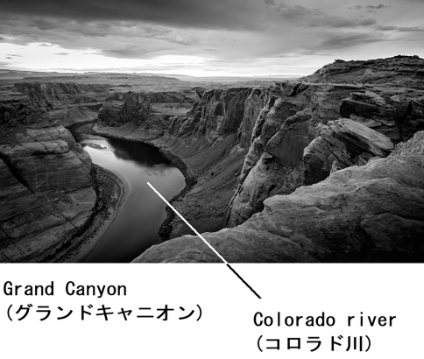
Sarah: Yes, I do. When I was in America, I visited Grand Canyon and I felt like that.
Mr. Kubo: Please tell us about your experience.
Sarah: OK. I will show you a picture.
Yoshio: Wow! Is it a mountain?
Sarah: It's not a mountain. Grand Canyon is a kind of valley. Before I visited Grand Canyon, I learned how it was made
Mr. Kubo: Oh, tell us more.
Sarah: OK. A long time ago, a river started to flow. The river has been carving Grand Canyon for many years.
Yoshio: A river?
Sarah: Yes. Yoshio, can you find a river in this picture?
Yoshio: Yes, I can. Oh, wait! Do you mean that this river made Grand Canyon?
Sarah: That's right! It is Colorado River. It started carving Grand Canyon about five or six million years ago. And, the river still keeps carving Grand Canyon.
Yoshio: So, we can say that Grand Canyon is made by a river.
Sarah: That's right, Yoshio.
Mr. Kubo: Sarah, when did you go to Grand Canyon?
Sarah: I went there three years ago.
Mr. Kubo: I remember that in 2019, special events were held at Grand Canyon, right?
Sarah: Yes. Grand Canyon became a National Park in 1919. 100 years passed after that, so special events like concerts, art lessons, and night tours were held in 2019. People from all over the world joined the special events. I joined one of them with my family.
Yoshio: Sounds fun.
Sarah: Before I visited Grand Canyon, I learned many things about it and I thought that I knew a lot about it. But, when I saw Grand Canyon in front of me, I felt something more than the things I learned. Grand Canyon was really great. I could understand that Grand Canyon was really great only by visiting it. I noticed this through my experience.
Mr. Kubo: Thank you for telling an interesting story. I really enjoyed listening to it.
Yoshio: I enjoyed it, too. I want to visit Grand Canyon someday.
(注) valley 谷 flow 流れる carve 削る National Park 国立公園

Question
１．Yoshioは誰と一緒に琵琶湖に行きましたか？
２．Sarahがアメリカで訪れた場所はどこですか？
３．グランドキャニオンの谷はどのようにできましたか？
４．グランドキャニオンが国立公園になったのはいつですか？
５．グランドキャニオンを実際に訪れて，Sarahは何に気付きましたか？

Answer
１．彼の叔母さん
２．グランドキャニオン
３．コロラド川によって長い時間をかけて削られた。
４．1919年
５．とても素晴らしい場所だと感じ，実際に訪れないと分からないことがあると気付いた。

※QuestionとAnswerは，ＡＩが作成しました。

