大阪府Ｂ-大問２ | 2022年 公立高校入試
※QRコードを読み込むと，英文と連動した音声再生ができます（スマホにも対応）

次は，高校生の雅代（Masayo）が英語の授業で行ったスピーチの原稿です。

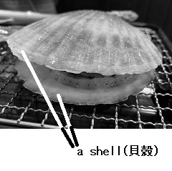
Do you like scallops? A scallop is a kind of shellfish with two shells. Scallops are delicious and they are my favorite food. One day, after I ate them for dinner, I saw an amazing scene on TV. Many scallops were swimming and jumping in the sea! When I saw it, I was very surprised because I didn't know that shellfish could move quickly. I thought, “How can they move like that?” I became interested and looked for information on the Internet. By reading some reports, I understood how they could move.
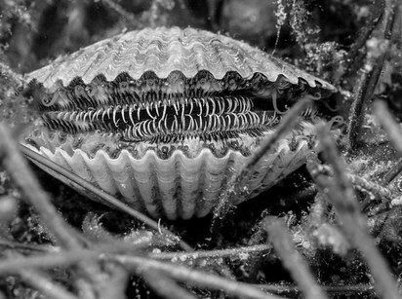
How do scallops move? Scallops move by taking water into their shells and pushing it out quickly. They can go forward or turn by changing how they push the water out. For example, if they want to go to the right, they push the water out to the left. This means scallops can move by pushing the water out quickly to the opposite side of the way they want to go. By using this way of moving, when other sea animals try to eat scallops, scallops swim away from them to protect their lives. Scallops also move to find a good place for getting their food, and some of them move 500 meters in one night. Scallops are the most active of all shellfish with two shells.
Well, I want to ask your experience. Have you tried to open the two shells with your hands? When I did that for the first time, I noticed it was not easy. It was hard work and it took a long time, and finally I couldn't. I remembered this experience, and wanted to know why shellfish could keep closing their shells. So, I went to a library, read some books, and then found the answer to the question.
According to the books, they have a strong muscle to keep closing their shells. When shellfish with two shells live in the ocean, to keep closing their shells, they usually keep using the strong muscle. For us, it is like holding a heavy bag for a long time. If we do that, we will be very tired because it needs a lot of energy. However, shellfish with two shells don't become tired. Their muscle needs very little energy to keep closing their shells. It has a special protein that we don't have. To keep closing the shells, the special protein connects with each other. When the proteins are in that condition, shellfish with two shells don't become tired by using the muscle. This means, if we had the same muscle that shellfish with two shells have, the shellfish are not tired by holding a heavy bag for a long time. When I learned about this, I thought it was very interesting and also very useful.
Now I know shellfish like scallops are not just delicious food. Scallops are active shellfish which can move quickly. In addition, I understand the muscle of shellfish with two shells has an amazing power that we don't have. If science and technology improve more in the future, we can use the power of the strong muscle. I think it will help people carry some heavy things or take care of people who need help. I believe we can support many people with difficulties. Thank you for listening.
（注) shellfish (生き物としての）貝（複数形もshellfish) muscle 筋肉 protein タンパク質
Question
１．ホタテガイはどのようにして移動しますか？
２．Masayoがホタテガイの動きに興味を持ったのはなぜですか？
３．Masayoはホタテガイの貝殻を手で開けることができましたか？
４．ホタテガイが貝殻を閉じたままでいられるのはなぜですか？
５．ホタテガイの強力な筋肉は，どのようなことに応用できるかもしれませんか？

Answer
１．貝殻に水を取り込み，急速に排出することで移動する。水をどのように排出するかによって前進や方向転換ができる。
２．テレビでホタテガイが海で泳いで跳ねるのを見て，速く動くことに驚いたから。
３．時間をかけたが，結局できなかった。
４．貝殻を閉じるための筋肉が強力で，特別なタンパク質が関与しているから。
５．ホタテガイの強力な筋肉の力を利用して重いものを運んだり，支援が必要な人々を助けたりすることができるかもしれない。

※QuestionとAnswerは，ＡＩが作成しました。

