奈良県-大問４ | 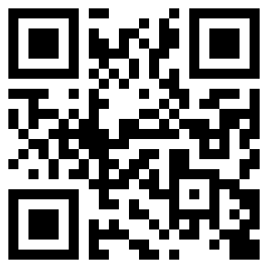  2022年 公立高校入試
※QRコードを読み込むと，英文と連動した音声再生ができます（スマホにも対応）

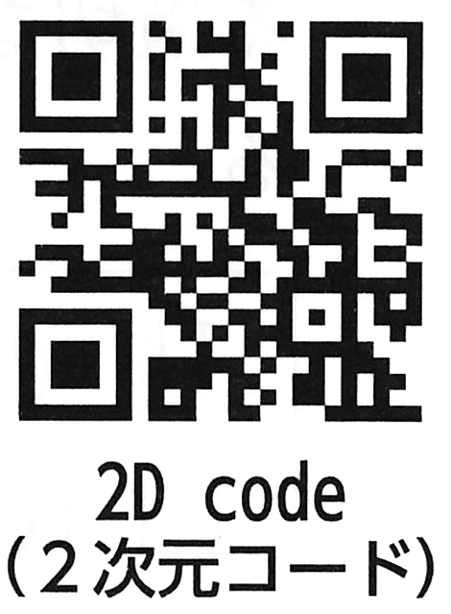
[１] Have you ever seen the 2D codes which have a special mark on the corners? For example, you can find the 2D codes in your textbooks. When you scan them with a tablet computer, you can see pictures or watch videos. Today, a lot of people around the world use them in many different ways. This type of 2D code was invented by engineers at a car parts maker in Japan.

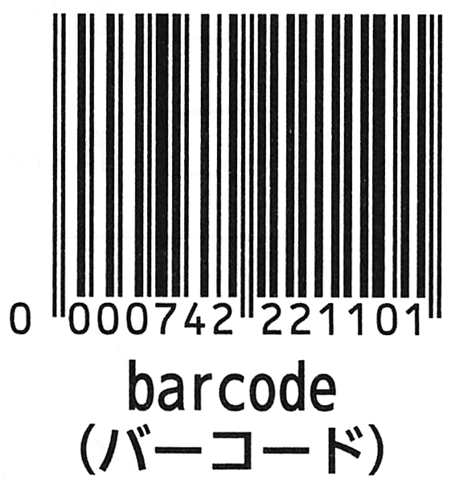
[２] When cars are produced, many kinds of parts are needed. Car parts makers have to manage all of the car parts. About 30 years ago, car companies needed to produce more kinds of cars, and car parts makers had to manage many different kinds of car parts for each car. At that time, they used barcodes to manage the car parts, but they could not put a lot of information in one barcode. So, they used many barcodes. Workers had to scan many barcodes. A worker at a car parts maker had to scan barcodes about 1,000 times a day. It took a lot of time to scan them. The workers needed some help to improve their situation.

[３] The engineers at a car parts maker in Japan knew the situation of the workers. They started to learn about 2D codes because 2D codes can contain more information than barcodes. There were already some types of 2D codes in the U.S. One type could contain a lot of information, but it took a lot of time to scan that type. Another type was scanned very quickly, but it contained less information than other types. The engineers at the car parts maker did not use these types. They decided to create a new type of 2D code which had both of those good points. The engineers needed a long time to create this new type which could be scanned quickly. Finally, they thought of an idea. They thought, “If a 2D code has a special mark on the three corners, it can be scanned very quickly from every angle.” In this way, the new type of 2D code with special marks was invented by the engineers at a car parts maker in Japan.

[４] How did people around the world start to use the new type of 2D code? After car parts makers started to use it, other businesses also started to pay attention to it. For example, a mobile phone company started to use it to help people visit websites directly by using their mobile phone cameras. By scanning a 2D code with their mobile phones, users can get a lot of information quickly and easily. With this technology, people learned that the new type of 2D code was very useful.

[５] Today, the 2D code invented by the engineers at a car parts maker in Japan has become popular in people's lives around the world. It was invented by engineers to help workers, but now, it helps people around the world a lot.
(注) mark ：目印 scan ：読み込む tablet computer ：タブレットコンピュータ type ：種類engineer ：エンジニア
part ：部品 maker ：製造業者 manage ：管理する put :（情報などを）入れるworker ：労働者 situation ：状況
contain ：含む quickly ：素早く think of ：～を思いつく angle ：角度 business ：事業
pay attention to ：～に注目する mobile phone ：携帯電話 directly ：直接 user ：利用者

Question
１．教科書の２次元コードをスキャンすると，何をすることができますか？
２．2次元コードは誰によって発明されましたか？
３．バーコードに比べて，2次元コードにはどのような利点がありますか？
４．2次元コードは最初，何のために発明されましたか？
５．2次元コードはどのように人々の生活を変えていますか？

Answer
１．写真を見たり，ビデオを見ることができる。
２．日本の自動車部品メーカーのエンジニア。
３．多くの情報を格納することができる。
４．車の部品メーカーで働く労働者が，部品の情報をスキャンするため。
５．スマートフォンやタブレットを使って簡単に情報を得ることができるようになり，ビジネスの促進や消費者の便利さに貢献している。

※QuestionとAnswerは，ＡＩが作成しました。

