山形県-大問３ |   2022年 公立高校入試
※QRコードを読み込むと，英文と連動した音声再生ができます（スマホにも対応）

中学生の千恵（Chie）さんは，姉妹・友好都市（sister city）に興味を持ち，姉妹・友好都市提携（sister city relationship）について調べ，グラフ（graph)，表（table)，図（chart）にまとめました。
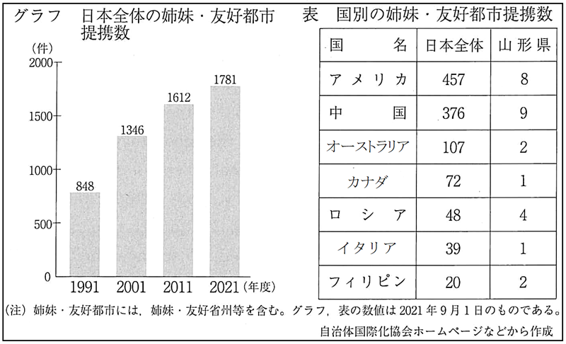

Chie: Last week, I met a lot of foreign people at an event, and I heard that my city has some sister cities in the world. One of them is your city in America. I wanted to know more about sister cities, so I made the graph after the event.
Bill: Wow! There are so many sister city relationships in Japan. The number is increasing.
Chie: I was surprised, too. Look at the table. Your country has many sister cities. In Japan, there are more sister city relationships with Canada than with Italy.
Bill: That's right.
Chie: In Yamagata-ken, there are eight sister city relationships with America, and two with Australia.
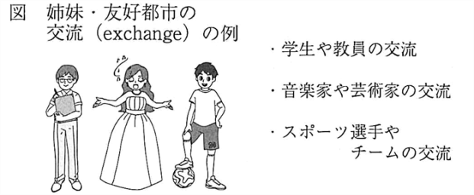
Bill: There is one with Italy, too. Chie, what does the chart tell us?
Chie: It shows exchanges between sister cities. For example, many cities send students to their sister cities. Your city in America has the exchange with my city, so you came to Japan. ①There are many good points of the exchange for you, right?
Bill: Yes. I can make new friends and learn a different culture.
Chie: That's good. I could learn a lot from you, too.

Question
１．Chieはイベントで何について聞きましたか？
２．日本の都市が，最も多くの姉妹都市を持つ国はどこですか？
３．山形県の都市が，最も多くの姉妹都市を持つ国はどこですか？
４．姉妹都市との交流活動にはどのような良い点がありますか？

Answer
１．彼女が住んでいる街にはいくつかの姉妹都市があること。
２．アメリカ
３．中国
４．学生を相手方の都市に送り出すなどの交流があり，新しい友人を作ったり，異なる文化を学ぶことができる。

※QuestionとAnswerは，ＡＩが作成しました。

