岐阜県-大問３ |   2022年 公立高校入試
※QRコードを読み込むと，英文と連動した音声再生ができます（スマホにも対応）

次の英文は，真衣( Mai )が，平均睡眠時間( average sleep hours )について，英語の授業で発表したときのものです。

Some of you may count sheep when you can't sleep. Do you know why? The sound “sheep” and “sleep” are similar, so counting sheep may be one of the good ways to sleep. Sleep is important for all of us. We can't live without sleeping. But many Japanese people say that they want to sleep longer if they can. How many hours do people sleep in Japan and around the world?
Look at the graph. This is the average sleep hours in Japan and the four other countries in 2018. You can see that people in Japan sleep 7 hours and 22 minutes on average. You may think that 7 hours of sleep is enough, but when you look at the graph, you will find that it is very short. The graph shows that people in China sleep the longest of all, and people in India sleep almost as long as people in America. People in Germany sleep shorter than people in those three countries, but I was surprised that they sleep about one hour longer than us.
Now look at the table. This is the average sleep hours of people in Japan in 2007, 2011 and 2015. What can you see from this table? In 2007, about one third of the people sleep 7 hours or longer. But in 2015, almost 40% of the people sleep less than 6 hours, and only about a quarter of the people sleep 7 hours or longer. It means that more people in Japan sleep shorter than before.
You may watch TV or use the Internet until late at night. But we need to sleep longer especially when we are young. Sleep is important not only for our bodies but also for our minds. To make our bodies and minds more active, let's go to bed earlier and count sheep tonight.
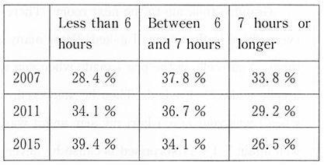
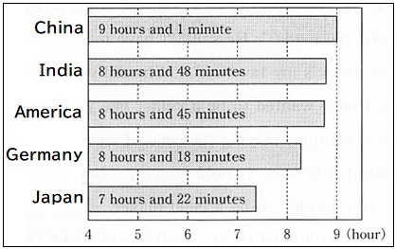

(注) sheep : 羊 similar : 似ている on average : 平均して one hour longer : １時間長く table : 表mind : 心

Question
１．日本人は平均して１日にどのくらい睡眠をとっていますか？
２．インド，ドイツ，中国，日本での人々の平均睡眠時間について，長い順に並び替えなさい。
３．2007年から2015年の間に，日本人の平均睡眠時間はどうなりましたか？
４．睡眠は体だけでなく（ ）にとっても重要です。

Answer
１．7時間22分
２．中国→インド→ドイツ→日本
３．減少した。
４．心（精神）

※QuestionとAnswerは，ＡＩが作成しました。

