岡山県(特)-大問５ | 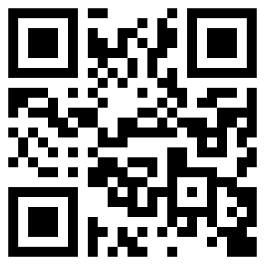  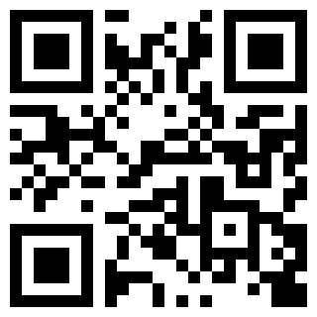  2022年 公立高校入試
※QRコードを読み込むと，英文と連動した音声再生ができます（スマホにも対応）

Can you imagine your life without medicine ? Many people around the world cannot buy medicine or go to a doctor when they are sick. Here's a story about one Japanese woman helping those people in Africa.
When she was a university student, she became a volunteer in India. She learned that there were a lot of poor people who could not get medical care. After that, she went to Niger to join another volunteer work. Though she kept telling people there that medicine was important, they still could not get it. There were some reasons for that. Medical costs were too high for them. People in remote villages also had to use time and pay money to get to hospitals in cities. People had to wait for hours at hospitals, too. She began to think, “What can I do to carry medicine to the people who need it ? How can I make a sustainable system which local people can use?” To find the answers, she went back to Japan and studied more about medicine and business. Finally, she got an idea called the okigusuri system.
Have you ever heard of okigusuri ? It's the traditional Japanese "use first, pay later" medicine system which started about 300 years ago. During the Edo period, people could not go to cities easily and families were quite large. So people used okigusuri boxes full of medicine. These boxes were put at homes and money was collected after medicine was used. This system became popular. The life in Niger now reminded her of life in the Edo period. She thought that okigusuri was useful for people in Niger, too.
In 2014, she made an NPO team with other members to spread the okigusuri system in Africa. Her team chose the medicine which local people needed and put it in their okigusuri boxes. Then its members started to transport the boxes to remote villages. Transporting medicine took a lot of time because okigusuri was a new system. It was difficult and expensive. However, later more villages joined this system and the transport procedure became easier. That made the transport costs lower. The team also gave people in those villages in Africa medical advice. Now the people there can live with safe medicine because of the okigusuri system. This system helps people solve some medical problems.
She said, “All the people in Africa should get medicine. In the future, I hope that local people can take care of themselves in Africa by using this okigusuri system. That's my goal. For their better lives, we really want more people in the world to know about our activity and to support us.” Her dream has just begun.

〔注〕 medicine 薬 medical 治療の，医療の Niger ニジェール（アフリカの国名) cost 費用
remote 離れたところにある village 村 pay ～ ～を支払う sustainable 持続可能な
business ビジネス，経済，経営 the Edo period 江戸時代 NPO 非営利組織 spread ～ ～を広める
transport 輸送する，輸送 procedure 手順，方法 safe 安全な

Question
１．この女性が，医療活動を始めたのはなぜですか？
２．アフリカの人々が医療にアクセスできないのはなぜですか？
３．彼女が日本に戻ったのはなぜですか？
４．彼女がアフリカで始めたokigusuriシステムとは何ですか？
５．彼女の目標は何ですか？

Answer
１．アフリカで，医療を必要とする人々を支援するため。
２．遠隔地に住む人々が都市の病院に行くために時間とお金を使わなければならず，病院での待ち時間も長いため。
３．医療とビジネスについて勉強するため。
４．日本の伝統的な「先に使用して後で支払う」医薬品システムで，医薬品が入った箱が家に置かれ，使用後にお金が回収される。
５．アフリカの人々が自分たちで医療を管理できるように，okigusuriシステムを使って多くの人々に医療支援を提供すること。

※QuestionとAnswerは，ＡＩが作成しました。

