岡山県-大問４ | 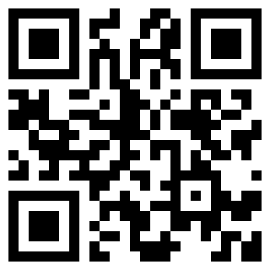  2022年 公立高校入試
※QRコードを読み込むと，英文と連動した音声再生ができます（スマホにも対応）

Glen先生の英語の授業で，中学生のTaku，Nick，Misakiが，自身の中学校における読書の状況についてのグラフ（graph）を見ながら，話し合いをしています。次の英文は，話し合いと，それを聞いてNahoが授業で書いたワークシートです。

■話し合い
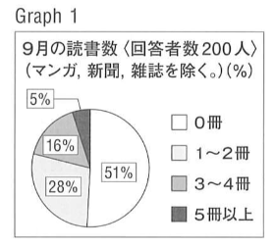
Mr. Glen: Look at Graph 1. This shows the results of the school survey that you answered. I found this last week. What can we learn from this graph?
Taku: About 100 students read no books in September.
Mr. Glen: Does it mean you don't have a reading habit?
Taku: Yes. We can see that by looking at that graph. Some students don't read books.
Nick: Really ? I don't think that is true. That graph shows the number of books that we read in September. We also need to see how many books the students read in other months.
Mr. Glen: With those data, we can see the changes between months. It is difficult to see everything only with Graph 1. To learn your reading habit, you need more data. Do you have any other ideas?
Misaki: We also need to consider when we answered the survey. We had our school festival in September, and we were busy then. I read books almost every month, but I didn't read any books in September.
Nick: That graph doesn't show that it was difficult for us to have time to read books then. We need to use the data carefully.
Taku: Now I understand. Mr. Glen, do you know why some students didn't read any books then? I think there are some causes of this. If we find them, we can think about ways to improve the situation.
Mr. Glen: OK, let's think about that. The survey asked the students why they didn't read any books in September. I made Graph 2 from the survey results. Now let's guess Reasons（X),（Y）and（Z）in Graph 2.
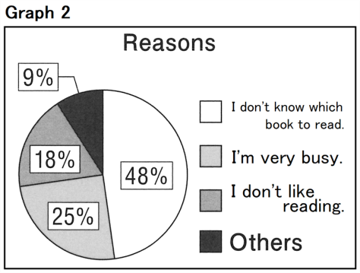
Taku: Maybe they're not interested in reading.
Misaki: Really ? Students often say that they are too busy. They say that reading takes a lot of time.
Nick: They don't know which book to read.
Mr. Glen: Now let's check. Nick's idea is Reason（X), Misaki's is Reason（Y), and Taku's is Reason（Z).
Taku: With Graph 2, we can see why they read no books in September.
Mr. Glen: It is difficult to find the true causes of this situation only by guessing. To find ways to solve a problem, we can use different data and ask “Why ? ” or “Is that really true?” many times. However, there are a lot of things to consider when we use data. What do we need to think about ? Please write your idea.

■Nahoが授業で書いたワークシート
I understand that it is important to have different data. When we use data, I think that it is also important to check that each data is right.. Some of the data may be wrong. If it is wrong, we can't find ways to improve the situation. We should not easily believe the data that we can get.

〔注〕survey アンケート調査 reading habit 読書習慣 data データ consider ～ ～を考慮する
cause 原因 situation 状況 wrong 誤っている

Question
１．9月に多くの生徒が読書をしなかった理由について，Takuはどのように考えていますか？
２．NickがTakuの発言に異議を唱えたのはなぜですか？
３．Misakiは，どのような理由で9月に本を読まなかったと述べていますか？
４．Mr. Glenがグラフ2を作成したのはなぜですか？
５．データを使用する際に考慮すべきことは何ですか？

Answer
１．生徒に読書習慣がないため。
２．他の月に読んだ本の数を知る必要があると考えたから。
３．学園祭があり忙しかったから。
４．生徒たちが9月に本を読まなかった理由を調べるため。
５．異なるデータを使用し，「なぜ？」「それは本当に正しいのか？」と問いかけること。

※QuestionとAnswerは，ＡＩが作成しました。

