愛媛県-大問５ |   2022年 公立高校入試
※QRコードを読み込むと，英文と連動した音声再生ができます（スマホにも対応）

中学生の武史 (Takeshi) と友紀 (Yuki) がジョーンズ先生 (Mr. Jones) と話をしている。

Mr. Jones: Hi, Yuki. Hi, Takeshi. How are you?
Takeshi: I'm fine, thank you. And you?
Mr. Jones: I'm fine, too. What are you talking about?
Yuki: About studying abroad. I'm going to study abroad next year.
Mr. Jones: Really? Where will you go?
Yuki: I'll go to America. I want to improve my English skills there.
Mr. Jones: How long will you stay there?
Yuki: For a year.
Takeshi: She says she wants to get a job that needs English. So studying abroad is good for her.
Yuki: I think people can learn a lot through studying abroad. But the percentage of Japanese students who are interested in it has gone down.
Takeshi: Here are two graphs about studying abroad. We found them on the Internet.
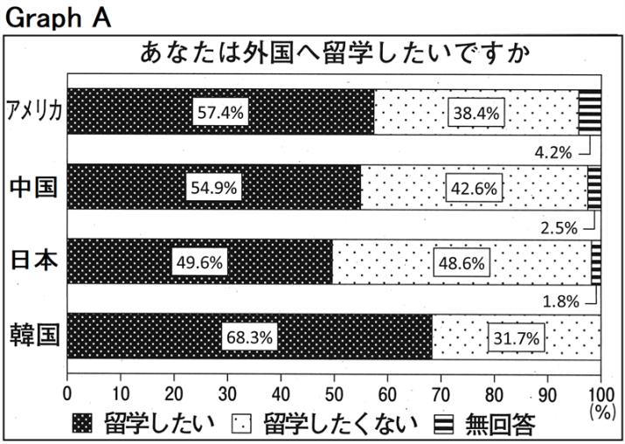
Mr. Jones: Oh, please explain them to me.
Takeshi: Sure. They show how high school students in Japan, America, China, and Korea feel about studying abroad. Graph A shows the result of the question: “Do you want to study abroad?” Japan has the highest percentage of students who don't want to do so.
Mr. Jones: I don't know why Japanese students don't want to study abroad.
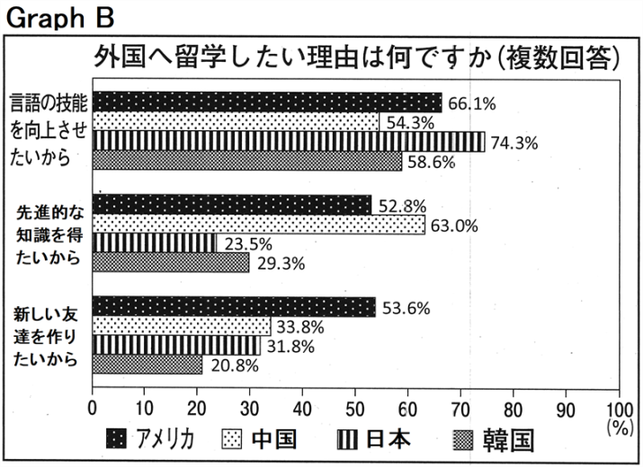
Takeshi: We found some reasons on the Internet. I'll tell you one of them. They think living alone in a foreign country is difficult for them.
Mr. Jones: That's not difficult for them. They don't have to worry about that. When I was young, I went to a foreign country alone to study. Many people there were so kind, and I had a good time.
Yuki: I hope I'll have such a wonderful time in America. Mr. Jones, please look at Graph B. It shows the result of the question: “Why do you want to study abroad?” In Japan, America, and Korea, the most popular reason is “I want to improve my language skills.” In China, the most popular one is “I want to get the advanced knowledge.” As for the reason: “I want to make new friends,” the percentage is higher in America than in the other countries.
Mr. Jones: That's interesting. I understand each country has a different characteristic.
Yuki: I also want to make new friends in America. Takeshi, do you want to study abroad?
Takeshi: Yes. I want to go to Australia in the future.
Yuki: Why?
Takeshi: Because I can learn a lot about tennis there. Many young people go there to learn it. My dream is to be a world tennis champion. Also, I have another reason. The player I want to meet lives there. I hope I can become like him. I want to improve my English skills there, too.
Mr. Jones: You have a big dream! I think studying abroad gives you the chance to learn many things.
Takeshi: I think so, too. Thank you very much, Mr. Jones.

(注) abroad 外国で skill(s) 技能 percentage 割合 explain ～ ～を説明する
China 中国 Korea 韓国 result 結果 reason(s) 理由 alone 一人で
advanced knowledge 先進的な知識 as for ～ ～について言えば
characteristic 特徴 champion チャンピオン chance 機会

Question
１．Yukiは何をするつもりですか？
２．日本の高校生が留学に興味がない理由は何ですか？
３．留学の理由で，「高度な知識を得たい」が最も高い国はどこですか？
４．留学の理由で，「新しい友達を作りたい」が最も高い国はどこですか？
４．Takeshiがオーストラリアに行きたいのはなぜですか？

Answer
１．来年留学するつもりで，アメリカに行きたいと思っている。
２．海外で一人暮らしをすることが難しいと思っているから。
３．中国
４．アメリカ
５．テニスについて学び，テニスの世界チャンピオンになりたいから。

※QuestionとAnswerは，ＡＩが作成しました。

