愛知県Ａ-大問４ | 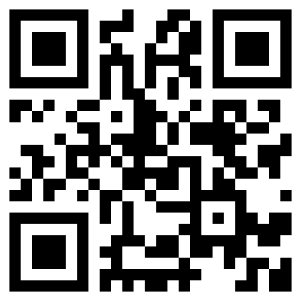  2022年 公立高校入試
※QRコードを読み込むと，英文と連動した音声再生ができます（スマホにも対応）

彩 (Aya) と帰国を控えた留学生のボブ (Bob) が昼休みに教室で話しています。

Aya: Hi, Bob. When will you go back to your hometown?
Bob: Hi, Aya. I'll go back to San Francisco next month.
Aya: Your stay in this school has passed quickly.
Bob: Wonderful! I have learned about Japan in our school since last year, so I often talk about it with my host family.
Aya: Please tell me more.
Bob: Well, I learned about QR codes in the class last week. So I talked about them with my host grandfather. I told him that the codes were made in Japan. Then he told me that he worked for a Japanese company which first invented the QR code in 1994.
Aya: Did he?
Bob: Yes. The codes are also popular in San Francisco. When I went to a restaurant with my family, my mother sometimes scanned the code with her smartphone to pay the money after the meal. It was very convenient. The Japanese technology has supported our daily lives in America.
Aya: Sounds good. Technology is a strong point of Japan. Did you talk about anything else?
Bob: Yes, we talked about evacuation drills. I think it's another strong point of Japan. Japanese drills are different from American drills.
Aya: Is that so?
Bob: Yes. On a fire drill day, students in my school don't know about it at all. Then fire alarms in the school make loud sounds suddenly, and let us know the drill has started.
Aya: I've heard that some schools in Japan have that kind of drill.
Bob: Great! During my stay here, I've known that many Japanese prepare for disasters, such as fires, earthquakes and heavy rain.
Aya: I see. Japan has a variety of disasters every year. My family has made an emergency kit and we keep it in the house.
Bob: Oh, have you? My host family knows how much food and water they should store, and they also know where the local shelter is during a disaster. It's amazing!
Aya: Our family, too. It's important for everyone to prepare for an emergency.
Bob: I agree with you. After going back to America, I'll tell my family to store food and water in case of a disaster.
(注) QR code 二次元コードの一つ scan ～ ～を読み取る loud 大きい

Question
１．Bobはいつサンフランシスコに戻る予定ですか？
２．Bobと彼のホストファミリーのおじいさんは，何について話しましたか？
３．ホストファミリーのおじいさんは，どこで働いていましたか？
４．ボブは日本の避難訓練について，どのように感じましたか？
５．AyaとBobは、災害に備えて何をするべきだと考えていますか？

Answer
１．来月
２．QRコード
３．QRコードを最初に発明した日本の会社
４．日本の避難訓練はアメリカの避難訓練と異なっている。
５．食料や水を貯蔵すること。

※QuestionとAnswerは，ＡＩが作成しました。

